Spectroscopic Investigation of a High-Valent Cobalt-Carbene Complex

Bellow, J.A.; Groysman, S. (Wayne State U.) and Stoian, S.A. (NHMFL)

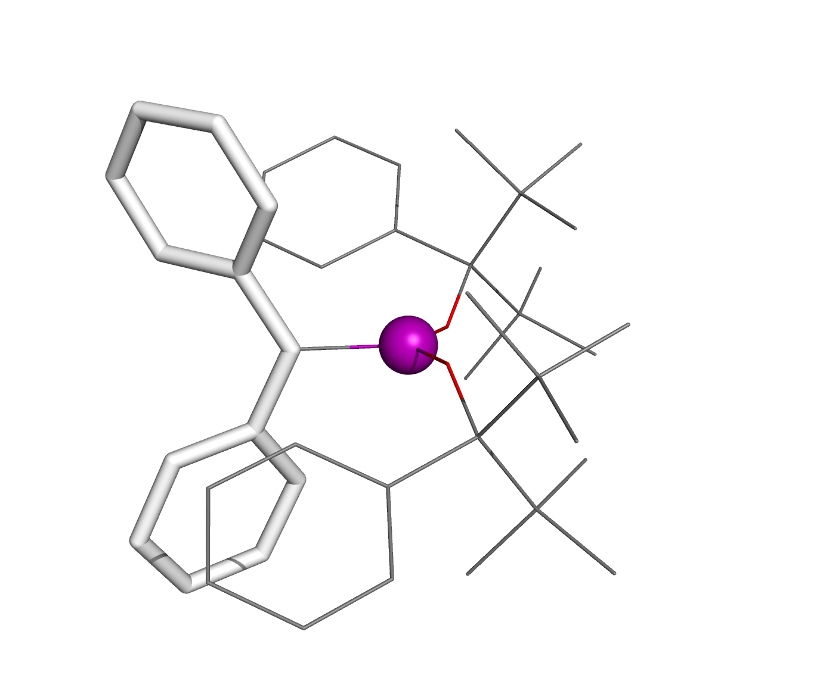
Fig. 1. X-ray crystal structure of 1. The cobalt ion is shown as a purple sphere, the carbene using sticks, and the two alkoxides using lines.
Introduction
Recently we reported the synthesis of a series of reactive bis(alkoxide) complexes supported by bulky alkoxide ligand OR⁻ (R = C^{t}Bu₂Ph).¹⁻³ The reaction of the cobalt bis(alkoxide) complex with diphenyldiazomethane (Ph₂CNN) allowed for the stabilization of an unusual, high-valent cobalt carbene species, 1, see Fig. 1. In order to establish the electronic structure of this complex we have undertaken an EPR spectroscopic investigation.

Experimental
A series of high-frequency, continuous-wave EPR and X-band, pulsed EPR spectra were recorded on frozen toluene solution samples of 1. The X-band spectra were recorded using a Bruker ElexSys 680 spectrometer and a LHe Oxofrd cryostat. The high-frequency EPR spectra of 1 were obtained using the homodyne, quasi-optical EPR instrument outfitted with a 15/17T superconducting magnet of the EMR facility.

Results and Discussion
The frequency- and temperature-dependent EPR spectra recorded for 1 were analyzed in the framework of a typical S = 1/2 spin-Hamiltonian described by Eq. 1. In addition to the electronic Zeeman interaction this Hamiltonian also accounts for the hyperfine coupling of the electronic spin to the I = 7/2 nuclear spin of the ⁵⁹Co nucleus.
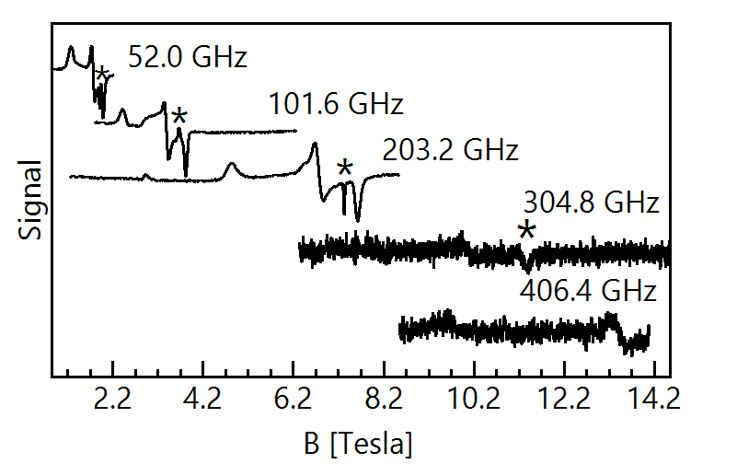
$\hat{H}=β_{e}\vec{B}∙\tilde{g}∙\tilde{S}-β_{n}g_{n}\vec{B}∙\tilde{I}+\tilde{I}∙\tilde{A}∙\tilde{S}$ [1]
Fig. 2. High-frequency EPR spectra recorded at 10 K for a frozen toluene solution of 1. The feature marked by (*) appears at g = 2.00 and originates from a radical impurity.

Conclusions
Analysis of the EPR spectra recorded for 1 allowed us to demonstrate that the electronic ground state of this complex consists of an isolated Kramers doublet. Furthermore, this investigation allowed us to quantify the magnitude of the observed hyperfine interactions. In turn, a theoretical analysis of the observed spectroscopic parameters revealed that the ground spin state of 1 originates not from the presence of a single unpaired electron but rather from the presence of three unpaired electrons: two alpha, majority-spin electrons localized on the cobalt(III) ion and a beta, minority-spin electron delocalized over the carbene ligand. Thus, the S = 1/2 ground state of 1 originates from the strong antiferromagnetic coupling of a cobalt(III) S = 1 spin with that of a carbene-based S = 1/2 spin.

Acknowledgements
Acknowledgment is made to the donors of the American Chemical Society Petroleum Research Fund for support of this research. A portion of this work was performed at the National High Magnetic Field Laboratory, which is supported by National Science Foundation Cooperative Agreement No. DMR-1157490, the State of Florida, and the U.S. Department of Energy.

References
[1] Bellow, J.A., et al., Inorg. Chem., 52, 12335-12337 (2013).
[2] Bellow, J.A. et al., Organometallics, 34, 2917-2923 (2015).
[3] Yousif, M., et al., Organometallics, 34, 5119-5128 (2015).

