**Assessing the Electronic Structure of a [Gd6Fe13], 3d-4f Cluster**

Zhou, H. (U. of Arkansas, High Density Electronic Center); Stoian, S.A. (FSU, NHMFL)

**Introduction**

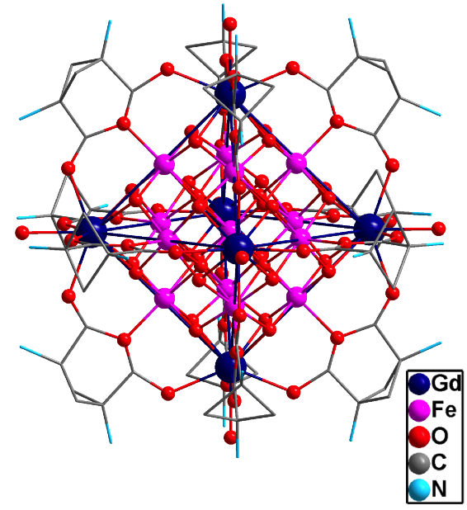

**Fig. 1**. X-ray crystal structure of **1**.

Heterometallic 3d-4f clusters hold the great promise of allowing for high-density information storage and processing at the molecular level through their putative use as qubits. In particular, the majority of the GdIII-containing, 3d-4f hetero-dinuclear complexes that have been characterized up to date have been shown to exhibit ferromagnetic exchange interactions between the two distinct types of spin carriers.1 We have recently synthesized a series of compounds among which the Gd6Fe13 bimetalliccluster,[Gd6Fe13O16(OH)16(H2O)18L12](ClO4)16, **1**, exhibits an unusual metal site topology. In this study we have used 57Fe Mössbauer spectroscopy to derive information about the nature of the ground spin state.

**Experimental**

A series of variable-field, variable-temperature Mössbauer spectra were recorded at temperatures ranging from 4.2 to 200 K and in magnetic fields of up to 8.0 T. The spectra were collected using a constant acceleration spectrometer that was fitted with a Janis 8DT cryostat and an 8.0 T superconducting magnet. This instrument is part of the instrumentation available to the user program at NHMFL.



**Fig. 2**. Field-dependent 57Fe Mössbauer spectra recorded at 4.2 K for **1.**

**Results and Discussion**

The field- and temperature-dependent 57Fe Mössbauer spectra recorded for **1** were analyzed in the framework of a phenomenological model that allowed us to assess the distribution and magnitude of the hyperfine fields experienced by the 57Fe nuclei. This investigation revealed that at 4.2 K **1** exhibits a nanoparticle-like magnetic behavior. Furthermore, analysis of the high-field spectra indicated that the iron ions of the [Gd6Fe13] cluster are distributed among two unequal, magnetic sublattices. Interestingly, this analysis further revealed that while the magnetic moments of the individual lattices are aligned parallel to the applied field, they are found antiparallel with respect to each other. This observation is indicative for the presence of a ferrimagnetic arrangement of the individual iron spins.

**Conclusions**

The 57Fe Mössbauer spectroscopic characterization of a [Fe13Gd6] heterometallic complex **1**, allowed us to determine that the ground spin state exhibits a ferrimagnetic arrangement of the local iron spins.

**Acknowledgements**

A portion of this work was performed at the National High Magnetic Field Laboratory, which is supported by National Science Foundation Cooperative Agreement No. DMR-1157490, the State of Florida, and the U.S. Department of Energy.

**References**

[1] Andruh, M., *et. al*., Inorg. Chem., **48**, 3342-3359 (2009).