High-Field EPR and ⁵⁷Fe Mössbauer Studies of Complexes Containing Fe-Fe Bonds

Greer, S.M. (FSU, Chemistry); Hill, S.O.; Stoian, S.A. (FSU, NHMFL); Kuppuswamy, S. and Thomas, C.M. (Brandeis U., Chemistry)

Introduction
Complexes containing multiple metal sites have been a subject of considerable attention. Interest in these complexes stems from their ability to facilitate catalysis, mimic enzyme active sites and serve as multi-electron redox agents^{1,2}. Despite this effort relatively little is known about the bonding interactions between multiple first row transition metal elements. A complex containing a diiron bond has been synthesized and studied using high field/ frequency electron paramagnetic resonance and variable field ⁵⁷Fe Mossbauer spectroscopy. This complex (1), shown in Fig. 1, contains one Fe(II) site and one Fe(I) site.²
Fig. 1. Structure of 1.

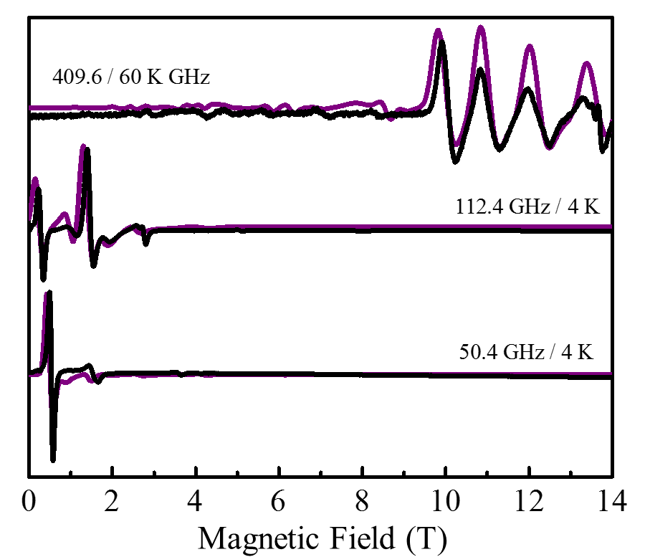
Experimental
A series of high-field EPR measurements were conducted on a ground solid sample of 1 using the homodyne, quasi-optical EPR instrument outfitted with a 15/17T superconducting magnet. Mössbauer spectra were recorded using an instrument fitted with a helium-flow cryostat that had a built in 8 T superconducting magnet. Both instruments are part of the instrumentation available at the NHMFL EMR facility.³

Results and Discussion
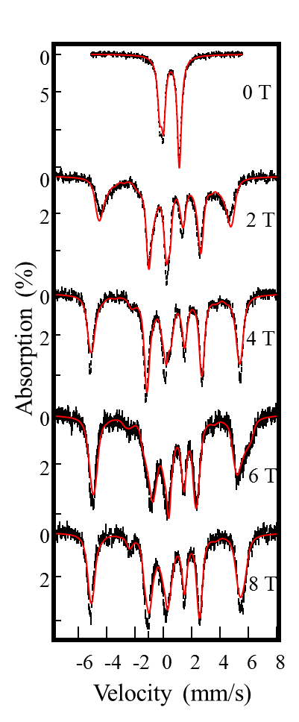
A series of temperature-dependent, high-frequency/field EPR were recorded for 1. These spectra were analyzed in the framework of a standard spin Hamiltonian (Fig. 2). This analysis allowed for the determination of the magnetic anisotropy of 1, which was found to be nearly axial. Variable-field Mössbauer spectroscopy was then employed to ascertain the hyperfine structure (Fig. 3). Analysis of the Mössbauer spectra allowed for the hyperfine structure of both Fe sites to be determined.
Fig. 2. Experimental (black) and simulated (purple) EPR spectra of 1 at various temperatures/frequencies.

Fig. 3. Experimental (black) and simulated (red) Mössbauer spectra of 1 under various applied fields.

Conclusions
The combination of high-frequency/field EPR and variable field Mössbauer yields a detailed picture of the electronic structure of 1.

Acknowledgements
S.G. acknowledges support from the National Science Foundation Graduate Research Fellowship Program under Grant No. 1449440. C.M.T. acknowledges support from the U.S. Department of Energy under Award no. DE-SC0004019. A portion of this work was performed at the National High Magnetic Field Laboratory, which is supported by National Science Foundation Cooperative Agreement No. DMR-1157490, the State of Florida, and the U.S. Department of Energy.

References
[1] Wheatley, N., et al., P. Chem. Rev., 99, 3379−3420 (1999).
[2] Kuppuswamy, S., et al., Inorg. Chem., 51, 1866-1873 (2012).
[3] Hassan, A. K., et al., J. Magn. Reson., 142, 300-312 (2000).

