High Resolution ¹³C CP-MAS NMR Study of the Dielectric Phase Transition in the Metal-Organic Framework [(CH₃)₂NH₂]Zn(HCOO)₃

Abhyankar, N. (Florida State U., Chemistry & Biochemistry); Kweon, J.J.; Fu, R. (NHMFL) and Dalal, N.S. (Florida State U., Chemistry & Biochemistry, NHMFL)

Introduction
We report the ¹³C CP-MAS NMR to probe the changes in the metal-formate framework during the phase transition. [(CH₃)₂NH₂]Zn(HCOO)₃, or Dimethylammonium Zinc Formate (DMAZnF) is an interesting material which undergoes a paraelectric/ferroelectric phase transition at ~160 K. The paraelectric/ferroelectric phase transition in this family of metal-organic frameworks (MOFs) has been classified as an order-disorder transition based on cooperative ordering of the DMA⁺ ion. But the exact nature of which has still not been elucidated. We employed high resolution ¹³C CP-MAS NMR to elucidate the phase transition mechanism of DMAZnF.
Experimental
A small piece of the crystal (~ 1 mm³) was packed in a 3.2 mm MAS rotor. The line-shape, spin-lattice relaxation time (T₁), spin-spin relaxation time (T₂), and 2D exchange spectroscopy (EXSY) measurements were made at NHMFL using a Bruker 3.2 mm triple resonance 600 MHz MAS WB DVT probe with a spinning speed of 10 kHz. All three gas channels of variable temperature, bearing and drive were cooled using Bruker cryo cooling unit PH2700.
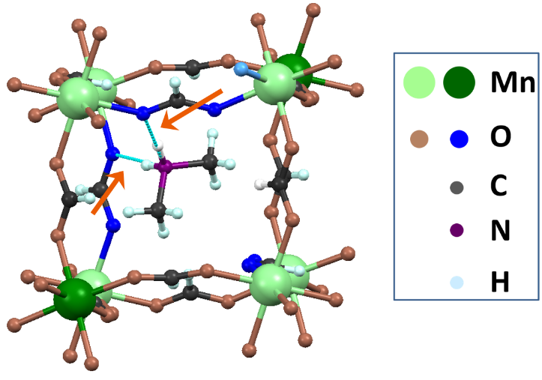

Fig. 1. The ABX₃ MOF cavity for the isomorphous MOF DMMnF in the low-temperature ferroelectric phase. The two DMA⁺ protons (indicated by orange arrows) become inequivalent as the DMA⁺ ion is shifted off-center in the cavity.
Results and Discussion
At the monoclinic phase below the structural phase transition temperature (Fig. 1), one of the methyl groups is pushed towards a corner of the cavity while the other is pulled away from the diagonally opposite corner. The formate carbons can be grouped into three types. The first type of formate carbon has no H-bonds on either of its oxygens. This carbon is the most upfield when the formate line splits into three resonances below the phase transition. The second and third types of formate (carbon) have one of their oxygens H-bonded to the central DMA⁺ cation.
Fig 2. Shows the 2D EXSY at 166K, where the low- and high-temperature phases coexist. The three narrow peaks belong to the low temperature clusters, while the broad peak centering at ~ 174.5 ppm corresponds to the high temperature cluster. Clearly, there are some narrow resonances in the close sections between the diagonal peaks. This is clear evidence that the three inequivalent formate carbons at low temperature cluster, experience chemical exchange. This observation demonstrates that the DMA⁺ ion in the cage hops between their three different configurations with the formate linkers in the low-temperature cluster. The most striking observation in Fig. 2 is the existence of cross peaks between the low- and high-temperature clusters. This implies that the low- and high-temperature clusters are in dynamical exchange at the phase transition temperature.
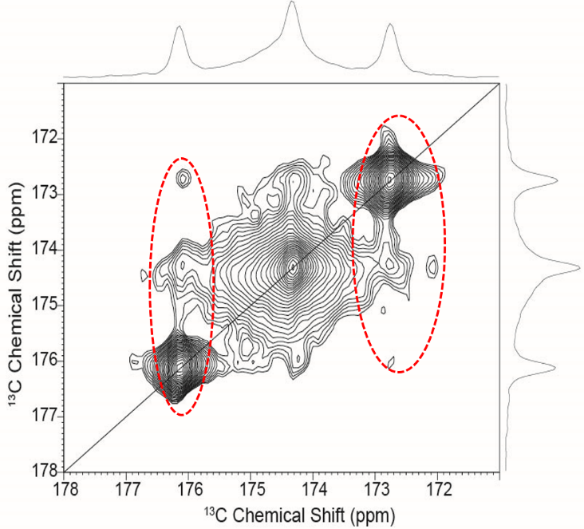

Fig. 2. 2D EXSY spectrum for formate group, acquired at 166 K with a mixing time of 5 s.
Conclusions
The high resolution ¹³C CP-MAS NMR enabled probing the phase transition of the DMZnF crystal and studies of the cluster formation through 2D EXSY cross-peaks.
Acknowledgements
We are grateful for financial support from the UCGP at NHMFL which is supported by National Science Foundation (NSF) Cooperative Agreement No. DMR-1157490 and the State of Florida.
References
[1] Abhyankar, N., et al., in preparation.

