Using ³⁵Cl Solid-State NMR at Ultra-High Magnetic Fields to Study Active Pharmaceutical Ingredients: Polymorphs and Dosage Forms

Schurko, R.W., Hirsh, D.A., Veinberg, S.L., Jaroszewicz, M.J., Sandre, A.R., Namespetra, A.M. (U. of Windsor, Chemistry & Biochemistry); Frydman, L. (Weizmann Institute, Chemical Physics); Hung, I. and Gan, Z. (NHMFL)

Introduction
The differentiation of polymorphs of active pharmaceutical ingredients (APIs) is of great importance in the pharmaceutical industry; distinct polymorphs may exhibit different physicochemical properties such as bioavailability, shelf life, stability, and each unique polymorph can be patented.¹ Since most APIs are prepared as solids, it is crucial to structurally characterize and identify polymorphs and impurities in both their initial bulk forms and their final dosage forms (e.g., pills, capsules, tablets, etc.). Polymorphs are most commonly differentiated with the use of X-ray diffraction (XRD) and ¹³C solid-state NMR (SSNMR) techniques.² Our group has demonstrated in 2008 that ³⁵Cl SSNMR can serve as a complementary technique to these conventional characterization methods.³ In 2014, we published a comprehensive study of the relationship between ³⁵Cl NMR parameters and molecular structures in a series of 20 APIs and related polymorphs.⁴ The current work describes the use of ³⁵Cl SSNMR for identifying the solid phases of APIs, along with impurities, in a variety of dosage forms. The 21.1 T NMR system at the MagLab has been crucial for the success of this work.
Experimental
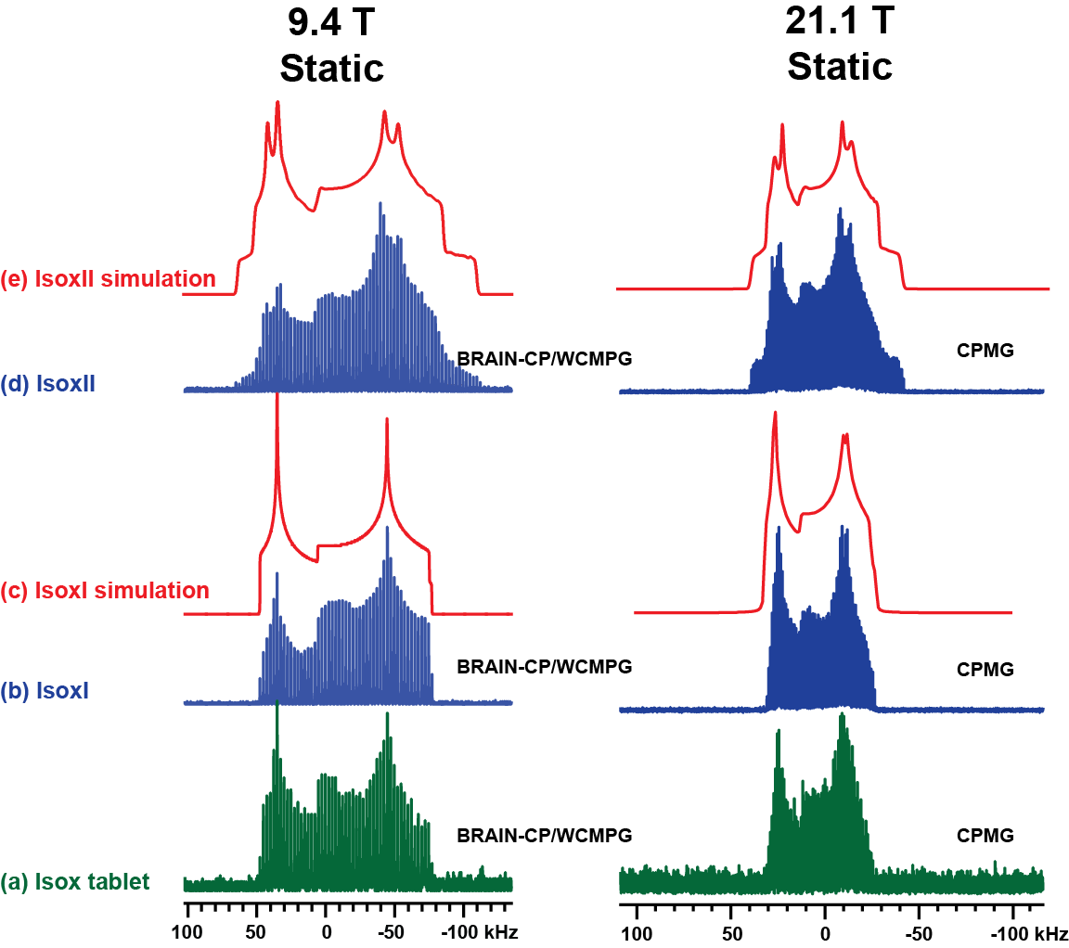
³⁵Cl SSNMR experiments were conducted at the NHMFL in Tallahassee, FL using the 900 MHz NMR spectrometer and a 3.2 mm HX MAS probe. Spectra were acquired with the QCPMG⁵ and BRAIN-CP/WURST-CPMG (BCP) pulse sequences.⁶ Samples were purchased from Sigma-Aldrich or prepared according to literature methods.

Results and Discussion
³⁵Cl SSNMR spectra of two polymorphs of isoxsuprine HCl (IsoxI and IsoxII) were acquired in short experimental times at 21.1 T (figs. b and d). The polymorphs are easily differentiated with simulations (figs. c and e) due to the different quadrupolar parameters for each polymorph. During the production of dosage forms, the API is generally mixed into an excipient matrix (cellulose, binders, etc.), which often renders ¹³C NMR spectra unhelpful due to overlap of signals from the excipient and API. Since the excipient does not contain chlorine atoms, undistorted ³⁵Cl SSNMR powder patterns arising purely from the API are observed, allowing easy identification of the phase in the dosage form (IsoxI, fig. a). The use of an ultra-high magnetic field (UHF) allows for rapid acquisition of ³⁵Cl SSNMR spectra of APIs in any form – this is very helpful for dosage forms, where the wt% of API is often very low. Our lower detection limit is currently less than 0.5%. We believe that UHF NMR, along with pulse sequences designed in our laboratory, will be of great use in many future studies of APIs, polymorphs, impurities, drug discovery and improving formulation processes.
Acknowledgements
This research is funded, in part, by the Natural Sciences and Engineering Research Council (NSERC, Canada), the Canadian Foundation for Innovation (CFI), the Ontario Innovation Trust (OIT) and the University of Windsor. RWS also thanks the Ontario Ministry of Research and Innovation for an Early Researcher Award, and the University of Windsor for a 50th Anniversity Jubilee Research Award. A portion of this work was performed at the NHMFL, which is supported by NSF DMR-1157490 and the State of Florida.
References
[1] Brittain, H.G., et al., Polymorphism in Pharmaceutical Solids; Marcel Dekker: New York, 95, 279-330 (1999).
[2] Harris, R.K., Analyst, 131, 351 (2006).
[3] Hamaed, H., et al., J. Am. Chem. Soc., 130, 11056 (2008).
[4] Hildebrand, M.P., et al., CrystEngComm, 16, 7334 (2014).
[5] Larsen, F.H., et al., J. Phys. Chem. A, 101, 8597-8606 (1997).
[6] Harris, K.J., et al., J. Magn. Reson., 224, 38-47 (2012).

