Parahydrogen Enhanced Nuclear Spin Polarization over Shaped Ceria Nanocrystals

Zhao, E.W.; Zhou, R.H.; Bowers, C.R. (UF Chemistry); Zheng, H.B. and Hagelin-Weaver (UF Chem. Eng.)

Introduction
Parahydrogen enhanced polarization¹ (or PHIP) is an inexpensive and scalable method for bulk production of nuclear spin hyperpolarized fluids for NMR spectroscopy and imaging. Spin polarization of order unity is attainable but only if H₂ adds to the substrate in a pairwise fashion. Here, a parahydrogen enhanced NMR study of the hydrogenation of propene (PE) and propyne (PY) over three different CeO₂ nanocrystal shapes (Figure 1) is presented. Ceria has been the subject of numerous catalytic studies. The metal oxide yields high activity and selectivity in the hydrogenation of alkynes to alkenes and the activity with respect to PE hydrogenation is highly dependent on the CeO₂ surface structure.

Experimental
Shaped CeO₂ nanocrystals with surfactant-free surfaces were synthesized by the hydrothermal method. TEM images are presented in Figure 1. Crystallinity was confirmed by XRD. All three shapes are formed with a cubic fluorite structure. The reactant gases, H₂ (normal or para-enriched) and PE or PY were fed into the reactor at flow rates of 600 mL/min and 20 mL/min, respectively. The PHIP experiments were performed in ALTADENA mode, where hydrogenation products formed at 5 mT are transported adiabatically to 9.4 T for NMR detection. The setup and reaction conditions are fully described in Ref. 2.

Results and Discussion

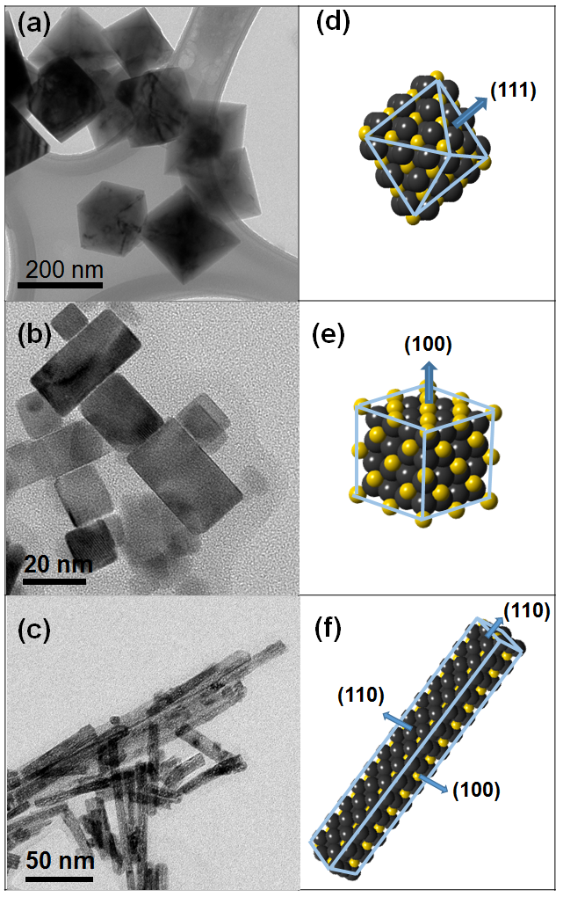 | 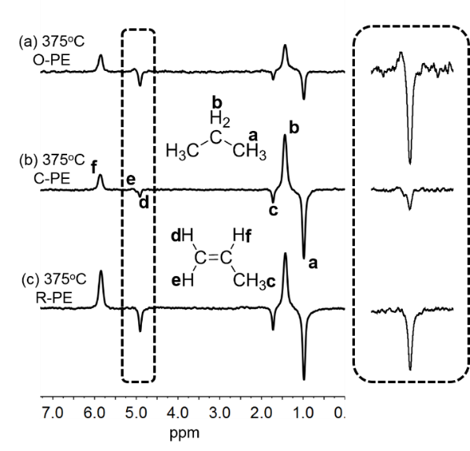
Fig. 1. TEM images of (a) CeO₂ nano-octahedra, (b) nano-cubes and (c) nano-rods. Structural models of (d) CeO₂ nano-octahedron, (e) nano-cube and (f) nano-rod simulated by CrystalMaker. | Fig. 2. 400 MHz ¹H NMR spectra acquired on the flowing reactor effluent gas resulting from a reactant gas mixture of PE and p-H₂ at a reactor temperature of 375 °C. (a) CeO₂ nano-octahedra, (b) CeO₂ nano-cubes or (c) CeO₂ nano-rods. Inset: Expansion of PE CH₂ (H^{d} and H^{e}) spectral region.

Conclusions
The well-defined ceria shapes expose different crystalline facets with varying oxygen vacancy densities. While the catalytic activity in the hydrogenation of propene over ceria is strongly facet dependent, the pairwise selectivity is low (2.4%), consistent with step-wise H atom transfer for all three nanocrystal shapes.

Acknowledgements
This work was supported by ACS-PRF #52258-ND5 and NSF CHE-1507230.

References
[1] Bowers, C. R.; Weitekamp, D. P., PRL, 1986, 57 (21), 2645-2648.
[2] Zhou, R. H.; Zhao, E. W.; Cheng, W.; Neal, L. M.; Zheng, H. B.; Quinones, R. E.; Hagelin-Weaver, H. E.; Bowers, C. R., JACS, 2015, 137 (5), 1938-1946.
[3] Zhao, E.W.; Zheng, H.; Zhou, R.; Hagelin-Weaver, H.E.; Bowers, C.R., Angew. Chem. Int. Ed., 2015, 54 (48), 14270-14275.

