900 MHz High Resolution ¹H MAS NMR Study of Displacive Behavior of the Model Order-Disorder Antiferroelectric Ammonium Dihydrogen Arsenate, NH₄H₂AsO₄

Kweon, J.J.; Fu, R.; Kitchen, J.A.; Gor’kov, P.L. and Brey, W.W. (NHMFL) and Dalal, N. S. (Florida State U., Chemistry & Biochemistry, NHMFL)

Introduction
NH₄H₂AsO₄ (ADA) exhibits a paraelectric (PE) to antiferroelectric (AFE) phase transition at T_{N} ~ 216 K whose mechanism remains unclear. We report ¹H NMR evidence of the coexistence of order-disorder and displacive features at the antiferroelectric phase transition in ADA using the newly designed VT probe for the Wide bore 900 spectrometer. Employing the high-field, high-resolution ¹H MAS NMR at 900 MHz, we measured the temperature dependence of the isotropic chemical shift as well as spin-lattice relaxation times of the O-H…O (acid) and NH₄⁺ protons to probe the role of the various protons in the transition mechanism. Our data suggest that the traditional classification of equilibrium phase transitions into “order−disorder” and “displacive” types should rather be “order−disorder cum displacive” phase transitions.
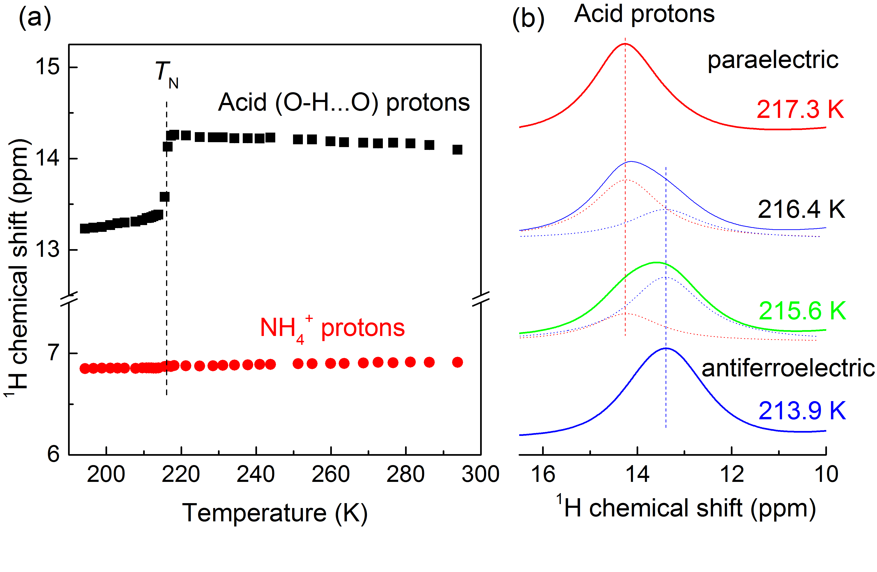
Fig. 1. (a) Temperature dependence of ¹H δ_{iso} in ADA showing anomaly at T_{N} for acid protons. (b) Temperature dependence of the 900 MHz ¹H MAS peaks of the acid protons in ADA around T_{N}.
Experimental
A small piece of ADA single crystal was packed in a 3.2 mm MAS rotor and used for ¹H MAS NMR line-shape and spin-lattice relaxation time (T₁) measurements on an ultrawide bore 900 MHz magnet equipped with a Bruker Avance III NMR console using a spinning speed of 13.5 kHz. The low temperature variable-temperature (VT) experiments on the 900 UWB magnet were carried out using an NHMFL-designed and fabricated 3.2 mm HX double resonance MAS probe with cooling for both the bearing and VT channels.
Results and Discussion
Fig. 1(a) shows the temperature dependence of the ¹H isotropic chemical shift (δ_{iso}) of the acid and NH₄⁺ protons. The δ_{iso} of the O-H…O (acid) protons undergoes a significant abrupt change around the T_{N}, implying the presence of a displacive character for the acid protons. For the NH₄⁺ protons, on the other hand, the δ_{iso} remains essentially unchanged through the T_{N}, showing that the NH₄⁺ groups execute essentially order-disorder dynamics. Fig. 1(b) shows the coexistence of resonances for the acid protons from the PE and AFE portions of the crystal lattice within about 3 K of T_{N}. Using the E_{a} and τ₀ values from the BPP fitting of the spin-lattice relaxation rates (1/T₁), the calculated correlation times (τ_{c}) of both protons (Fig. 2) are found to increase by 1 order of magnitude from the PE to the AFE phase, implying that the motion of both types of protons slows down on entering the AFE phase.
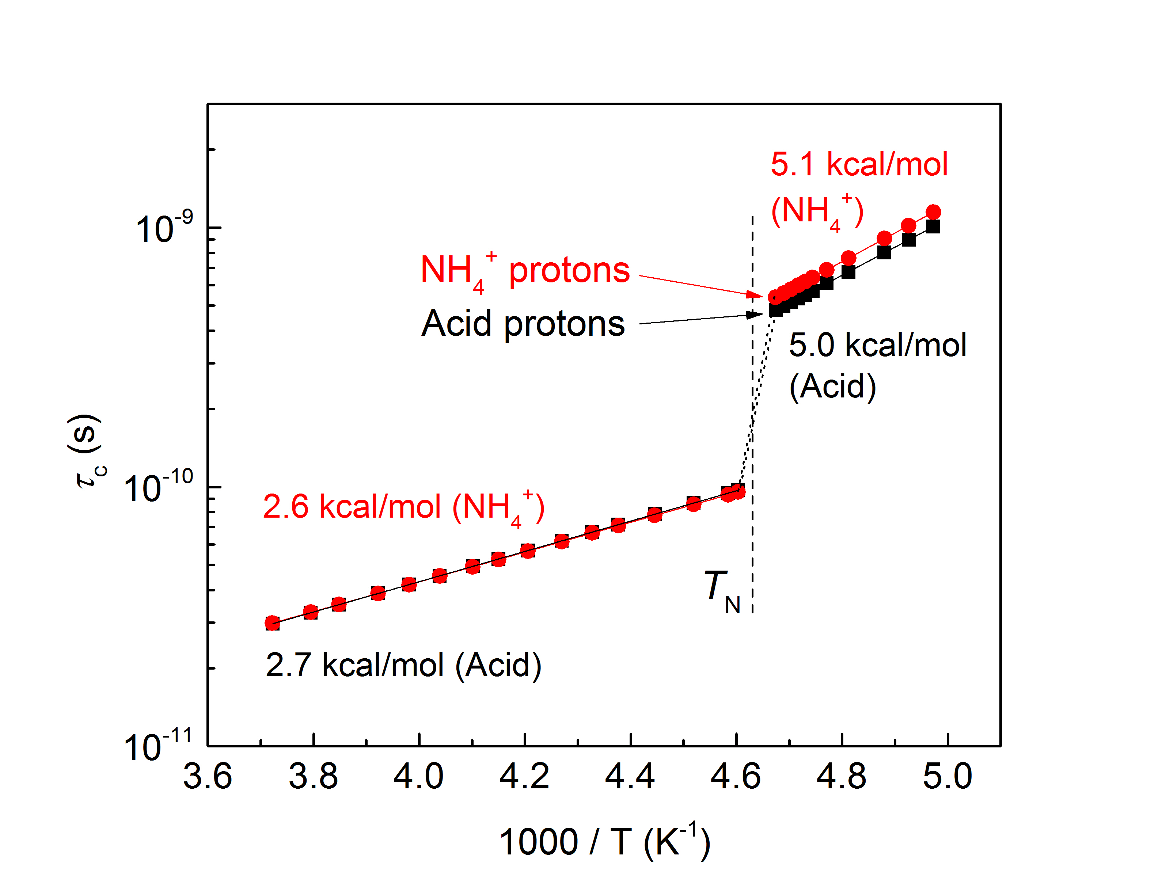
Fig. 2. Temperature dependence of correlation times (τ_{c}) of protons in ADA across T_{N}.
Conclusions
The 900 MHz ¹H MAS NMR measurements enable us to probe the mechanism of the PE-AFE phase transition in ADA, using the acid (O-H…O) and NH₄⁺ protons as probes. The ADA phase transition exhibits simultaneously features of both “order-disorder” and “displacive” character, a long sought-after feature.
Acknowledgements
We are grateful for financial support from the User Collaboration Grants Program (UCGP) 5084 at the National High Magnetic Field Laboratory (NHMFL) which is supported by National Science Foundation (NSF) Cooperative Agreement No. DMR-1157490 and the State of Florida.
References
[1] Kweon, J.J., et al., J. Phys. Chem. C, 119, 5013-5019 (2015).

