High Resolution ¹H and ³¹P NMR Detection of a Displacive Component in the Mechanism of Ferroelectric Phase Transition in KH₂PO₄

Kweon, J.J.; Fu, R.; Choi, E.S. (NHMFL) and Dalal, N.S. (Florida State U., Chemistry & Biochemistry, NHMFL)

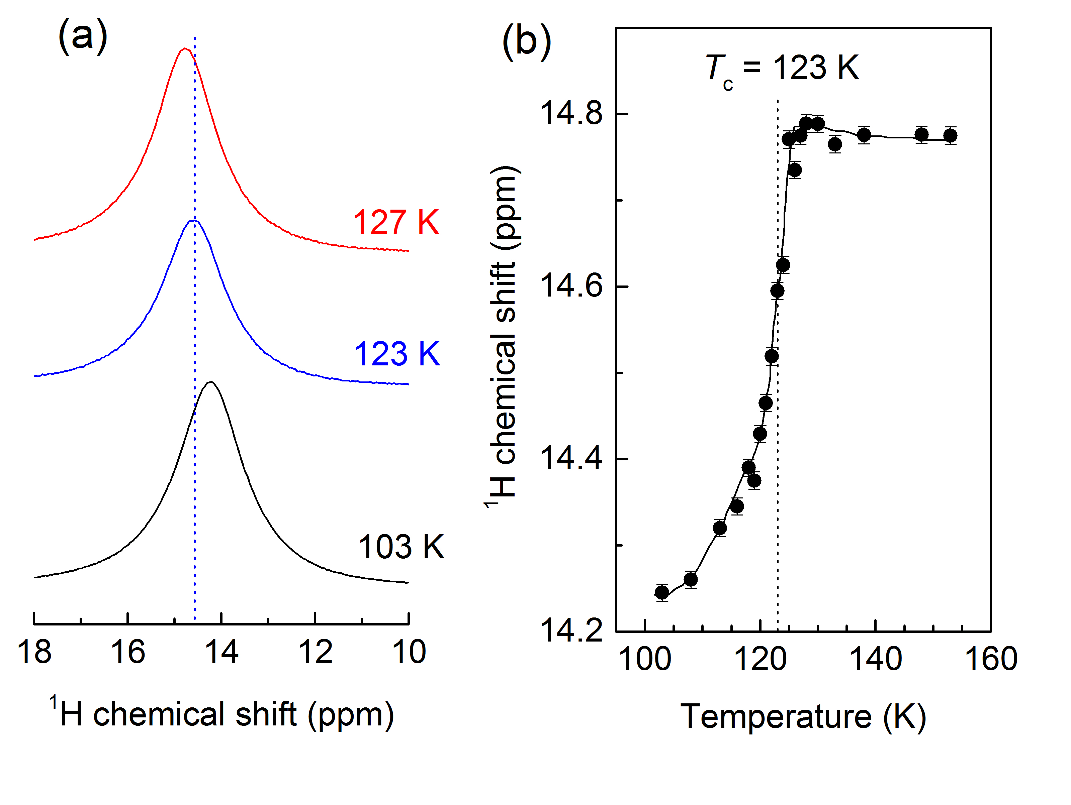
Fig. 1. (a) ¹H MAS spectra of a KDP single crystal at 600 MHz, showing a clear shift at T_{C} (123K). (b) Temperature dependence of δ_{iso} of ¹H in KDP at 600 MHz.
Introduction
We report magic angle spinning (MAS) ¹H and ³¹P NMR measurements to detect the presence of a displacive component in the model of the phase transition in KH₂PO₄ (KDP), in close vicinity of its paraelectric-ferroelectric (PE-AFE) phase transition at T_{c} of 123 K. KDP has been considered as a model compound in which the order-disorder behavior of the ¹Hs in the O-H…O bonds is thought to be the cause of cooperativity and phase transitions. The high-resolution at 14.1 T with our current instrumentation enabled MAS down to 100 K showing that the isotropic chemical shift of both ¹H and ³¹P undergo sharp anomalies at T_{c}, providing direct evidence of a ‘displacive’ component in the mechanism of the paraelectric-ferroelectric transition in KDP, the parent compound of this family.
Experimental
A small piece of KDP single crystal was packed in a 3.2 mm MAS rotor and used for ¹H and ³¹P MAS NMR line-shape measurements using a 3.2 mm Bruker triple resonance MAS probe on the 600 MHz spectrometer. In the probe all three gas channels of bearing, drive and VT gas were cooled using a cryo cooling unit, PH2700, enabling the measurements over the range of 300 K down to about 100 K. The MAS NMR spectra were recorded using a spinning speed of 10 kHz for ¹H and 7.5 kHz for ³¹P.
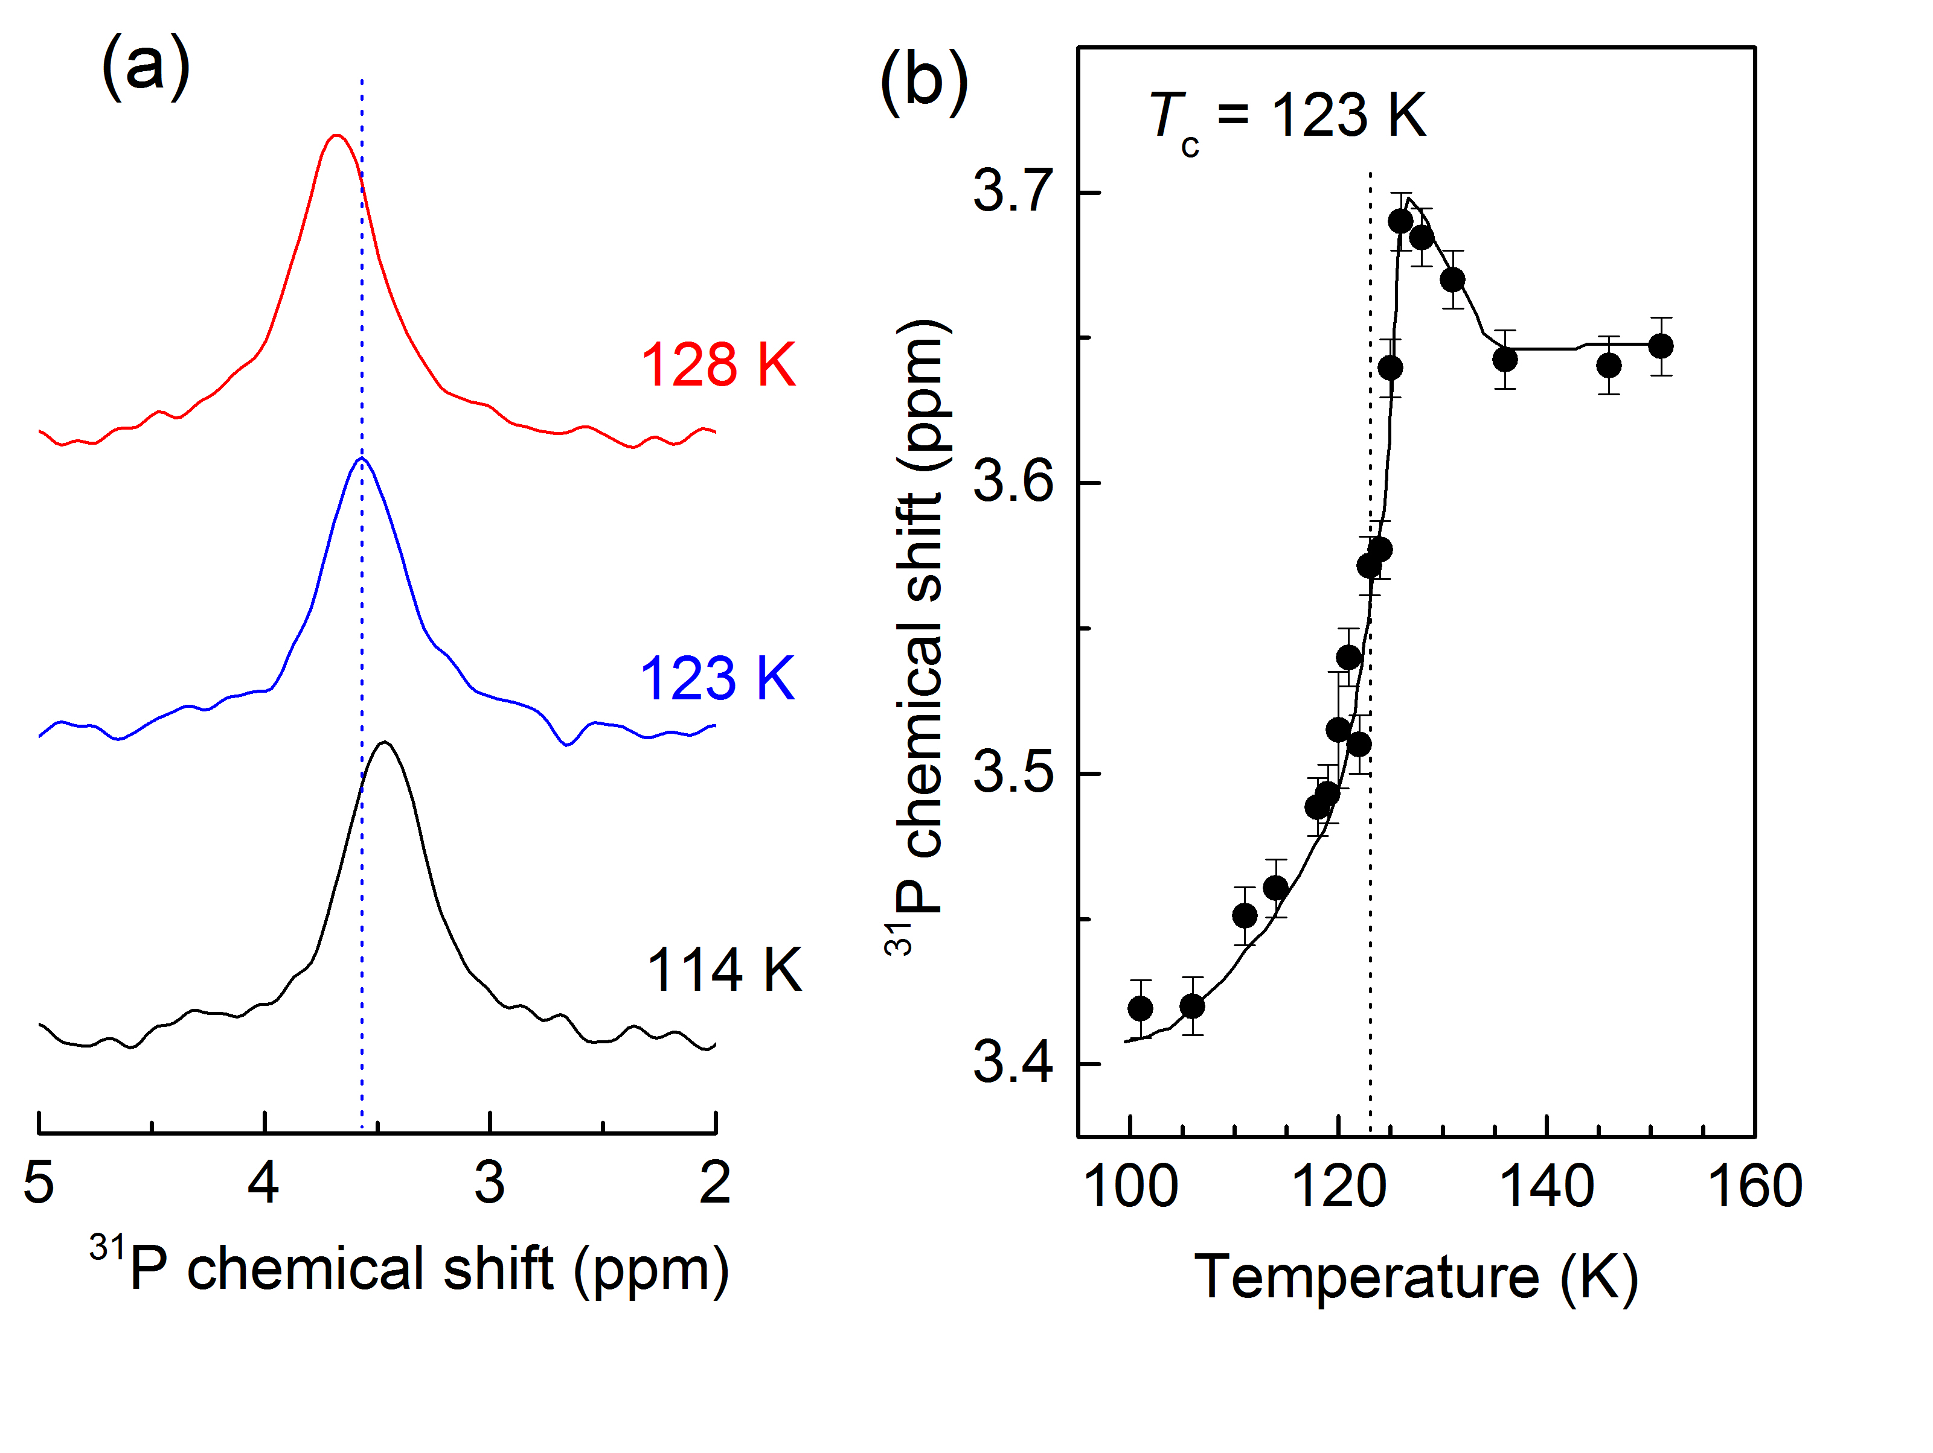
Fig. 2. (a) ³¹P MAS spectra of a KDP single crystal at 243 MHz recorded around T_{c}. (b) Temperature dependence of ³¹P chemical shift of KDP.
Results and Discussion
Fig. 1(a) shows the ¹H MAS NMR spectra of the protons around the phase transition temperature T_{c} = 123 K. The ¹H MAS spectra show a dramatic change around T_{c}. This study was to measure the temperature dependence of the isotropic chemical shifts, δ_{iso} of the O-H…O protons on going through the T_{c} i.e. to determine whether δ_{iso} remains essentially unchanged (sign of an order-disorder transition) or whether it changes anomalously (as expected for a displacive transition). The δ_{iso} of the protons of Fig. 1(b) undergoes a significant abrupt change around the transition temperature T_{c}, implying the presence of displacive character for the protons.
Fig. 2(a) shows ³¹P direct polarization (DP) MAS NMR spectra around the phase transition T_{c} = 123 K. The ³¹P MAS spectra show a significant change around T_{c}. Clearly the δ_{iso} of the PO₄ moiety as in Fig. 2(b) undergoes a significant abrupt change around T_{c}, implying the presence of displacive character for the PO₄³⁻ ions while taking part in the FE phase transition.
Conclusions
High-field (14.1 T) MAS NMR measurements of temperature dependence of the δ_{iso} of the ¹H and ³¹P nuclei in KDP around its PE-FE phase transition reveal that the δ_{iso} of both sets of nuclei undergo anomalous changes around the transition temperature; constituting direct evidence of a significant ‘displacive’ component in the [H₂PO₄]⁻ moieties in KDP, resolving a long-standing query regarding this parent lattice of hydrogen-bonded ferroelectric compounds.
Acknowledgements
We are grateful for financial support from the User Collaboration Grants Program (UCGP) 5084 at the National High Magnetic Field Laboratory (NHMFL) which is supported by National Science Foundation (NSF) Cooperative Agreement No. DMR-1157490 and the State of Florida.
References
[1] Kweon, J.J., et al., in preparation.

