Electron Spin Resonance (ESR) Studies of the Phillips’ Ethylene Polymerization Catalyst

Peek, N.; Lita, A. (FSU, Chemistry); Krzystek, J. (NHMFL) and Stiegman, A.E. (FSU, Chemistry)

Introduction
The Phillips’ ethylene polymerization catalyst has been used in the commercial production of high-density polyethylene (HDPE) ever since Hogan and Banks patented it in 1958. Even today, it is responsible for as much as 50 % of world HDPE production. The Phillips’ catalyst is a supported metal oxide catalyst made by the dispersion of Cr⁶⁺ ions on silica. In practice, the active sites are formed during the reduction of Cr⁶⁺ by ethylene at elevated temperatures. Because of its longstanding industrial importance, extensive mechanistic studies have been carried out and it is generally believed that Cr⁶⁺ is ultimately reduced to a Cr²⁺ precursor site during the activation process. This Cr²⁺ site then reacts with ethylene to form an organometallic active site.
Recently, in our laboratory, using sol-gel chemistry, we prepared the Phillips’ catalyst as a microporous, optically transparent monolith. Using this microporous matrix we are able to monitor the reduction of Cr⁶⁺ down to the precursor site, which is Cr²⁺, and then, with addition of ethylene, the formation of the Cr³⁺ active site, the structure of which was ultimately determined to be a Cr³⁺ vinyl species (eq. 1) [1].
(SiO-)₂Cr⁽⁶⁺⁾(O)₂ + 2CO → (SiO-)₂Cr⁽²⁺⁾ + 3H₂C=CH₂ → (SiO-)₂Cr⁽²⁺⁾(CH=CH₂) (1)
A key question that emerged from this study was at what temperature did the reaction between the Cr²⁺ site and ethylene take place? We sought to answer this though a temperature-dependent EPR study where the temperature at which Cr³⁺ is formed in the presence of ethylene was determined from the emergence of the characteristic EPR spectrum for that ion.
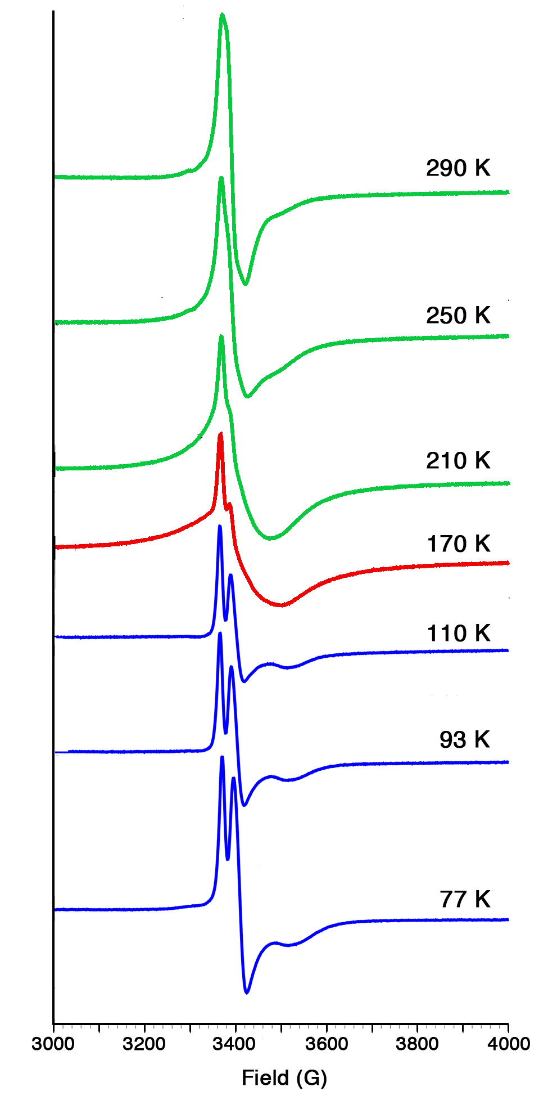
Experimental
Experiments were carried out on the Bruker Elexsys 680 instrument operating at X-band (9 GHz) and utilizing temperature control of the sample. A sample of 1 mol % Cr⁶⁺ on silica was heated to 350 °C and reduced with CO to generate the Cr²⁺ precatalyst (eq. 1). The sample was then transferred to an evacuated EPR tube, which was sealed, placed in the spectrometer and cooled to 77 K. The spectrum was collected and then ethylene gas was added to the system and another spectrum was collected. The temperature was then systematically increased to specific temperature for the liquefaction and vaporization of ethylene and the spectrum recorded.

Results and Discussion
At 77 K, the EPR spectrum shows resonance(s) attributable to Kramers ions (Cr⁵⁺ and Cr³⁺) that form during the CO reduction process (Fig. 1). The spectrum remains unchanged until 170 K, which is the melting point of ethylene. At this temperature an abrupt increase in EPR intensity indicated the onset of further Cr³⁺ formation.

Conclusions
This is a significant result as it indicates that as soon as the ethylene melts and becomes mobile the reaction at the active site occurs. This happens at much lower temperature than was previously thought.

Acknowledgements
A portion of this work was performed at the NHMFL funded by NSF Cooperative Agreement No. DMR-1157490 and the State of Florida. Funding was also provided by the Catalysis Science Initiative of the U.S. Department of Energy, Basic Energy Sciences (DE-FG02-03ER15467).
Fig. 1. Temperature dependent EPR spectra of Cr⁵⁺ and Cr³⁺ in the presence of ethylene.
References
[1] Brown, C., et al., ACS Catal., 5, 5574-5583 (2015).

