Strong Correlations Generically Protect $d$-Wave Superconductivity against Disorder
Tang, S. (FSU, Physics); Dobrosavljevic, V. (Magnet lab, FSU, Physics) and Miranda, E. (Unicamp U, Brazil, Physics)

Introduction
For many classes of unconventional superconductors, such as the cuprates, heavy fermion superconductors, organic materials and iron pnictides electronic interactions are believed to be essential. Among the many puzzling features of these systems is their behavior in the presence of disorder. In weakly interacting d -wave superconductors, Abrikosov-Gor'kov (AG) theory predicts that a tiny amount of non-magnetic impurities should bring the transition temperature $T_{c}$ to zero. In the case of the cuprates, however, experiments have shown that these d-wave superconductors are very robust against disorder. This feature was frequently ascribed to scattering by charged off-plane impurities, which is mostly in the forward direction. The puzzle was partially clarified, however, once strong electronic interactions were shown to give rise to the impurity screening effects seen in these experiments, as captured by the Gutzwiller-projected wave function. Despite this progress, it would be desirable to understand both qualitatively and quantitatively whether disorder screening has any significant influence on $T_{c}$ as well as on the normal state transport properties.

Results and Discussion
In the presence of impurities, the strongly correlated state readjusts itself and creates a renormalized disorder potential. In the dilute limit, the AG theory can be extended to describe the effect of this renormalized potential on $T_{c}$ degradation and transport properties. We show that how electronic interactions lead to a much slower decrease of $T_{c}$ as compared to the weak-coupling theory. Our results demonstrate that (i) this effect is intrinsically tied to the proximity to the Mott insulating state, although it is significant even above optimal doping; (ii) the doping dependence of normal state resistivity is different from that of the pair-breaking scattering rate, which governs $T_{c}$; and (iii) the softening of the disorder potential by interactions leads to a strong enhancement of the forward scattering amplitude.

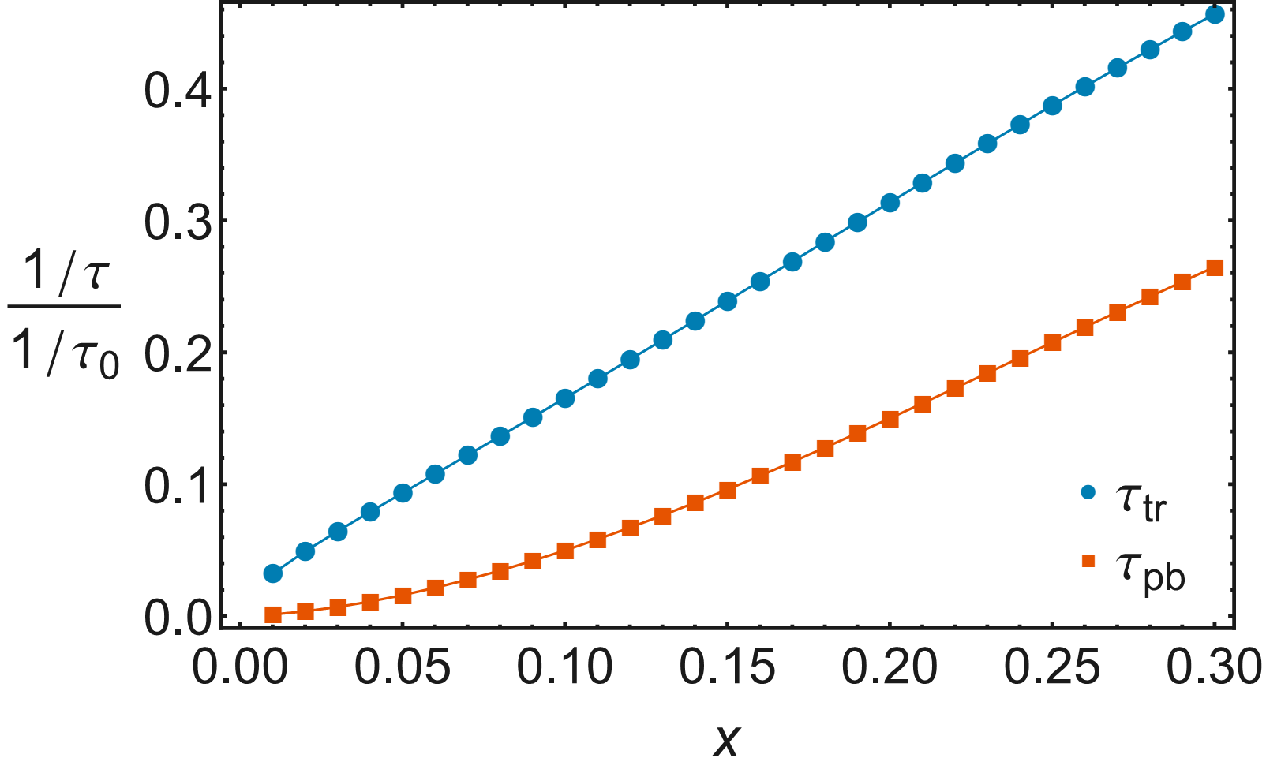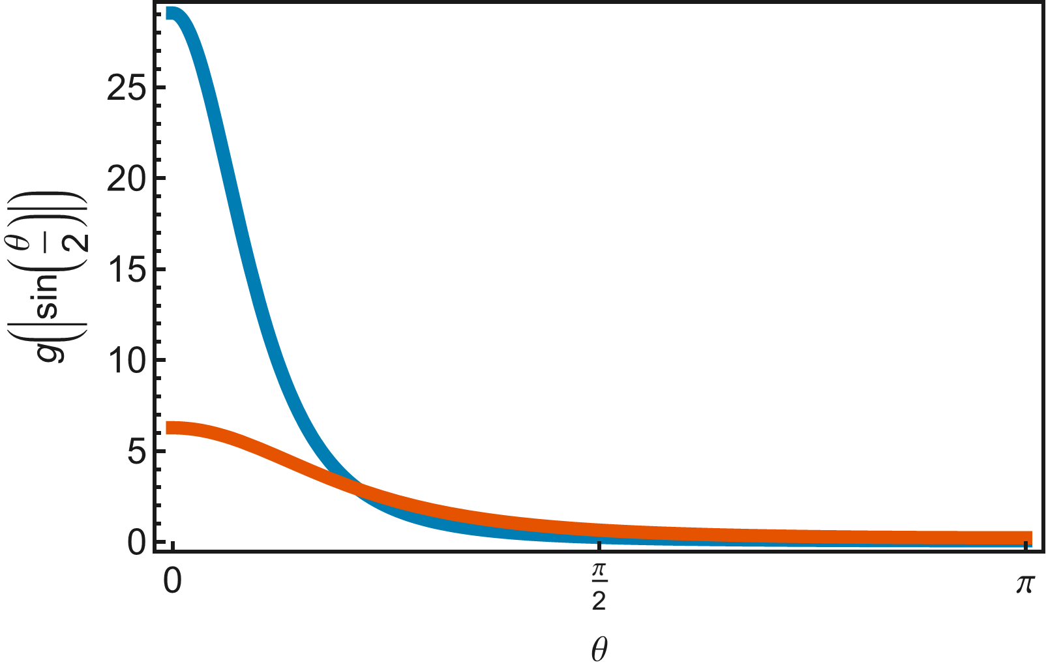

Figure 1. Left Panel: The pair-breaking and transport scattering rates normalized by the non-correlated value $1/ τ_{0}$ as a function of the doping level. Right Panel: The angular dependence of the renormalized $T$-matrices at $x=0.15$ (blue) and $x=0.3$ (red).

Conclusions
We have shown how the weak-coupling AG theory of $T_{c}$ suppression and normal state resistivity by dilute non-magnetic impurities is modified in a strongly correlated metal. Even though the renormalized scattering amplitude is strongly enhanced in the forward direction, the most significant effect comes from the suppression of the electron fluid compressibility by 'Mottness', which is effective even relatively far from the Mott insulating state. Given its simplicity, we suggest that this phenomenon is generic to other systems close to Mott localization.
Acknowledgements
We acknowledge support by CNPq (Brazil) through Grants No. 304311/2010-3 and No. 590093/2011-8 (E.M.) and NSF (USA) through Grants No. DMR-1005751 and DMR-1410132 (S.T. and V.D.)
Reference
[1] arXiv:1510.08152, submitted to PRL

