Unstable Domain-Wall Solution in the Metal-Mott Insulator Coexisting Regime
Lee, T.-H.(FSU, Physics); Dobrosavljević, V. (Magnet lab, FSU, Physics); Vučičević, J. (Saclay, France); Tanasković, D. (U. Belgrade, Serbia) and Miranda, E. (Unicamp U., Brazil, Physics)

Introduction
Domain wall (DW) formation between two coexisting phases occurs for generic the first order. Theoretically, the DW solution can be related to the unstable solution at the free energy barrier between the two phases; its properties typically display intermediate behavior between the two corresponding phases. In strongly correlated materials, DW structures separating metallic and Mott-insulating domainshave been observed through optical imaging in materials of the vanadium-oxide family. The DW structure displays an intermediate optical conductivity between that of the metal and the insulator. As we approach to critical temperature ${T }_{c}$, the thickness of the domain walls, corresponding to the appropriate correlation length, diverges and the DW contribution to the transport properties becomes significant. It is, therefore, desirable to understand the dynamics and the transport properties of the domain walls, which theoretically can be accomplished through a study of the unstable solution . the unstable solution of the relevant Dynamical Mean Field Theory (DMFT), using the numerical exact Continuous Time Monte Carlo (CTQMC) methods.

Results and Discussion
We study the unstable solution as a function of temperature T, for fixed interaction U=2.4, as shown in Fig.1. Our results indicate (i) The unstable solution’s quasi-particle shrinks as we lower the temperature, and the resistivity increases. The corresponding scattering rate increases as $Γ∼T^{-2}$ more than two orders of magnitude above Mott limit, while the quasi-particle weight $Z∼T^{2}$ decreases towards zero. Both features indicate strong deviations form conventional Fermi liquid behavior. (iii) Still, the transport property of the unstable solution can be well described by the Sommerfeld approximation with only two parameters Z and $Γ$ as $1/ρ=σ≈\frac{1}{Γ}tanh\left(\frac{Z}{2}T\right)$. Such “resilient quasiparticle” bahavior is the hallmark of strongly correlated electrons away from the Fermi liquid regime.

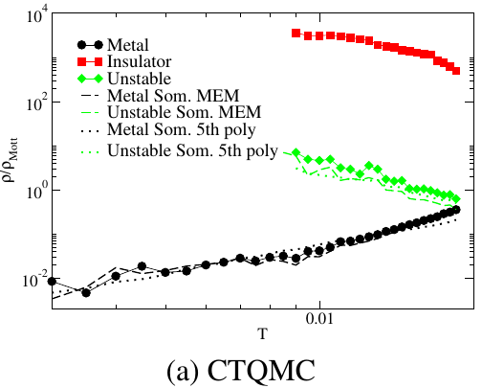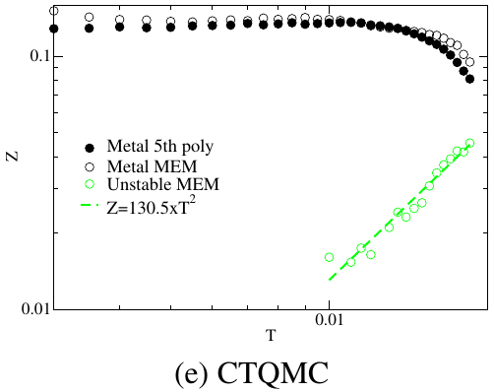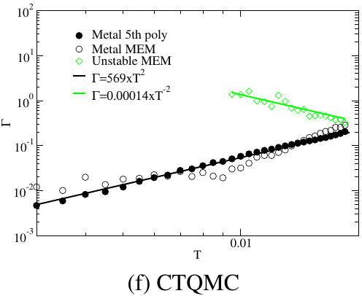
(b)
(c)

Figure 1. Resistivity for metal (black circle), insulator (red square), and unstable (green square) solution along the constant U=2.4 trajectory in logarithmic $ρ$ scale for (a) CTQMC. (b) Quasiparticle weight, Z, for metal and unstable solution. (c) Scattering rate , $Γ$ , for metal and unstable solution.

Conclusions
We show that the unstable solution of the Mott point, describing the domain wall, represents a new state of matter, which resembles the incoherent metal with the scattering rate around or above the Mott limit. The transport properties of the unstable solution can be described by the Sommerfeld approximation to the lowest temperature with two parameters Z and $Γ$. The unstable solutions quasiparticle weight Z and scattering rate $Γ$ display a pronounced non-Fermi liquid behavior. This result is firmly established in an exactly solvable model.

Acknowledgements
We acknowledge support by CNPq (Brazil) through Grants No. 304311/2010-3 and No. 590093/2011-8 (E.M.) and NSF (USA) through Grants No. and DMR-1410132 (T-H.L. and V.D.)

