Higher-Order Spin Noise Spectroscopy
Li, F.; Sinitsyn, N. (Theoretical Division, LANL); Yang, L. and Crooker, S.A. (NHMFL-LANL)

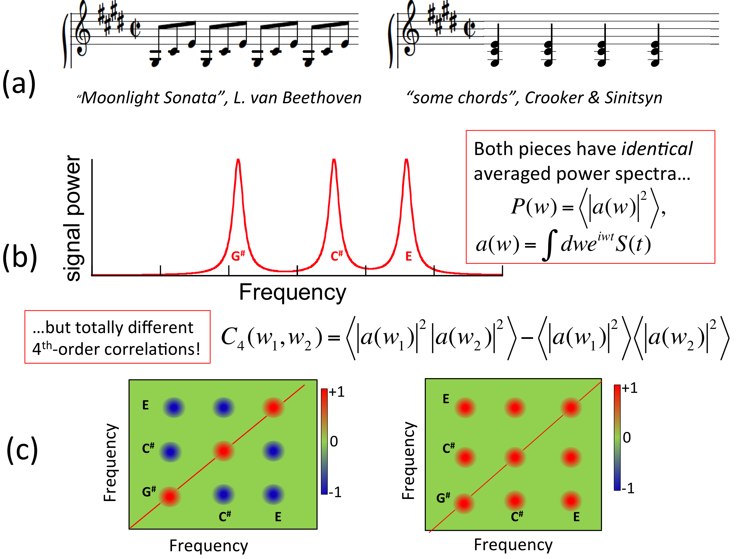
FIG 1: (a) The “Moonlight Sonata” and some chords: the same notes are used but the underlying structure is completely different. (b) The averaged frequency power spectrum (2nd correlator) cannot distinguish the two. (c) But the 4th correlator can: the Sonata shows anti-correlations between different notes (blue spots) because they are played one at a time (C# is never played with E, etc); in contrast, strong positive correlations between notes necessarily exist in chords.
Introduction & Background
Could one reconstruct music by knowing only the number of time each note was played? As shown in Figure 1, there is usually no hope of doing this. However, in physics we face similar challenges all the time. For example, the standard measurable of an interacting spin system is the spin susceptibility, which [per the fluctuation-dissipation theorem (FDT)] is expressed as the 2nd-order time correlator of the spin density S(t): C₂(t)=<S(t)S(0)>. Its power spectrum is P(ω)=<|a(ω)|²> [where a(ω) is the Fourier transform of S(t)] tells us how often each frequency ω is represented in the dynamics of the spin polarization. Thus, trying to fully understand spin interactions knowing only the susceptibility [i.e., only C₂(t)], is like trying to reconstruct music knowing only how many times each note was played!
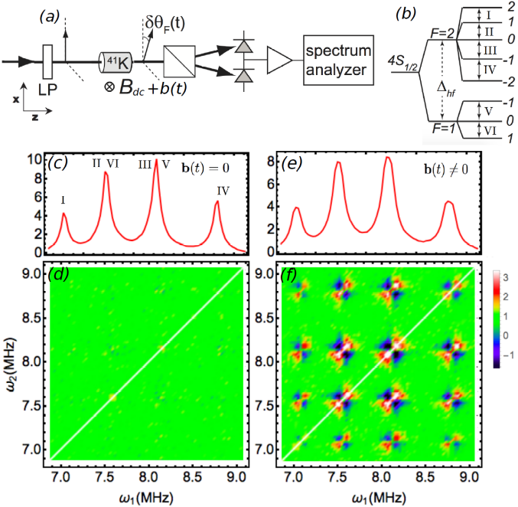
Most common measurables in condensed matter, such as conductivities, susceptibilities etc., can be expressed as 2nd order correlators of variables, i.e. averages of products of two measurables. To avoid such a restriction imposed by the FDT, one usually must apply strong fields and observe nonlinearities, but strong fields lead to unwanted effects such as heating and purely nonequilibrium excitations that destroy subtle equilibrium correlations and distort parameters. Moreover, nonlinear characteristics are not even directly related to correlations of a system in the ground state.
Considerable new information can be derived from higher order correlators, that depend on higher-than-2nd power of the measured variables, the simplest of which in the frequency domain are C₃(ω₁,ω₂)=<a(ω₁)a(ω₂)a*(ω₁+ω₂)>, and C₄(ω₁,ω₂)=<|a(ω₁)|² |a(ω₂)|²> - <|a(ω₁)|²>< |a(ω₂)|²>. Such correlators depend on more than one frequency
and do not duplicate information of P(ω). Their functional form tells how different frequencies “talk" to each other.
Experiment & Results
We are using Spin Noise Spectroscopy, an optical technique developed at LANL [1], to experimentally explore such higher-order correlators. Initial studies are being performed using classical atomic vapors, wherein higher-order correlations of the spin noise signals can be artificially induced via (intentionally) noisy applied magnetic fields [2]. The figure at the right shows the 2nd and 4th-order spin correlators from a potassium vapor in a static (Fig. 2b,d) and slightly noisy applied field (Fig. 2e,f). Although C₂(ω) changes very little besides some inhomogeneous broadening, C₄(ω) reveals pronounced correlations between different frequencies when noise is added to the applied field. The “bow-tie” correlation patterns between different frequencies can be modeled via theory.
Acknowledgements: This work was supported by the Los Alamos LDRD program. The NHMFL-PFF facility is supported by National Science Foundation Cooperative Agreement No. DMR-1157490, the State of Florida, and the U.S. Department of Energy.
[1] S. A. Crooker et al, Nature 431, 49 (2004); Glasenapp et al., PRL 113, 156601 (2014)
[2] F. Li et al., submitted to Physical Review A (December 2015).

