Phase Separation in ³He-⁴He Solid Solutions

Huan, C. (NHMFL & Univ. of Florida); Candela, D. (Univ. of Massachusetts); Cowan, B. (Royal Holloway Coll., London); Yin, L.; Xia, J.S. and Sullivan, N.S. (NHMFL & Univ. of Florida)

Introduction
Phase separation in ³He-⁴He mixtures represents an especially clear example of a first order phase transition with a conserved order parameter. The quantum nature of the diffusion sets “fast” time scales (~ hours) for the phase separation dynamics (in contrast to that for metal alloys), enabling measurements on experimental time scales. ³He-⁴He mixtures have very few defects, and substantial supercooling is possible. The separation is well understood [1-3] for high concentrations but has not been tested for very low concentrations, i.e. tens of ppm where the transitions are especially sensitive to asymmetries in the mixing interaction and free energy differences of the hcp & bcc phases.

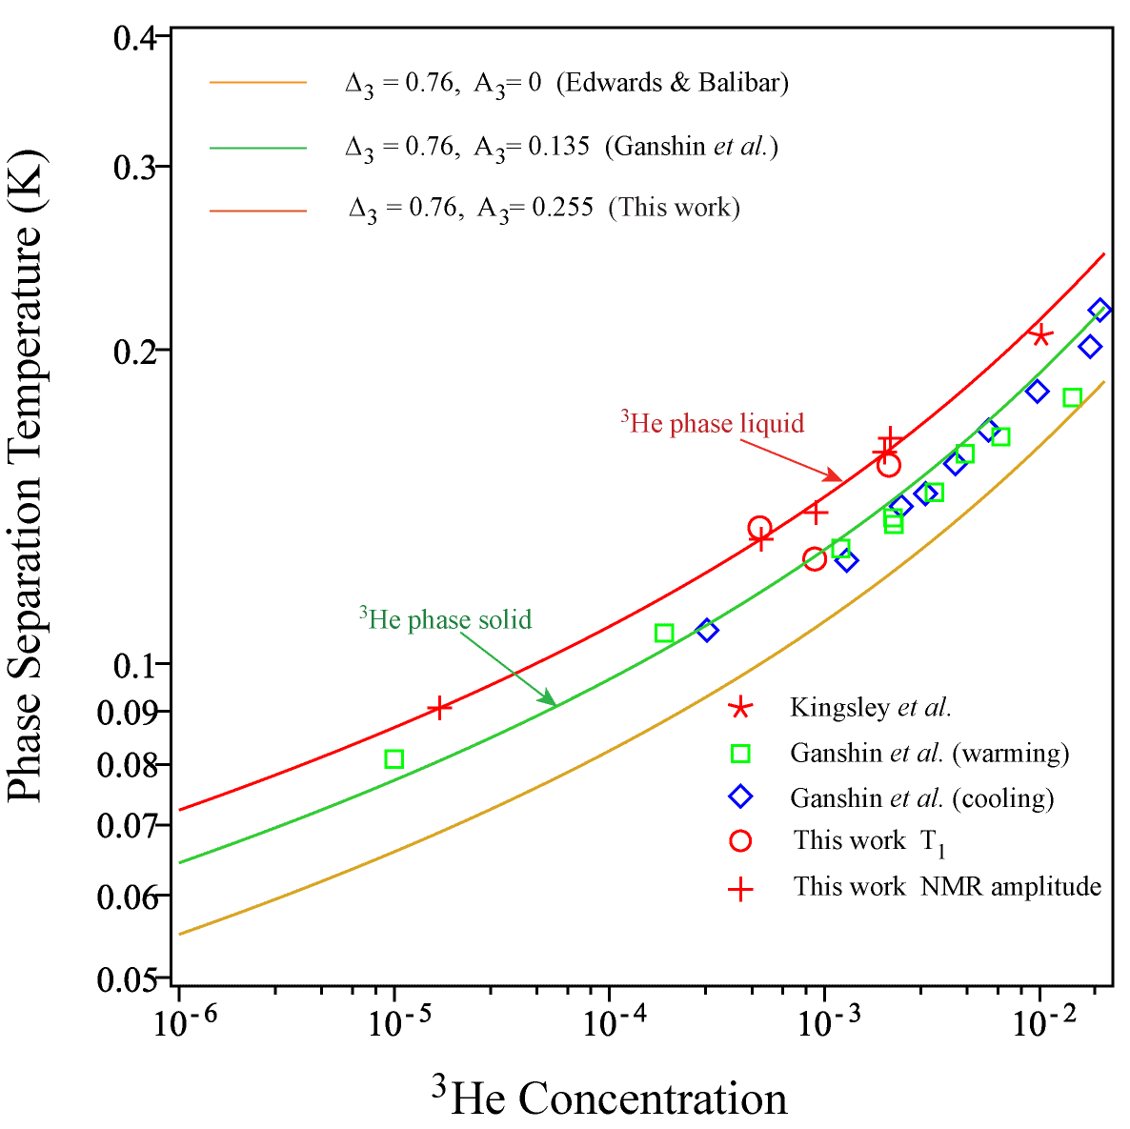
Experimental
The samples were prepared with carefully controlled ³He concentrations and grown slowly in an NMR cell under pressures such that the homogeneous mixtures are solid solutions but for which the ³He separates as a liquid phase. The sample was thermally linked to a dilution refrigerator via sintered silver. Pulsed NMR techniques were used to monitor the NMR amplitude that undergoes a sharp drop at the separation because of the reduced susceptibility of the Fermi liquid.

Results and Discussion
The phase separation temperatures were found to be in excellent agreement with the predictions of regular solution theory given by equation (1).
$$T_{ps}= \frac{0.76}{k_{B}}\frac{\left(1-2x_{3}\right)+A_{3}}{\left[ln\frac{1}{x_{3}}-1\right]}$$
[1]
Fig.1 Variation of the phase separation
temperatures with ³He concentrations for solid solutions of ³He in ⁴He.
A₃ is a correction that accounts for the different free energies of the different lattice structures of pure ³He and pure ⁴He.

Conclusions
The observed phase separation temperatures for solid ³He-⁴He mixtures are in excellent agreement with regular solution theory provided one accounts for the difference in free energy of the bcc ³He and hcp ⁴He structures.

Acknowledgements
A portion of this work was performed at the National High Magnetic Field Laboratory, which is supported by National Science Foundation Cooperative Agreement No. DMR-1157490 and the State of Florida. Support was also provided by the National Science Foundation via the award DMR-1303599.

References
- D. O. Edwards and S. Balibar, Phys. Rev. B39, 4083(1989).
- A. Smith et al. Phys. Rev. B67, 245314 (2003).
- M. Poole et al. Phys. Rev. Lett. 100, 075301 (2008).
- A. N. Ganshin et al. Low Temp. Phys. 26, 869 (2000).
- V. Maidanov et al. J. Low Temp. Phys. 122, 475 (2001).

