Quantum Oscillation Signatures of Pressure-Induced Topological
Phase Transition in BiTeI
Kim, J.S.; Park, J.; Jin, K.-H.; Jhi, S.-H. (POSTECH, Physics); Jo, Y.J. (Kyungpook U., Physics); Choi. E.S. (NHMFL); Kang, W. (Ewha U., Physics); Kampert, E. (HLD) and Rhyee, J.-S.(Kyunghee U. Physics)

Introduction
A Topological quantum phase transition (TQPT) is a zero temperature transition between distinct topological phases which are defined by topological invariants reflecting a “twist” of bulk electronic wave functions in the presence of an energy gap. When the TQPT occurs by tuning an external parameter like pressure, there should be band-gap closing in the momentum space, offering a fertile ground to test quantum critical phenomena of unconventional Dirac fermions. Applying pressure provides a continuous and reversible means to tune electronic structures, but experimental identification of the pressure-induced TQPT has remained a challenge so far.

Experimental
BiTeI single crystals were grown using the Bridgman method. Using a homemade indenter type pressure cell, transport measurements under pressure were done in an 18 T superconducting magnet at NHMFL, Tallahassee.

Results and Discussion
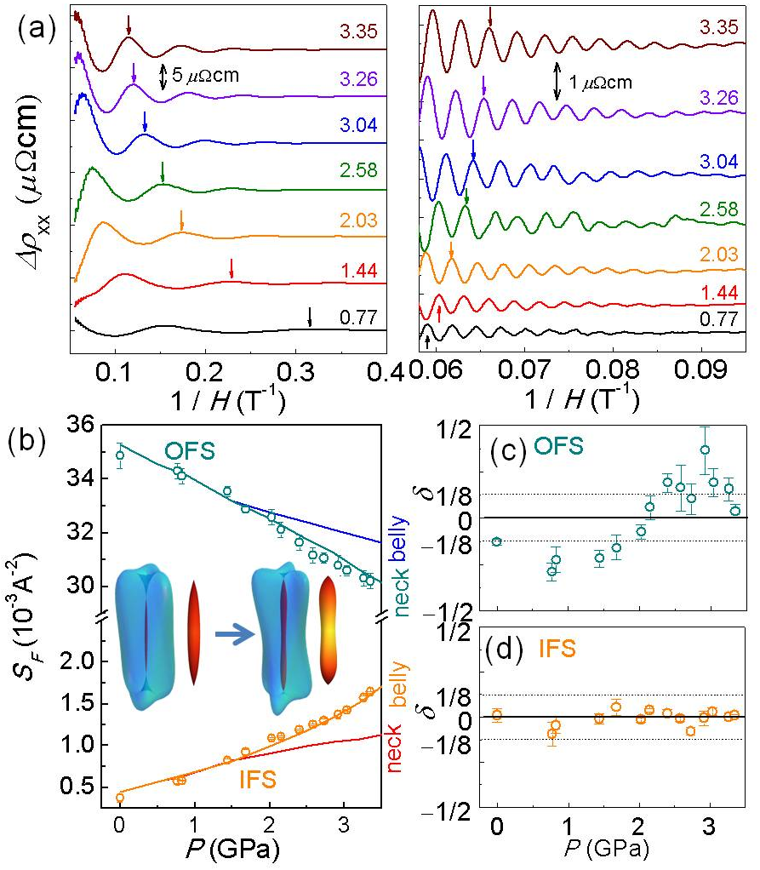
Figures 1(a) shows the SdH oscillations as a function of inverse magnetic fields for both inner Fermi surface (IFS) and outer Fermi surface (OFS). The size of the IFS increases by 330% up to P ~ 3 GPa, while the OFS shrinks only by 12% as shown in Fig. 1(b). Such pressure dependence can be understood in terms of modification of the bulk FS shape by band inversion at the TQPT. In this case, valence band with dominant Te 5p character penetrates into the conduction band of the Bi 6p state at P_{c}. The changes in relative band character induce the FS shape change from the needle- to peanut-type for the IFS [see the inset ofFig. 1(c)]. The similar but weaker FS shape change also occurs for the OFS at the TQPT. We found that the OFS shape change can be observed by the phase offset δ of the SdH oscillations [Fig. 1(c) and 1(d)]. The phase offset δ is determined by the Berry’s phase from the spin texture and also the curvature of the FS in the k_{z} direction. Having the Berry’s phase constant due to spin chirality in the bulk Rashba bands, δ is set by the k_{z} curvature near the orbit; δ = -1/8 (+1/8) for maximum (minimum) extremal cross sections. For the OFS, the δ changes abruptly near P_{c} ~ 2 GPa [Fig. 1(c)]. Furthermore, above P_{c} ~ 2 GPa, the size of the IFS increases unusually. As shown in Fig. 1(b), the size of the IFS linearly grows with pressure, but starts to bend upwards at P_{c} ~ 2 GPa. This unusual upturn is attributed to the shape change of the IFS near P_{c}. Above P_{c}, the belly orbit has a higher SdH frequency than the neck orbit, e.g. by 70% at P = 3.35 GPa. The calculated IFS size for the belly position nicely reproduces the upward behavior in experiment. Thus, the unusual increase of the IFS size also reveals the TQPT at P_{c} ~ 2 GPa.[1]
Fig.1 (a) SdH oscillations for (left) the Inner FS (IFS) and (right) the outer FS (OFS). (b) Pressure dependence of the sizes of IFS and OFS. Solid lines are the calculated curves at the neck and the belly positions of IFS and OFS shown in the inset. (c,d) The phase offset of the SdH oscillations for (c) OFS and (d) IFS.

Conclusions
In conclusion, we present experimental evidence of pressure-induced TQPT in BiTeI. These results clearly demonstrate that monitoring bulk FSs using quantum oscillations offers an effective means to identify the TQPT

Acknowledgements
This work was supported by National Research Funding (NRF) in Korea. A portion of this work was performed at NHMFL, supported by National Science Foundation Cooperative Agreement No. DMR-1157490, the State of Florida, and the U.S. Department of Energy.

References
[1] Park, J., et al., Sci. Rep. 5, 15973 (2015)

