Quantum Transport of Two-Species Dirac Fermions in Dual-Gated Three-Dimensional Topological Insulators

Xu, Y.; Miotkowski, I. (Purdue Univ., Physics and Astronomy) and Chen, Y.P. (Purdue Univ., Physics and Astronomy & ECE)

Introduction
Topological insulators (TI) are a novel class of quantum matter with a gapped insulating bulk yet gapless spin helical Dirac fermions. Previously [1], we have shown surface-dominated conductance in an intrinsic 3D TI BiSbTeSe2 (BSTS) and “half-integer” quantum Hall effect (QHE) arising from the topological surface states.
In this work [2], we fabricated dual-gated BSTS devices, in which the carrier type and density of the top and bottom surfaces (each possessing a single species of Dirac fermion) can be independently tuned, allowing us to investigate the quantum transport of two-species (two-component) Dirac fermions in a 3D TI.

Experimental
BSTS single crystal were synthesized in Purdue and then fabricated into dual-gated devices on Si substrates (300 nm SiO₂ coating) with hexagonal boron nitride as top-gate dielectric. Transport measurements were mostly performed in SCM2 with base temperature down to 0.3 K and magnetic field up to 18 T.

Results and Discussion
We performed local and non-local electrical and magnetotransport measurements in dual-gated BSTS thin film TI devices and observed a zero-magnetic-field minimum conductivity of ~4e²/h at the double Dirac point, a series of ambipolar two-component “half-integer” Dirac quantum Hall states (see Fig. 1) and an electron-hole total filling factor ν=0 state (with a zero-Hall plateau) in high magnetic field, exhibiting dissipationless (chiral) and dissipative (non-chiral) edge conduction respectively.

Conclusions
The fully-tunable 3D TI system paved the way to explore rich physics ranging from topological magnetoelectric effects to exciton condensation.

Acknowledgements
A portion of this work was performed at the National High Magnetic Field Laboratory, which is supported by National Science Foundation Cooperative Agreement No. DMR-1157490 and the State of Florida. In addition, this work is supported by the DARPA MESO program (Grant N66001-11-1-4107).

References
[1] Xu, Y., et al., Nature Physics, 10, 956-963 (2014).
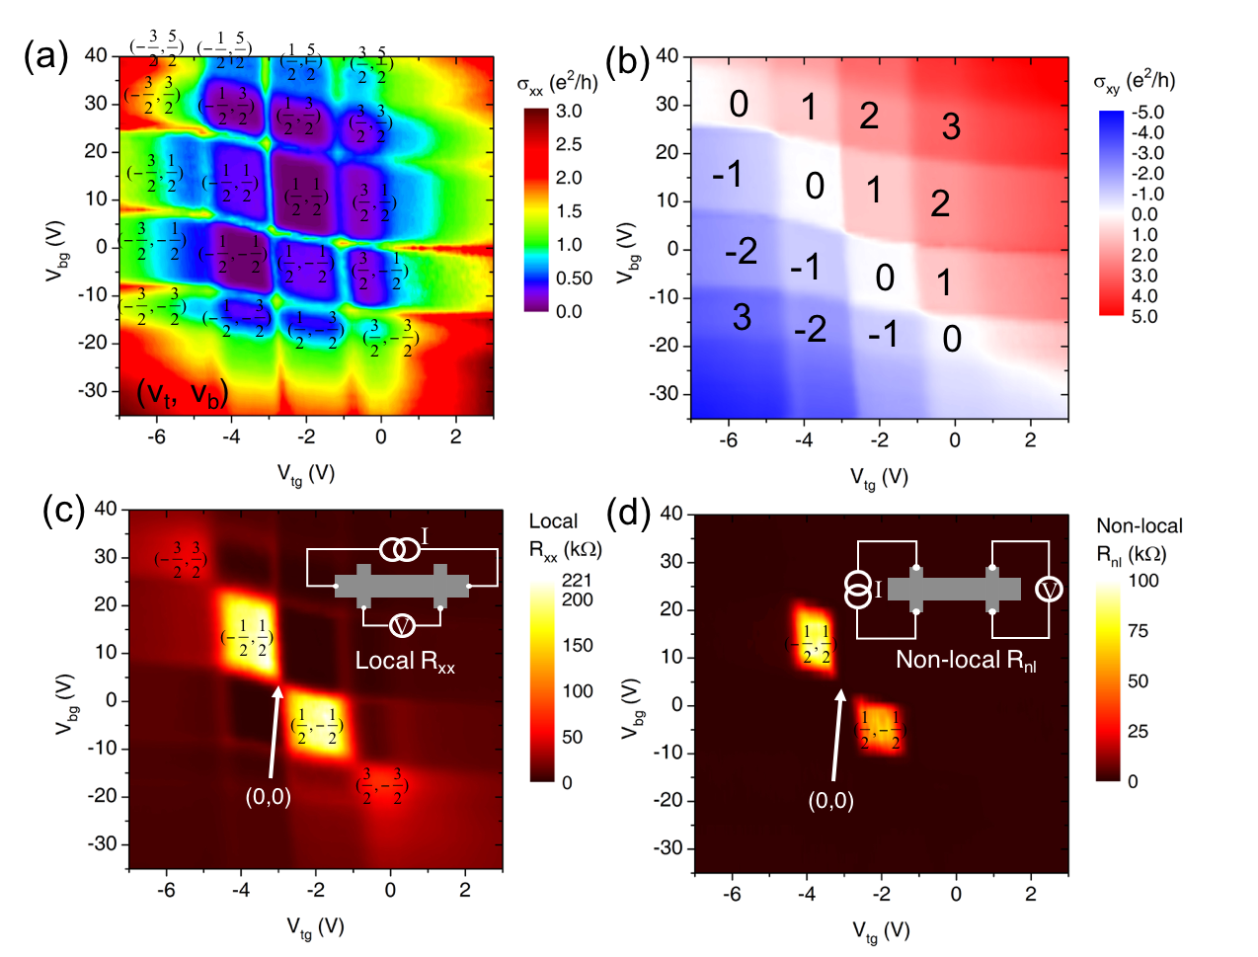
[2] Xu, Y., et al., submitted (2015), arXiv:1511.04597.
Figure 1. (a) Longitudinal resistivity σ_{xx}, (b) Hall resistivity σ_{xy}, (c) local resistance R_{xx} and (d) non-local resistance R_{nl} shown as 2D color maps, as functions of topgate voltage V_{tg} and backgate voltage V_{bg} at B=18 T and T=0.3 K, with (ν_{t}, ν_{b}) labeling (top, bottom) surface half- integer filling factor of corresponding QH state. The integer in (b) labels the total filling factor ν of each state. Inset of (c) and (d) is the corresponding measurement setup. At (ν_{t}, ν_{b})=(1/2,-1/2) or (-1/2,1/2), there’s an intriguing ν=0 state, characterized by zero Hall plateau and simultaneously large local and nonlocal resistance.

