Broadband Spin Detection Setup for Use in a Broad Temperature Range

Chiorescu, I. (NHMFL and Physics Dept. FSU); Zabalo, A. (NHMFL and Physics Dept. FSU); Martens, M. (NHMFL and Physics Dept. FSU) and Baumbach, R. (NHMFL)

Introduction
Spin relaxation times can vary over many orders of magnitude when the temperature is varied between room temperature and 4K. Spin lifetime is essential for planning successful measurements which require repetitive initializations of the spin quantum state, as well as for properly understanding results on spin dynamics [1]. We propose to build a detection scheme which can be inserted in a usual SQUID or VSM setup to perform spin spectroscopy over a large temperature range and broad frequency spectrum.

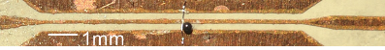  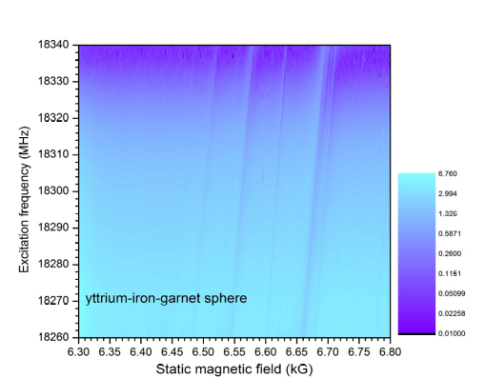  Fig. 1 (top) photo of the broadband waveguide with a sample in the middle. (bottom) Reflected signal versus frequency and magnetic field, showing oblique lines of spin resonance. | Experimental  We designed a broadband waveguide (see Fig. 1) and mounted it on a specially designed sample holder, which is adapted to the geometry of a commercial setup dedicated to magnetic measurements. The photo shows a test YiG sphere placed near a shortcut in the waveguide, to increase the effect of the microwave excitation on sphere’s spins. Through the central part of the probe, a coaxial cable is running from the room temperature environment, down to the waveguide. A home-made heterodyne detector, using also a power detector and lock-in amplifier, injects microwave excitation to a sample placed in the middle of the waveguide. The microwave excitation is reflected by the shortcut shown in figure while reaching the sample in a near-field approximation. Ramping the external field creates a Zeeman splitting which defines the resonance frequency. When the microwave photon energy is equal to the Zeeman splitting, spins absorb the radiation and thus populate the excited level.

Results and Discussion
The bottom of Fig. 1 shows reflected power in shades of blue, when both excitation frequency and magnetic field are scanned, at room temperature. One observes oblique lines of minimum reflected power, indicating resonance frequencies of various dynamical modes existing in the YiG test sphere. The lines are parallel meaning that the g-factor associated with these modes is the same for all of them (~2). The microwave absorption by the sample is quite effective, one note that the level drops to almost zero (dark blue).
We have tested the setup at lower temperatures, by inserting the newly designed probe into a VSM (available in the group of Dr. Ryan Baumbach). The data shows that the spins seems to be detectable. However, more studies need to be done in the near future, to unveil all the applications of the setup.

Conclusions
We have developed a broadband setup capable of detecting spin Zeeman splitting over a large temperature range. The setup requires more testing, with different samples and different experimental conditions but the initial tests are very encouraging.

Acknowledgements
A portion of this work was performed at the National High Magnetic Field Laboratory, which is supported by National Science Foundation Cooperative Agreement No. DMR-1157490 and the State of Florida. The work is supported by the NSF Grant No. DMR-1206267. A. Zabalo is partially supported by the APS Bridge Program.

References
[1] S. Bertaina, M. Martens, M. Egels, D. Barakel, I. Chiorescu, Phys. Rev. B 92, 024408 (2015).

