Magnetic Torque Anomaly in the Quantum Limit of Weyl Semi-Metals
Moll, P.J.W.; Potter, A.C.; Nair, N.L.; Ramshaw, B.J.; Modic, K.A.; Riggs, S.; Zeng, B.; Ghimire, N.J.; Bauer, E.D.; Kealhofer, R.; Ronning, F. and Analytis, J.G.

Introduction
Electrons in materials with linear electronic dispersion behave as massless, fermionic Weyl- or Dirac-quasiparticles, and continue to intrigue physicists due to their close resemblance to elusive ultra-relativistic particles as well as their potential for future electronics. Yet the experimental signatures of Weyl-fermions are often subtle and indirect, in particular if they coexist with conventional, massive quasiparticles. However, in high magnetic fields above the quantum limit, the behavior of topologically trivial and non-trivial electrons is strikingly different due to the additional Berry’s phase in topological semi-metals. We show that an anomaly in the high field torque above the quantum limit in NbAs is a direct result of the presence of Weyl quasiparticles in the system.

Experimental
We have studied the high field magnetic torque above the quantum limit in the Weyl semi-metal NbAs, using two different techniques: a) static torque measurements in dc-fields up to 45T using CuBe-cantilevers with a capacitive detection method; and b) pulsed field torque experiments up to 65T using piezoresistive Si-microcantilevers. The results obtained by both techniques were in good agreement.

Results and Discussion
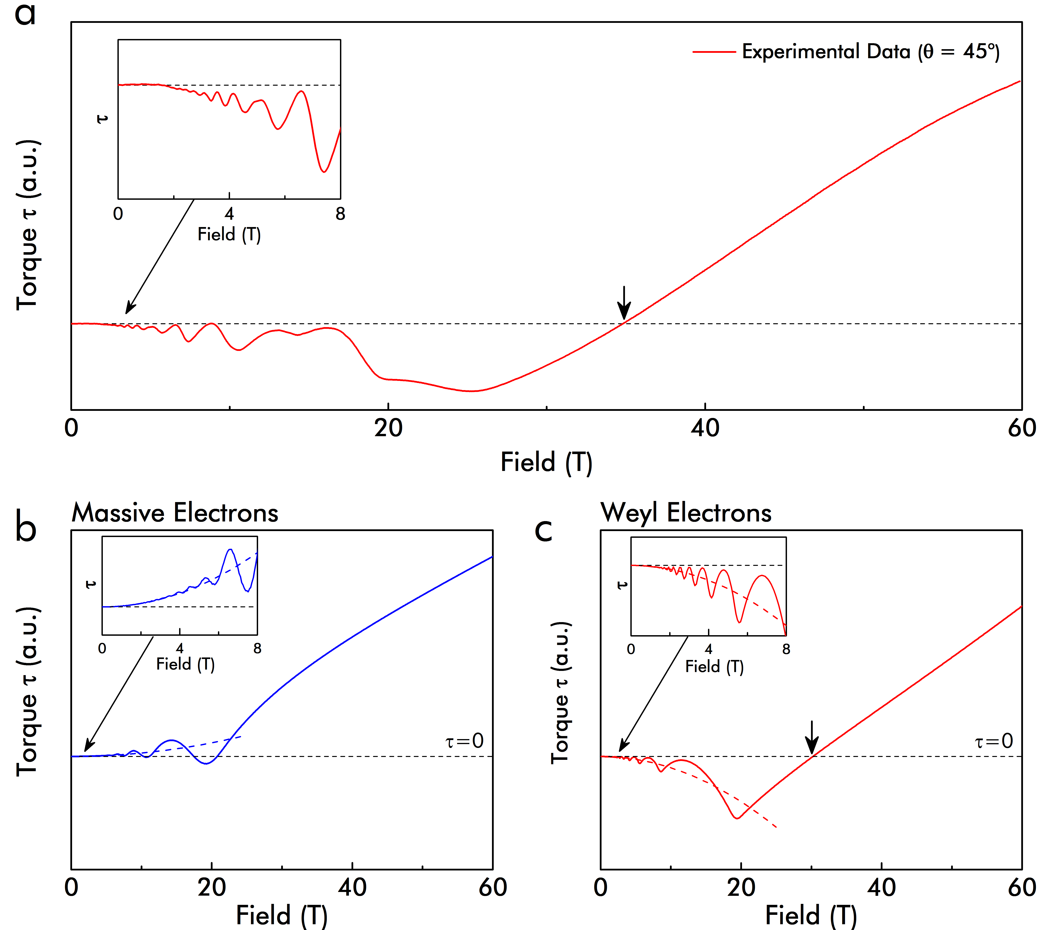
We have observed a pronounced anomaly in the magnetic torque at the (field angle dependent) quantum limit of NbAs. The anomaly is characterized by a striking change in sign, signaling a reversal of the magnetic anisotropy that can be directly attributed to the topological nature of the Weyl electrons. The low-energy Hamiltonian of massive electrons is described by $ε_{n,k}=\frac{ℏeB}{m}\left(n+\frac{1}{2}\right)+\frac{{ℏ^{2}k}_{z}^{2}}{2m}$, while$ε_{n,k}=ℏv_{F} \sqrt{2Bn+k_{z}^{2}}$ describes massless Weyl-electrons, where n denotes the Landau level index. At the quantum limit, the electrons are all confined into the lowest Landau level (n=0). The high field behavior is thus clearly distinct: While the energy of trivial, massive electrons remains field dependent even above the quantum limit as usual, the energy of Weyl fermions is field-independent for n=0. This leads to a jump in the magnetization $M_{n=0}=-{∂ε_{0,k}}/{∂B}$, which can be detected as an anomaly in the magnetic torque. Furthermore, the situation for Dirac-semimetals is different due to the field-dependent splitting of the Weyl subsystems. Our results establish that anomalous quantum limit torque measurements provide a direct experimental method to identify Weyl and Dirac systems and distinguish between them.

Acknowledgements
A portion of this work was performed at the National High Magnetic Field Laboratory, which is supported by National Science Foundation Cooperative Agreement No. DMR-1157490 and the State of Florida. This work was also supported by Gordon and Betty Moore Foundation’s EPiQS Initiative through Grant GBMF4374.
Fig.1 (a) Torque anomaly in NbAs at the quantum limit. A clear break-in-slope signals the quantum limit, followed by a change in sign at higher fields (arrows). Lower panels show simulated data for massive trivial (b) and Weyl (c) electrons. Such an anomalous torque is absent in conventional metals, yet well-reproduced by calculations assuming massless Weyl fermions.

References
[1] Moll, P.J.W. et al. (arXiv:1507.06981, 2015)

