Investigating the Fermi Surface of the Pd-based Superconductor Ta₄Pd₃Te₁₆

Helm, T.; Moll, P.J.W.; Flicker, F.; Louie, S.; Kealhofer, R.; Analytis, J.G. (University of California, Berkeley); McDonald, R. and Riggs, S. (NHMFL)

Introduction
Recently, the layered Pd-based ternary chalcogenide Ta₄Pd₃Te₁₆ (TPT) has drawn attention as it was found to become superconducting (SC) below a critical temperature of Tc = 4.6 K [1]. The layered material has a monoclinic crystal structure and the main conduction channel is suspected to run along quasi-one dimensional (q1D) PdTe₂-chains. Low dimensional systems are known to exhibit a wide range of interesting physics due to enhanced correlations. Indeed, band structure calculations revealed multiple bands at the Fermi level including 1D sheets that fulfill nesting conditions prerequisite for a possible stabilization of a charge density wave (CDW). Till this point, no unambiguous evidence for a competing or coexisting phase has been found. The most famous q1D superconductors like TMTSF, Purple bronze, etc. have a lower Tc but their electronic anisotropies are several orders of magnitude larger than that reported for TPT.

Experimental
Here we report studies of magnetic torque and normal-state magnetotransport in the quasi one- dimensional superconductor Ta₄Pd₃Te₁₆. The observation of Shubnikov-de Haas (SdH) as well as de Haas-van Alphen (dHvA) oscillations reveal the multiband nature of TPT’s bulk Fermi surface.

Results and Discussion
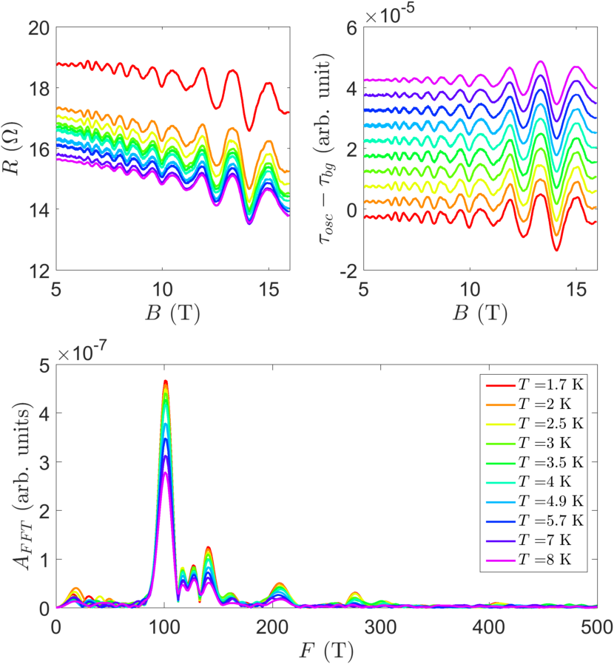
Using high magnetic fields we observe the Fermi surface of TPT via both Shubnikov-de Haas and de Haas-van Alphen oscillations. We observe both quasi-2D and quasi-3D oscillations, unambiguously indicating that these materials strongly disperse in all directions. The masses are light for all measure Fermi surfaces, measuring below 0.5m_{e}.
Figure 1: Shubnikov-de Haas oscillations observed in TPT. (Top left) oscillations as a function of temperature from the raw signal. (Top Right) Oscillations as a function of temperature with background subtracted. (Bottom) FFT of the oscillations showing multiple frequencies, indicative of a multipband, strongly dispersing system.
This work therefore begs the question as to what drives the transport anisotropy in these materials and indeed the CDW-like instability that we observe.

Acknowledgements
A portion of this work was performed at the National High Magnetic Field Laboratory, which is supported by National Science Foundation Cooperative Agreement No. DMR-1157490 and the State of Florida. This work was also supported by Gordon and Betty Moore Foundation’s EPiQS Initiative through Grant GBMF4374.

References
[1] Wen-He Jiao, Zhang-Tu Tang, Yun-Lei Sun, Yi Liu, Qian Tao, Chun-Mu Feng, Yue-Wu Zeng, Zhu-An Xu, and Guang-Han Cao. Superconductivity in a layered Ta4Pd3Te16 with pdte2 chains. J. Am. Chem. Soc., 136(4):1284–1287, January 2014

