Weak Antilocalization due to Surface States
in Metallic Bi₂Te₃ Topological Insulator

Shrestha, K.; Lorenz, B. (U. Houston, TCSUH); Chu, C.W. (U. Houston, TCSUH; and LBNL); Graf, D. (NHMFL); Chou, M. and Yang, H.D. (National Sun Yat-Sen U.)

Introduction
We have studied weak antilocalization (WAL) effect in metallic Bi₂Te₃ samples, HD1, HD2, and HD3, having different bulk carrier concentrations. From the angle dependence of WAL, we have found the dominance of topological surface states (SS) in the samples having lower carrier concentrations.

Experimental
Low field measurements up to 7 Tesla have been performed in Quantum Design PPMS at the Texas Center for Superconductivity. High field experiments were carried out at the National High Magnetic Field Laboratory (NHMFL), Tallahassee, with fields up to 31 Tesla in Cell 9.

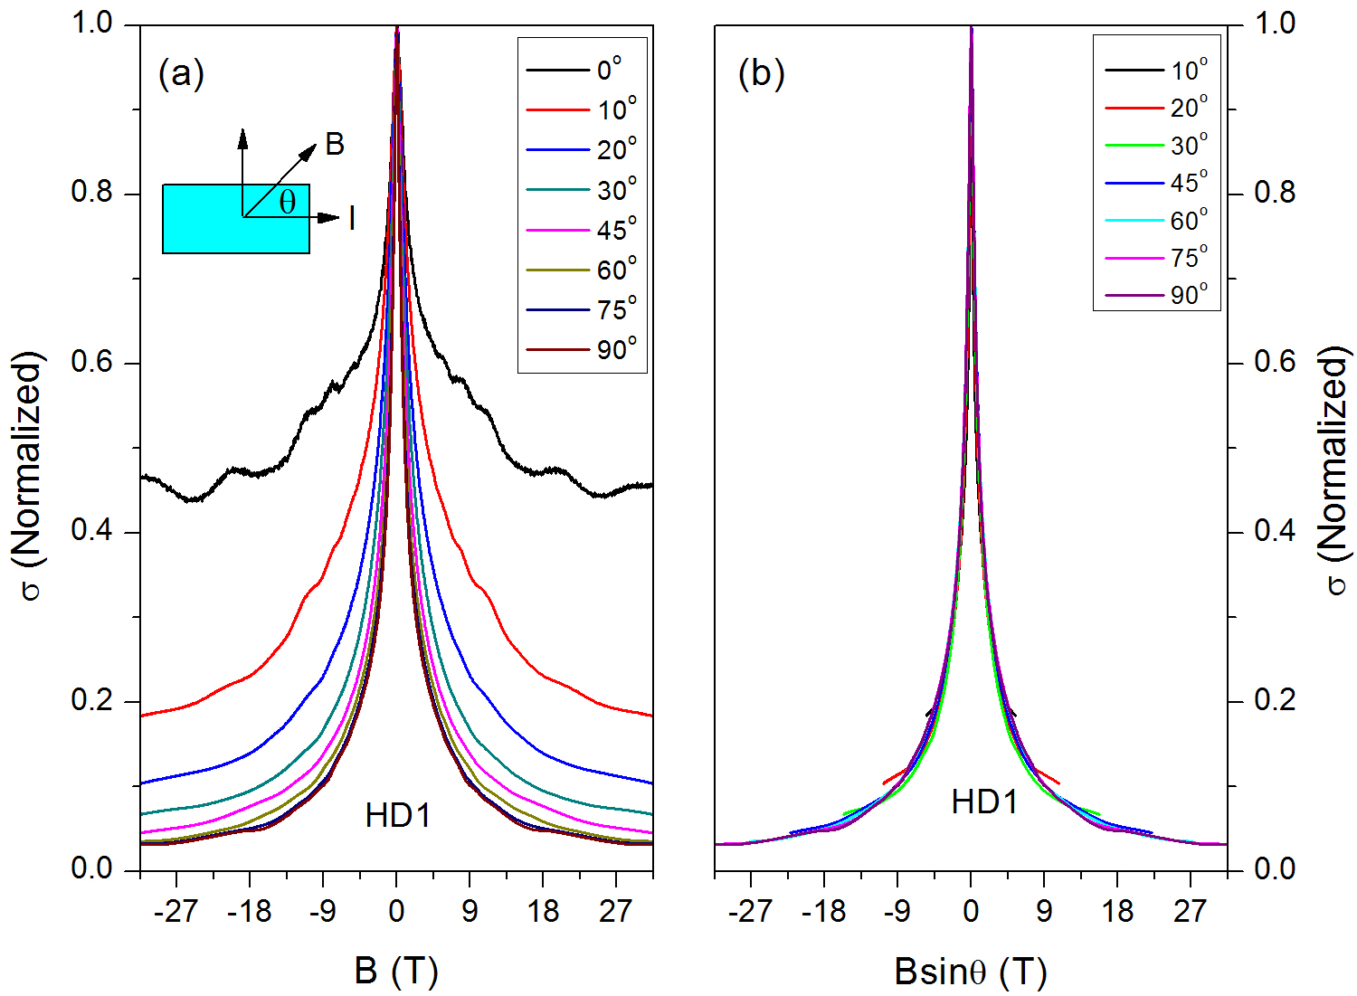
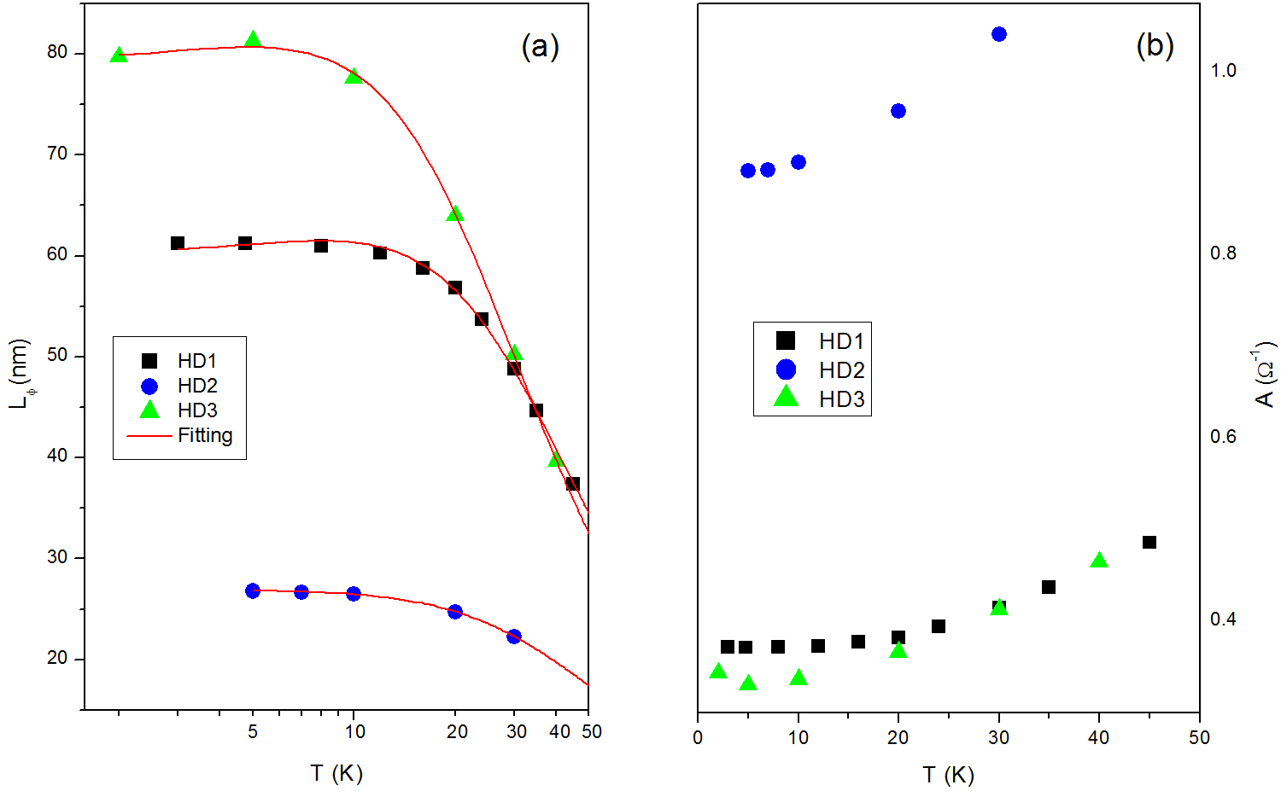
Results and Discussion
Figure 1 shows angle dependence of WAL for HD1 sample. The WAL curves depend on the angle of rotation of sample w.r.t. the direction of magnetic field B. However, the WAL curves merge together with normal component Bsinθ of the field, showing existence of topological SS [1][2]. Using the Hikami-Larkin-Nagaoka (HLN) formula, we have found smaller number of conduction channels (A) but larger phase coherence length (L_{φ}) in the samples HD1 and HD3, which have lower carrier concentrations (Fig. 2).

Conclusions
In this work, we have demonstrated WAL due to topological SS in the metallic Bi₂Te₃ samples having lower carrier concentrations. The surface SS in WAL depends only on the number of carrier concentrations and does not depend on the nature of the bulk charge carriers (p or n-type).
Fig. 1 (a) The angle dependence of WAL curves at different angle of rotation of sample. (b) WAL curves plotted against the perpendicular component, Bsinθ, of the magnetic field.

Acknowledgements
A portion of this work was performed at the National High Magnetic Field Laboratory, which is supported by National Science Foundation Cooperative Agreement No. DMR-1157490 and the State of Florida. Work at Texas Center for Superconductivity is supported in part by the US Air Force Office of Scientific Research, the T.L.L. Temple Foundation, the J.J. and R. Moores Endowment, and the State of Texas through TCSUH; and at LBNL through the US Department of Energy.

References
[1] Lee, J. et al., Phys. Rev. B, 86, 245321 (2012).
[2] Chen, T. et al., Nature Commun., 5, 5022 (2014).
Fig. 2 (a) Comparison of the temperature dependence of phase coherence lengths L_{φ}. (b) Temperature dependence of the parameter A.

