**New Magnetic Features Unveiled in Double Layered 4d-oxide Ca3Ru2O7**

Chikara, S.; Singleton, J.; Zapf, V. (NHMFL-PFF); Hao, Z.; Terzic, J. and Cao, G. (Univ Kentucky)

**Introduction**

The bilayered Ruddlesden-Popper (RP) phase Ca3Ru2O7 displays a wide variety of physical properties and exhibits the signatures of almost every ordered state (except superconductivity) known in condensed matter physics, including exotic phenomena not found in other materials [1 and references therein]. Ca3Ru2O7 exhibits conflicting hallmarks of both insulating and metallic states. It shows - colossal magnetoresistance (CMR) via suppression of a ferromagnetic (FM) state, a strong spin valve effect in bulk single crystals, quantum oscillations in a nonmetallic state, and, oscillatory magnetoresistance periodic in B (rather than 1/B). Since this material has very low carrier density and the QO observed so far are very low frequency, we need very high magnetic fields to further investigate the unusual quantum oscillation behavior.

**Experimental**

Single crystals were grown using both flux and floating zone techniques [2]. The high quality of these crystals was confirmed by single-crystal x-ray diffraction, SEM and TEM. The highly anisotropic magnetic properties of Ca3Ru2O7 were used to orient the magnetic easy b-axis and to identify twinned crystals that often show a small kink at 48 K in the a-axis susceptibility. We measured quantum oscillations (QOs) at the pulsed field facility in Los Alamos to 60 T. QOs are observed through a magnetic field-dependent change with rotation of sample skin depth using a proximity detector oscillator (PDO) [3].

**Results and Discussion**

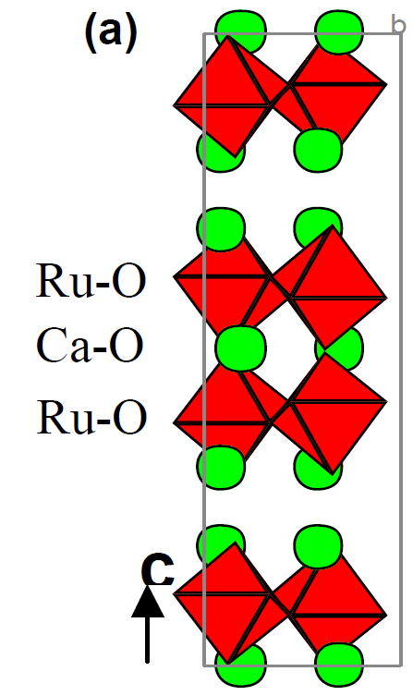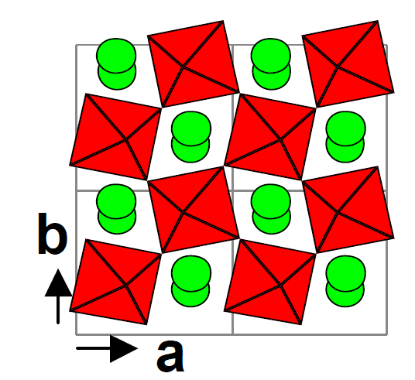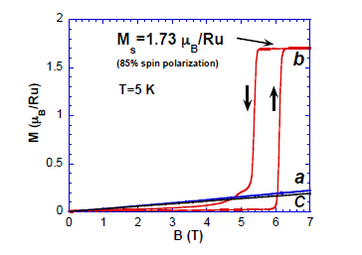

Fig.1 (a) Crystal structure of Ca3Ru2O7 along c-axis and ab-plane (bottom), top panel shows the meta magnetic transition along the easy b-axis (b) PDO frequency as the sample is rotated from b- to c-axis in 60 T magnetic field (c) phase diagram extracted from PDO frequency derivative on second sample (not shown here) that shows the meta magnetic transition as a function of sample rotation.

Our preliminary measurements are consistent with frequencies obtained in the published data [1]. We also uncovered some new features at high fields that seem consistent with the low field meta-magnetic transition. We need further investigation of this with magnetic susceptibility measurements and Quantum oscillations using thicker samples.

**Conclusions**

We have the unveiled some new features in the bilayered Ca3Ru2O7 which were not seen previously in high magnetic fields up to 60 T. The frequencies seen are consistent with the published results but we need optimally sized single crystals to map out the quantum oscillations in high magnetic fields.

**Acknowledgements**

The NHMFL-PFF facility is supported by National Science Foundation Cooperative Agreement No. DMR-1157490, the State of Florida, and the U.S. Department of Energy. Scientific work was funded by the LDRD program at LANL.

**References**

[1] G. Cao and L. E. De Long, Frontiers of 4d- and 5d- Transition Metal Oxides, World Scientific, 328 (2013)

[2] G. Cao, X.N. Lin, L. Balicas, S. Chikara, J.E. Crow and P. Schlottmann, New Journal of Physics 6 (2004) 159

[3] S. Ghannadzadeh, M. Coak, I. Franke, P. A. Goddard, J. Singleton and J. Manson, Rev. Sci. Instr. 82 (2011)