1D-1D Coulomb Drag in Vertically-Integrated Quantum Wires in the T 0 Limit

Laroche, D.; Bilodeau, S.; Gervais, G. (McGill U., Physics); Lilly, M.P.; Reno, J.L. (Sandia National Laboratories, CINT); West, K.W. and Pfeiffer, L.N. (Princeton U., Electrical Engineering)

Introduction
Coulomb drag is a phenomenon by which a current $I$ in a “drive” conductor induces a voltage $V$ in a nearby open “drag” conductor. For two 1D wires, Luttinger Liquid (LL) theory predicts the temperature dependence of the drag resistance,${ R}_{D}(T)=-V_{drag}/I_{drive}$, to transit from a quadratic to an exponential/power-law behavior below a crossover temperature $T^{*}$, in stark contrast to the monotonic behavior of Fermi Liquids [1]. The ultralow temperatures achieved by the nuclear demagnetization cryostats of the High B/T Facility of the NHMFL allows measurements in a temperature regime sufficiently low to explore the 1D-1D Coulomb drag behavior in the T 0 limit. [1]
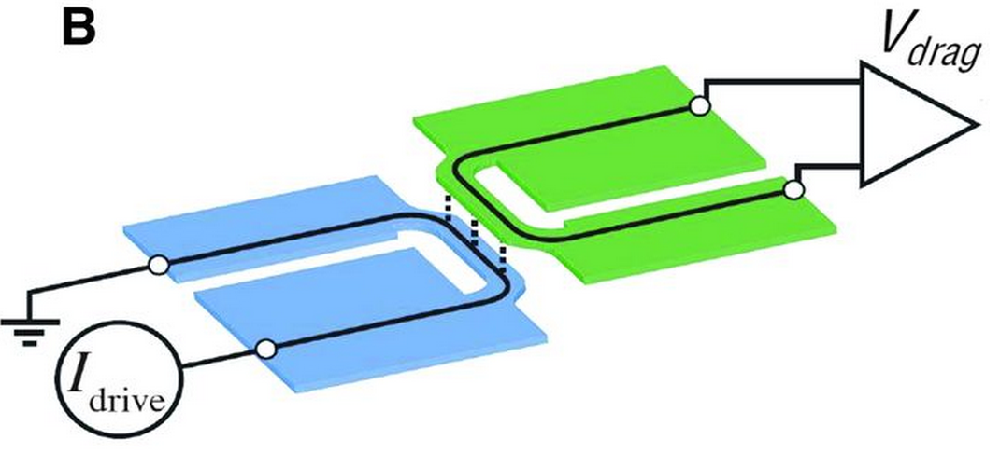
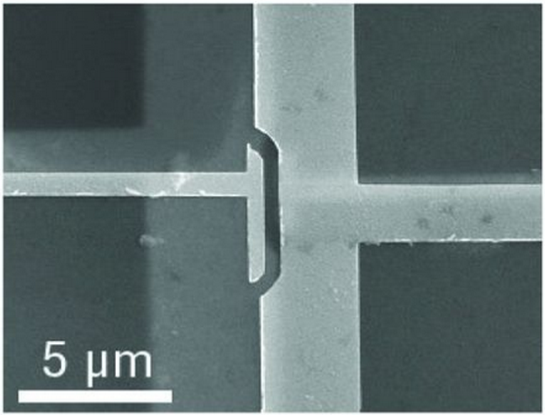
Experimental
Figure 1: (a) SEM of typical 1D-1D drag devices.
(b) Drag resistance measurement diagram.
(a)
(b)
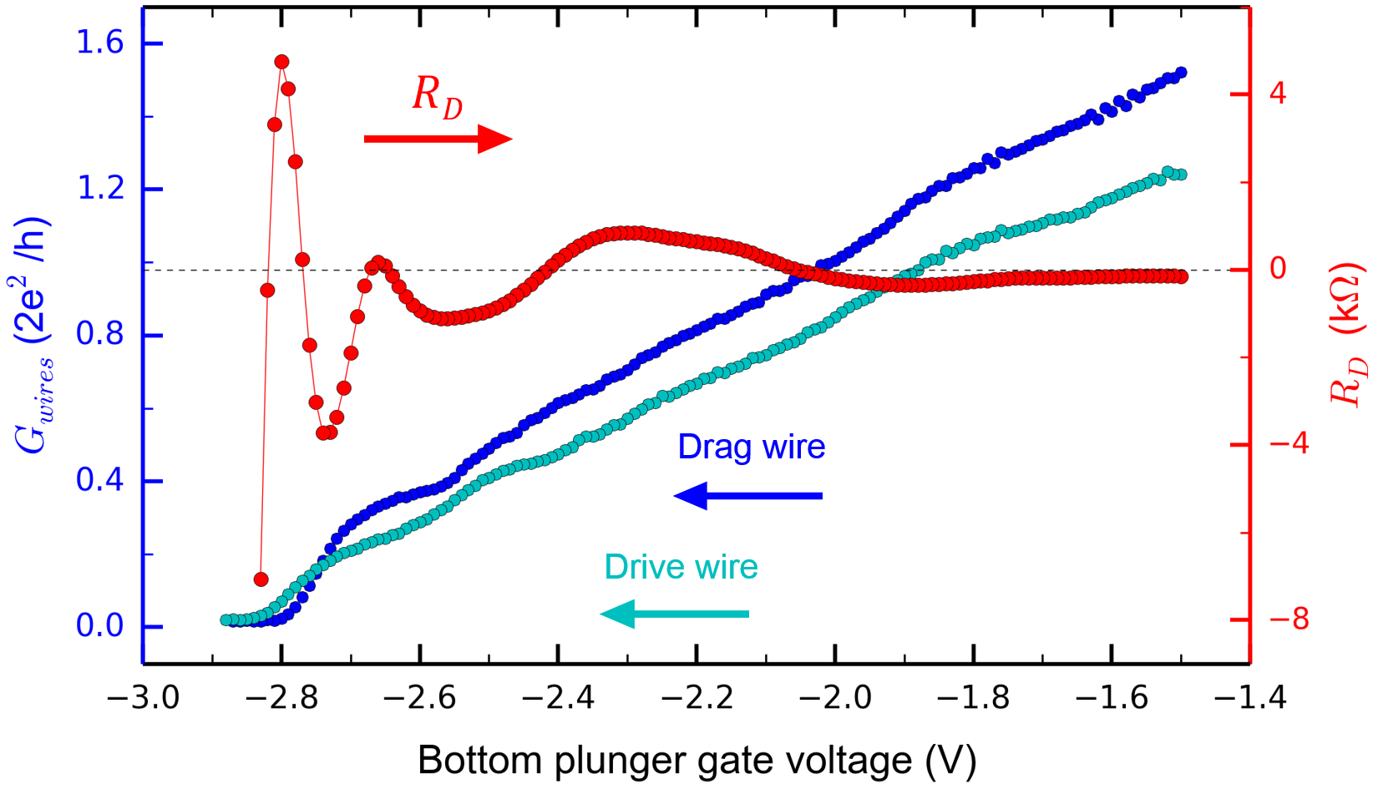
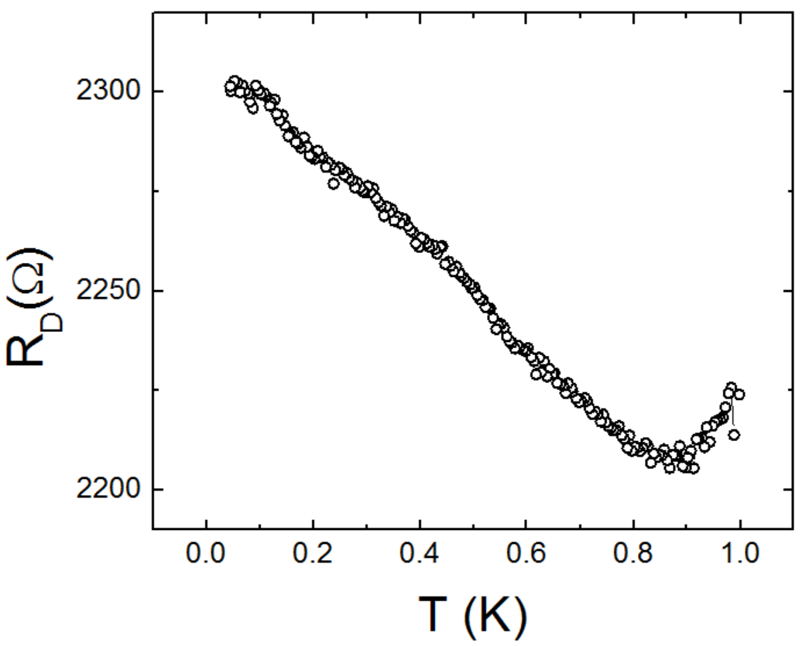
Vertically-coupled, individually-tunable quantum wires were fabricated from double quantum well heterostructures (Fig. 1a) grown by two distinct molecular beam epitaxy groups (Reno at Sandia and Pfeiffer at Princeton). The drag resistance was first measured (Fig. 1b) at dilution refrigerator temperatures (∼ 35 mK) for different 1D subband configurations, and the temperature dependence of the $R_{D}$ was then obtained.
Figure 2: (a) $R_{D}$ vs the voltage applied on an electrostatic gate defining the quantum wires in device B. (b) $R_{D}$ vs $T$ in device A, with visible upturn.
(b)
(a)
Results and Discussion
Both device A (grown at Sandia) and device B (grown at Princeton) show the typical qualitative features of drag as a function of 1D subband occupancy – a re-entering negative drag signal and $R_{D}$ maxima concomitant with 1D subband openings [2], see Fig. 2a. The previously observed upturn in the temperature dependence of $R_{D}$, attributed to LL physics [3], was also observed in device A. However, the temperature dependence of R_{D} in device B fabricated from a heterostructure with a higher un-patterned 2D mobility remains unclear owing to device stability issues as well as thermometry problems which prevented further characterization of the drag resistance in this device.
(b)
(a)

Conclusions
Although the ultralow temperature behavior of $R_{D}$could not be fully determined in either device, we have learned that i) signatures of 1D Coulomb drag is robust across a variety of heterostructures grown in different MBE and ii) an important proof-of-concept has been realized whereby an extremely complex multi-gated nano-engineered quantum circuits was measured at the Gainesville micro-Kelvin Facility. In the future, we plan on measuring $R_{D}(T)$ down to the lowest temperatures achievable, potentially below 2 mK, a measurement that could help solve an outstanding problem in the condensed matter physics of one-dimensional systems.

Acknowledgements
A portion of this work was performed at the National High Magnetic Field Laboratory, which is supported by National Science Foundation Cooperative Agreement No. DMR-1157490, the State of Florida, and the U.S. Department of Energy. This work has been supported by the Division of Materials Sciences and Engineering, Office of Basic Energy Sciences, U.S. Department of Energy (DOE). This work was performed, in part, at the Center for Integrated Nanotechnologies, a U.S. DOE, Office of Basic Energy Sciences, user facility. Sandia National Laboratories is a multiprogram laboratory managed and operated by Sandia Corporation, a wholly owned subsidiary of Lockheed Martin Corporation, for the U.S. DOE’s National Nuclear Security Administration under contract DE-AC04-94AL85000. We also acknowledge financial support from NSERC, CIFAR, and FQRNT.
References
[1] Narozhny, B. N et al. arXiv:1505.07468 [cond-mat.mes-hall] (2015)
[2] Laroche, D. et al., Nature Nanotechnology 6, 793–797 (2011)
[3] Laroche, D. et al., Science, 343 no. 6171 pp. 631-634 (2014)

