Field-Rotatable Calorimeter for NHMFL Top-Loading Portable Dilution Refrigerator

Fortune, N.A.; Gu, C.; Liang, L. (Smith College, Physics); Hannahs, S.T. and Park, J-H. (NHMFL)

Introduction
We recently developed a new generation of rotatable sample-in-vacuum calorimeter [1] capable of operation in the DC field facility’s resistive magnets. Samples are typically on the order of 1 mg in mass and can be up to 2 mm² × 0.5 mm in volume. The 0.300” diameter and 0.500” long cylindrical calorimeter is small enough to fit inside the top-loading single-axis rotator probe for the NHMFL DC field facility’s portable dilution refrigerator (PDF); it can be rotated in field 360 degrees while the fridge remains at base temperature. The PDF is compatible with the DC field facility’s 32 mm bore resistive and hybrid magnets, allowing measurements down to 0.1 K in fields up to 36 T and 45 T respectively. This was a significant advance over our previous 0.450” diameter calorimeter [2] designed for the 18 T dilution refrigerator/ superconducting magnet SCM1, but was time-consuming to assemble.

Experimental
This year, we designed, constructed and tested an updated version of this new generation 0.300” diameter calorimeter, with 3 improvements in mind: (1) easier preparation and interchange of samples and sensors by mounting them on modified industry standard ceramic QFN chip carrier modules (VEED-5 3 mm x 3mm, 12 contacts on a 0.5 mm spacing), (2) improved ease of assembly by stacking of QFN chips and (3) extending range of experiments beyond calorimetry to include transport and torque magnetometry. Holes and grooves can be cut into the QFN assembly to serve as calorimeter frames for sample heaters and thermometers. See Figs. 1 - 3.

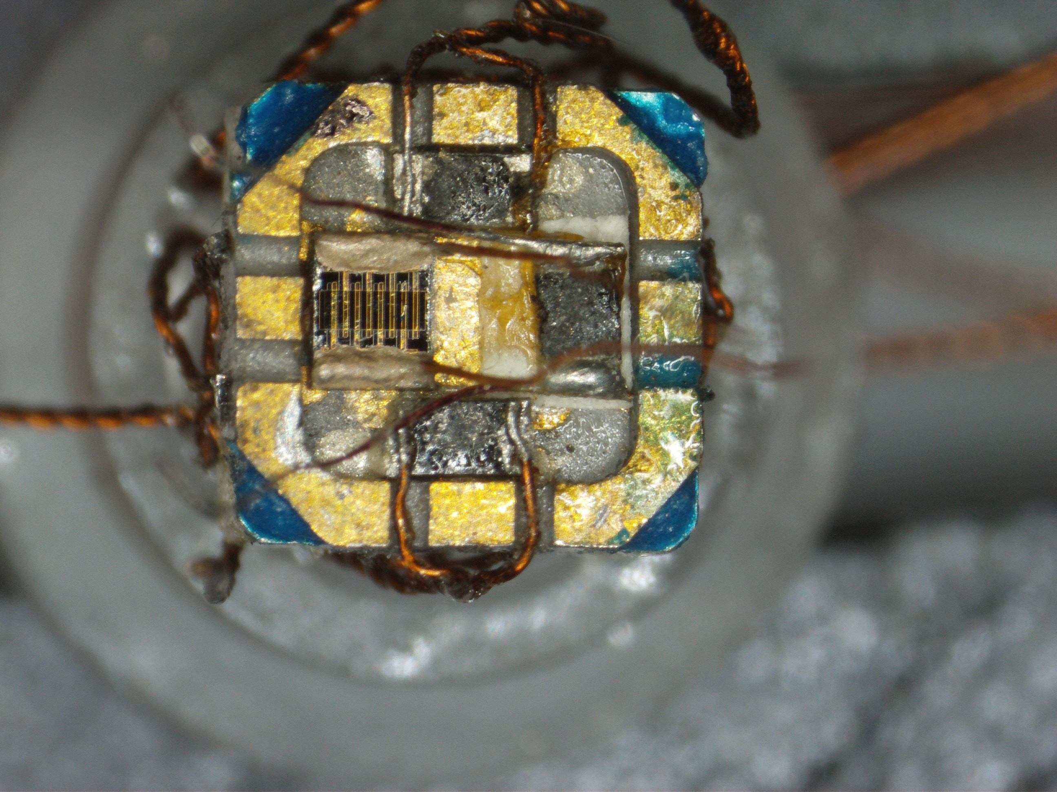 | 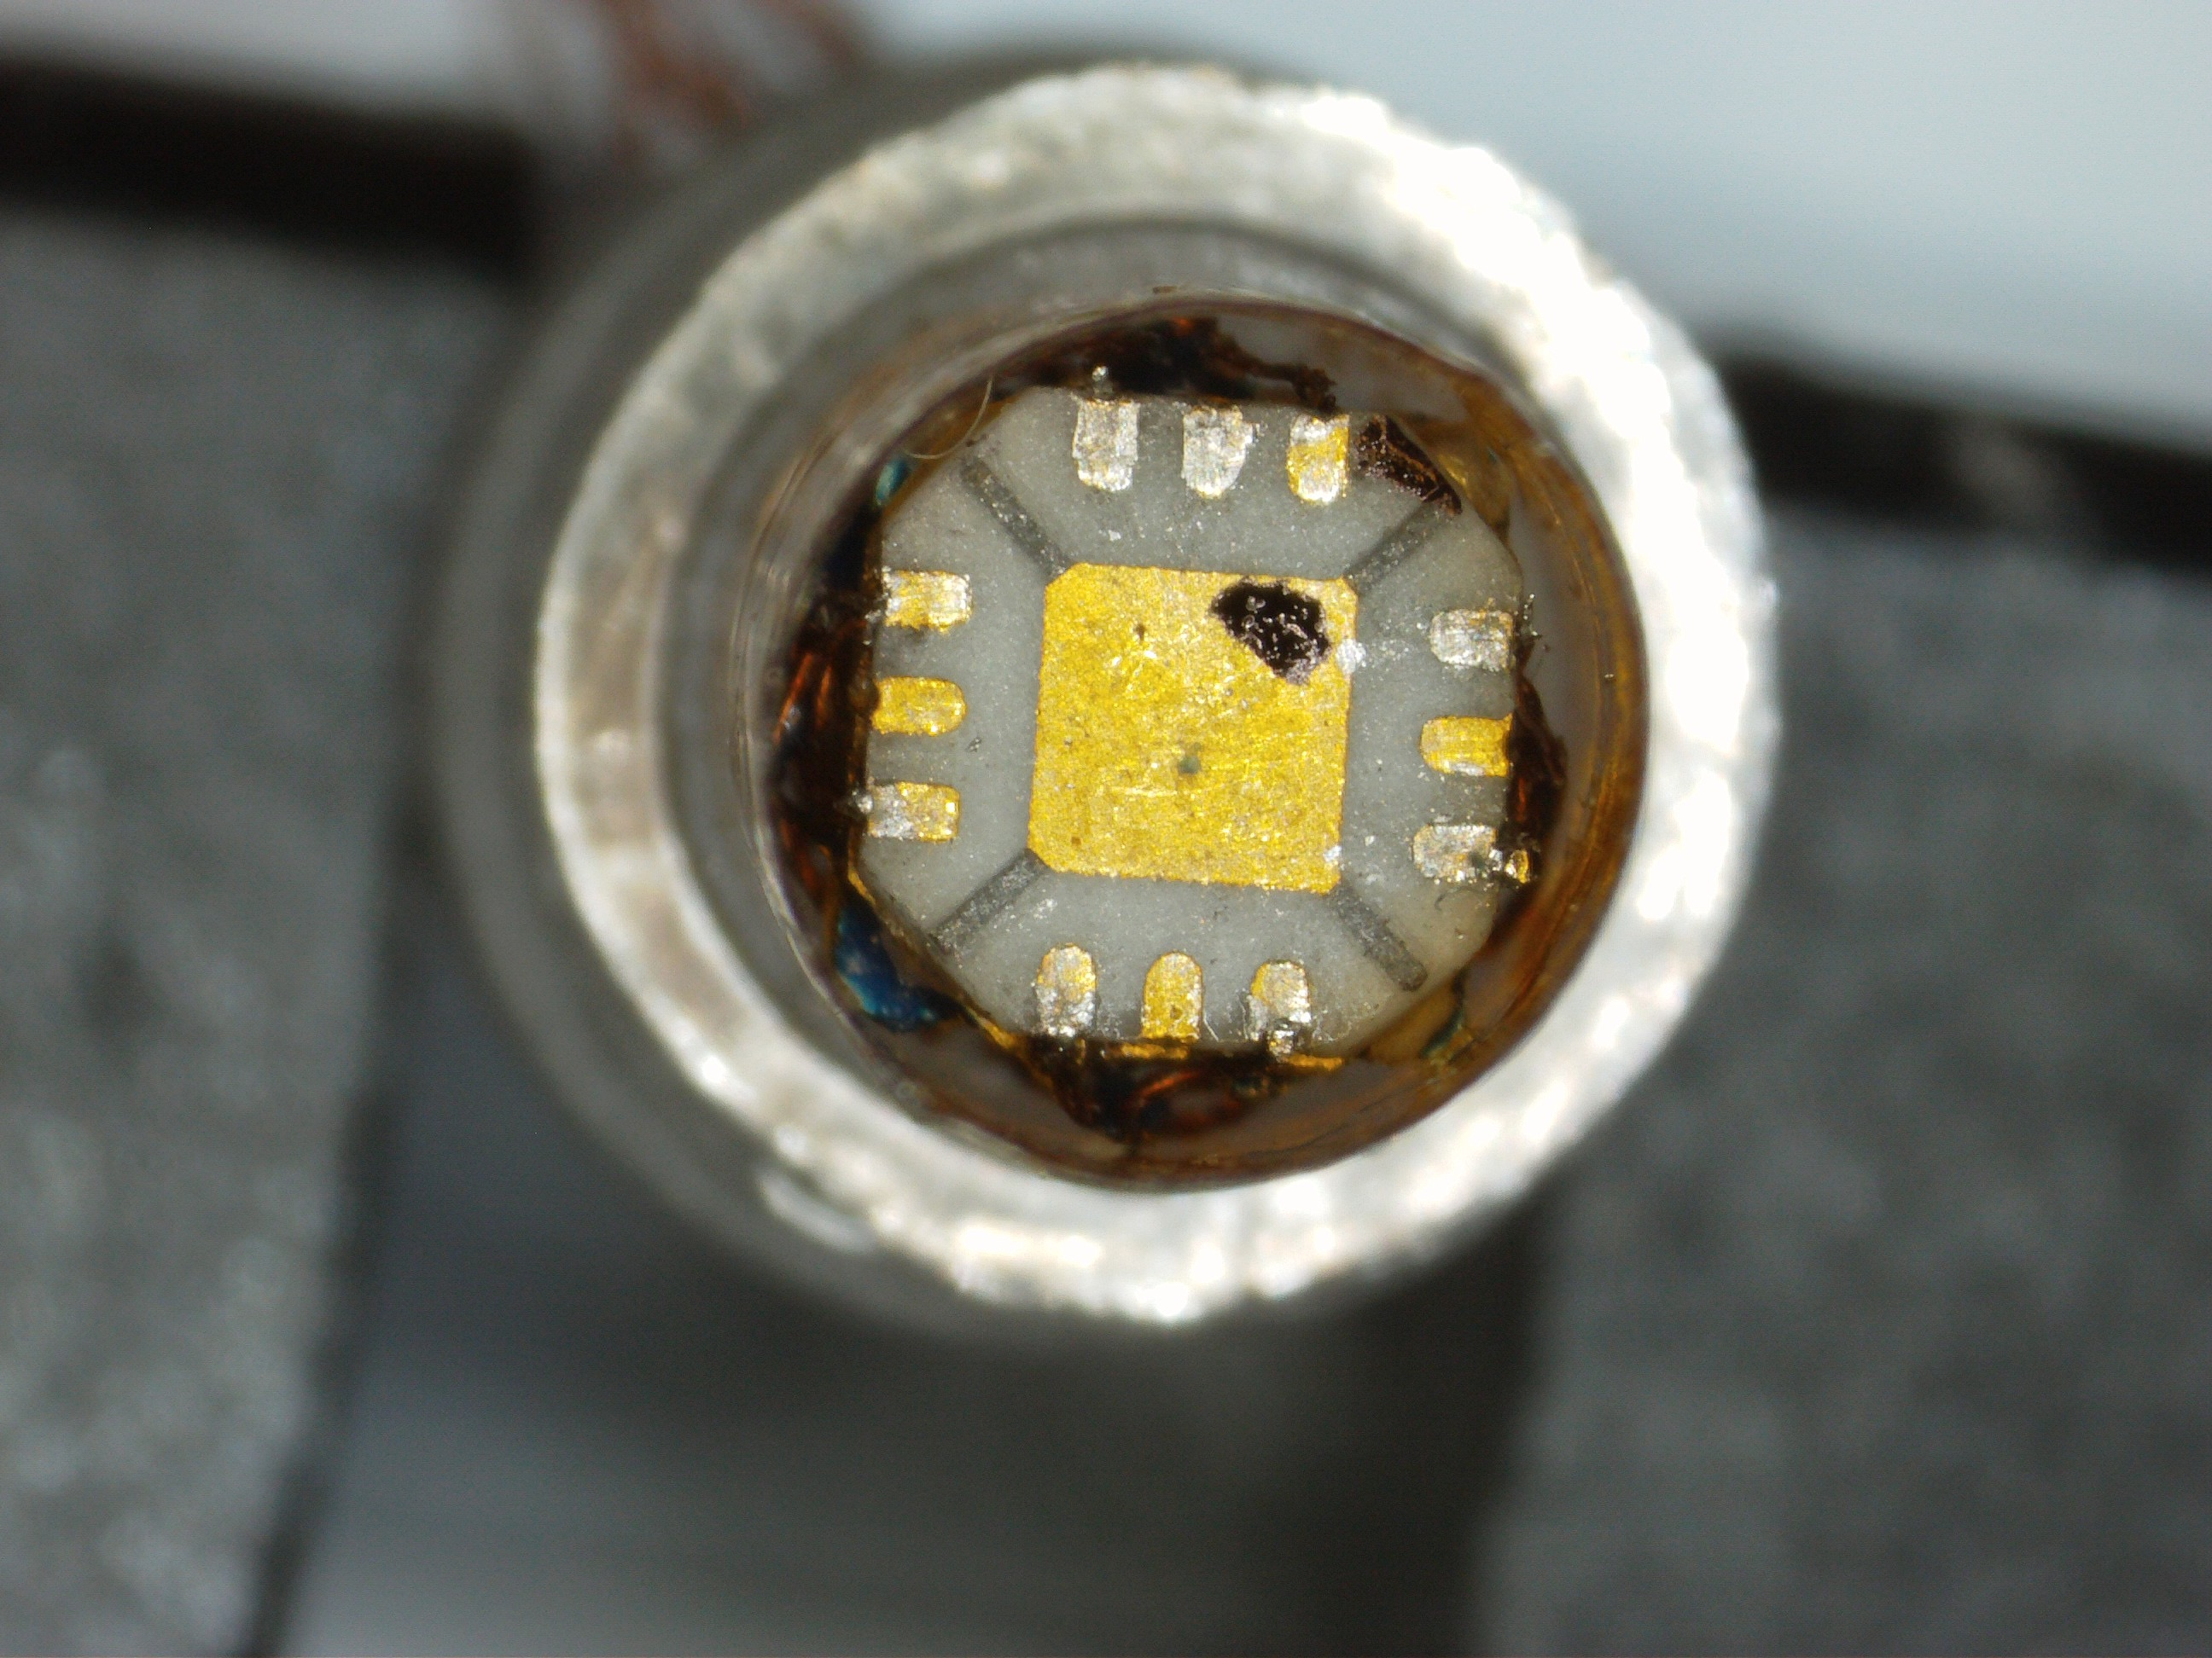 | 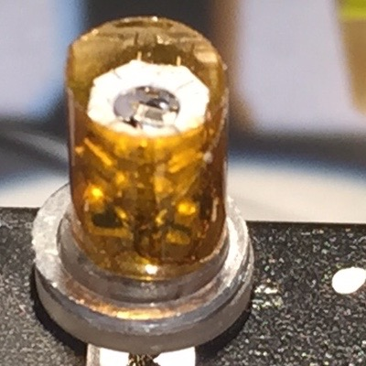
Fig. 1 photo of platform base chip, including thermometers for control of temperature in field, platform heater and zero-field calibrated thermometer (LakeShore Cernox) | Fig. 2 photo of platform cover chip. This chip sits on top of the platform base chip. It also functions as the contact terminals for capsule wiring. | Fig. 3 photo of calorimeter “sandwich” (mounted on top of cover chip) and indium o-ring gasket (sitting on base), along with protective Kapton tube.

Results and Discussion
Following a testing and calibration run in the 18 T SCM1/dil fridge/rotator probe, this calorimeter was successfully used to carry in calorimetric and magneto measurements of the layered-structure 2D organic superconductor K-(BEDT-TTF)2Cu(NCS)2 as a function of temperature, field strength and field orientation up to 36 tesla using the NHMFL portable dilution refrigerator (PDF), single-axis rotator probe, and 36 T resistive magnet.

Acknowledgements
A portion of this work was performed at the National High Magnetic Field Laboratory, which is supported by National Science Foundation Cooperative Agreement No. DMR-1157490, the State of Florida, and the U.S. Department of Energy. NAF received support from NHMFL Visiting Scientist Program award #12411.

References
[1] Fortune, N.A. et al., Journal of Physics: Conference Series, 568, 032008 (2014).
[2] Hannahs, S.T. et al., Physica B – Condensed Matter, 329-333, 1586-1587 (2003).

