Probes for Ultrasonic Measurements at the NHMFL DC Field Facility

Suslov, A.V. (FSU, NHMFL)

Introduction
Addressing requests from our users I designed, built, and tested a prototype of a probe designated specifically for ultrasonic measurements at the NHMFL DC Field Facility. Such probes are desired for measurements of signals with small amplitudes, as there is an increasing need for them in studies of modern nonlinear systems.

Experimental
In the new probes 0.0865 inch in diameter cryogenic stainless steel semirigid cables from Micro-coax [1] are used to carry on RF bursts, which is the usual form of the signals in the pulse-echo ultrasonic technique. The prototypes of these probes were tested in SCM2 and SCM1 systems of the NHMFL DC Field Facility. Special care was given to thermal anchoring of the cables. An image of the probe installed on the top of SCM2 is shown in Fig. 1.

Results and Discussion
In both SCM1 and SCM2 magnets the base temperature of 20 mK and 0.25 K, respectively, was reached during the probe tests. In SCM2 the dependences on the magnetic field of the signal level and the phase were studied using 30MHz RF bursts with duration of 1 μs propagated through the probe cables. The stability of the signal amplitude in the field was measured to be of about ± 0.1 dBm and can be considered sufficiently good. However, the phase change in the field 18T was about 5° and was larger than typically required for ultrasonic measurements, see Fig. 2. Most likely the observed phase dependence is due to magnetic properties of the RF adapters used to interconnect the cables in the probe, and these adapters should be replaced by other models.

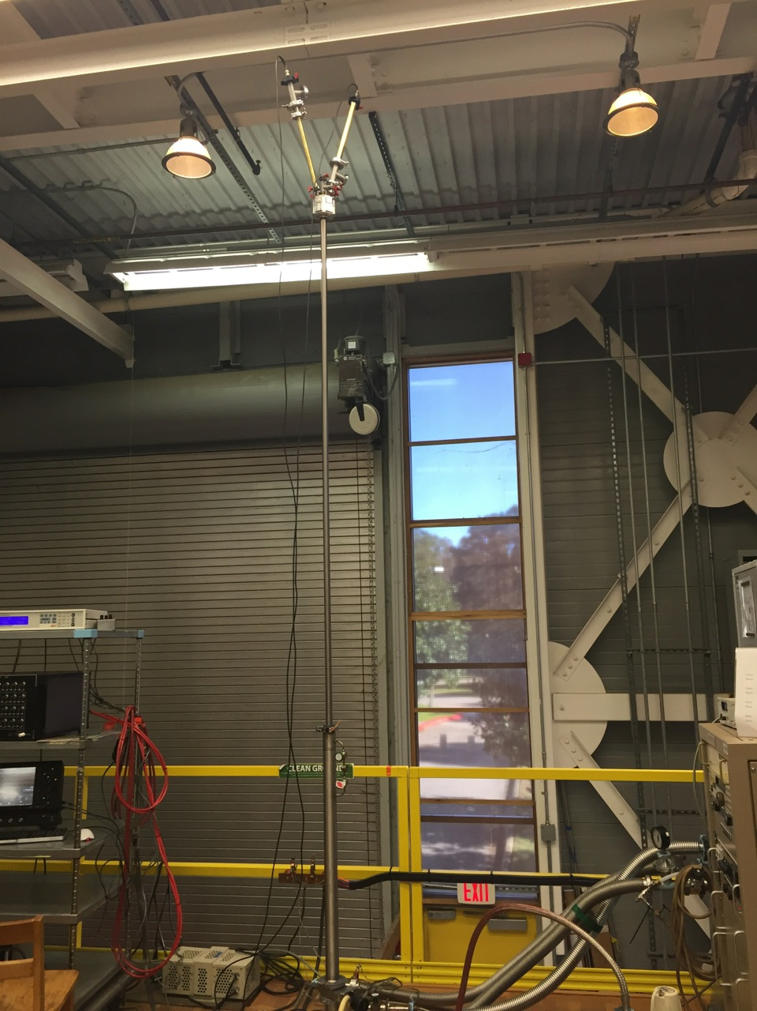
Fig. 1. An ultrasonic probe mounted on the top of SCM2. | Fig. 2. Dependence of the RF signal amplitude and phase on the magnetic field.
Conclusions
The origin of the magnetic field affect on the RF signal phase in newly developed probe should be identified and the phase stability in the magnetic field has to be improved.

Acknowledgements
This work was performed at the National High Magnetic Field Laboratory, which is supported by National Science Foundation Cooperative Agreement No. DMR-1157490 and the State of Florida.
The author is thankful to T. Murphy, J.-H. Park, D. Semenov, S. Maier, and I. Yu. Smirnov for useful discussions and help.

References
[1] www.microcoax.com

