Impact of Acid-Cleaning on the Solar Wind Layer of Genesis Flight Wafers – Partial Dissolution and Recovery of the Lithium-6 Implant

Waeselmann, N. (EOAS, FSU); Humayun, M. (EOAS, FSU); Goreva, Y.S. (Smithsonian Institute); Burnett, D.S. (California Institute of Technology) and Jurewicz, A. (Center for Meteorite Studies, Arizona State University)

Introduction
Determination of the oxygen isotope composition of the Sun was the top priority for the NASA Genesis mission [1]. The successful measurement of oxygen isotopes has triggered a discussion on the role of mass fractionation due to Inefficient Coulomb Drag (ICD) that may have displaced the oxygen isotope composition of the solar wind from that of the photosphere. There are other interpretations involving photochemically-induced mass-independent fractionation in the solar wind (SW). These issues can be resolved by determining the Mg isotope composition of the solar wind, which is currently the highest priority objective for the Genesis mission.
The surfaces of Si wafers have to be thoroughly cleaned to remove Mg from UTTR debris due to the 2004 crash landing of the mission. The aggressive acid cleaning procedures devised to clean Genesis flight wafers cause concerns that some of the SW implant may be removed, as well, biasing the δ²⁶Mg to heavier values. Achieving a quantitative removal of the SW-bearing layer is not easy, which could bias the δ²⁶Mg to lighter values since the heaviest Mg isotopes are the most deeply implanted. To overcome both of these problems, the wafers under investigation were ion-implanted with ⁶Li (Leonard Kroko Inc., 15 keV, 0.4 µA, of 3E14 ions/cm²). The ⁶Li implant was designed to overlay the solar wind layer at a depth of 50–200 nm below the exposed surface.
Experimental
Three ⁶Li implanted samples were subjected to acid cleaning in order to remove the UTTR debris. 60491 and 60500 were cleaned with aqua regia [2] while 60493 was cleaned with boiling sulfuric acid [2]. All samples were imaged using ToF-SIMS [2] before and after the cleaning and showed no residual contamination. In addition a non-flight control sample (A-5) was processed to confirm the ⁶Li yield of the implant. The ⁶Li was extracted from the silicon wafer by placing the implanted surface on a 100 µL drop of a 1% HF-HNO₃. This sets the partial dissolution to ~300 nm for 1 cm² of Si wafer surface. After 5 minutes the reaction was stopped by adding 900 µL of water. The solution was split in aliquots for isotope composition (IC) and isotope dilution (ID) measurements. Each Si wafer was subjected to two dissolution steps to ensure that there was no ⁶Li remaining in the Si wafer. The measurements were performed on an Element XRTM using Thermo Super Jet 8.2 Ni sampler and Spectron T1001 Ni-X skimmer cones with a sensitivity of 60 Mcps/ppb of ¹¹⁵In. Sample introduction was performed with an ESI ApexQ™ sample introduction system and a 20 µL/min Savillex™ PFA nebulizer. The detection limit of ⁶Li was 0.1 ppt or 0.00006E14 atoms/cm² ⁶Li.
Results and Conclusions
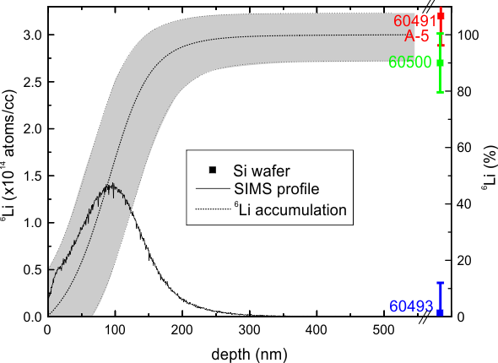
As hoped for, the aqua regia cleaning technique was not found to remove any significant ⁶Li (<0.1%) from the implanted wafers. The HF-HNO₃ dissolution step obtained quantitative yields for ⁶Li on each wafer. Each wafer was processed twice with HF-HNO₃ dissolution. The first dissolution step removed all of the ⁶Li as expected (see figure 1), and no ⁶Li was detected in the second dissolution step. We infer that we removed >300 nm of Si during each dissolution. These results demonstrate that – with a single ⁶Li implant at 15 keV – Genesis Si collectors can be suitably used for Mg isotope analyses of the solar wind by ICP-MS analysis.
Acknowledgements
A portion of this work was performed at the National High Magnetic Field Laboratory, which is supported by National Science Foundation Cooperative Agreement No. DMR-1157490 and the State of Florida.This work was funded by NASA Laboratory Analysis of Returned Samples (LARS) grant# NNX13AD11G.
Fig.1 The cumulative ⁶Li with depth from the surface is plotted as a black dashed line. The gray area represent a 10% error on the cumulative ⁶Li. The SIMS ⁶Li profile is shown as a solid black line. Sample and control measurements are represented by colored symbols. Note that the red square represents both the control A-5 and 60491.

References
[1] Burnett D. S. et al. Space Science Rev 105, 509-534 (2003)
[2] Goreva Y. et al. LPS 45, Abstract #2568 (2014)

