Halogen Chemistry by LA-ICP-MS

Waeselmann, N. (Geochemistry, FSU EOAS); Branch, J.Jr. (RET Elsik High School, Houston, TX); Bush, D.Jr. (Lake Region High School, Eagle Lake, FL) and Humayun, M. (Geochemistry, FSU EOAS)

Introduction
The halogen (F, Cl, Br and I) cycle on Mars has gained a lot of interest recently, due to the identification of chlorate and perchlorate salts on the Martian surface by the NASA Phoenix and Curiosity missions. On Earth, volcanic emissions of halogens end up as halide salts, like NaCl, or dissolved in water. Mars lacks water and has a very oxidized surface. Accordingly, halogens are redistributed between halides and oxy-halide compounds in different ratios. Further, alkali perchlorates are highly insoluble so that Br and Cl can be fractionated, i.e. separated into distinct rocks, by the action of water. A search for evidence of these processes might be found in minerals within Martian meteorites that contain trace levels of halogens, but the analytical techniques required to achieve such a measurement are still under development. Bromine and Cl are not routinely measured by LA-ICP-MS, due to their high ionization energies, and suitable standards are rare. In this study, we have analyzed scapolite grains (BB1) with reported Cl and Br concentrations [1] using LA-ICP-MS to show that scapolite can be used as a halogen standard (Cl and Br) for LA-ICP-MS.

Experimental
In this study, we analyzed stoichiometric potassium halide salts by LA-ICP-MS to calibrate the halogen abundances in scapolite and compared these results with data obtained by the noble gas method used by [1].

Results and Discussion
The chlorine content increases with the Marialite component (Na and Cl-bearing end member) in Fig. 1a as expected. Figure 1b shows the Cl/Br ratios from several measured pieces of scapolite BB1 as well as the value from [1]. Our measurements show a consistent Cl/Br ratio independent of the Marialite component.

Conclusions
For the identification of geochemical processes on the Martian surface utilizing Martian meteorites, the determination of the Cl/Br ratio, rather than absolute abundances, is important to determine fractionation processes. Our scapolite standard shows a consistent Cl/Br ratio while the absolute composition varies slightly due to the solid solution. Thus, we conclude that we have successfully characterized scapolite BB1 as a standard for determining Cl/Br ratios by LA-ICP-MS.

Acknowledgements
A portion of this work was performed at the National High Magnetic Field Laboratory, which is supported by National Science Foundation Cooperative Agreement No. DMR-1157490 and the State of Florida.
This research has been done as part of the RET program 2015. Analytical support was provided by NASA Cosmochemistry grant# NNX13AI06G.
Fig.1 Halogen concentrations with respect to scapolite composition are shown. The reference value BB1 from [1] is shown by a star. Several pieces taken from the exact same mineral used by [1] were obtained from the Museum Victoria collection. Measurements of the chlorine concentration as well as the Br/Cl with respect to the Marialite component on 5 different pieces are shown by the symbols.
References
[1] Kendrick, M.A., Chemical Geology, 292-293, 116-126 (2012).
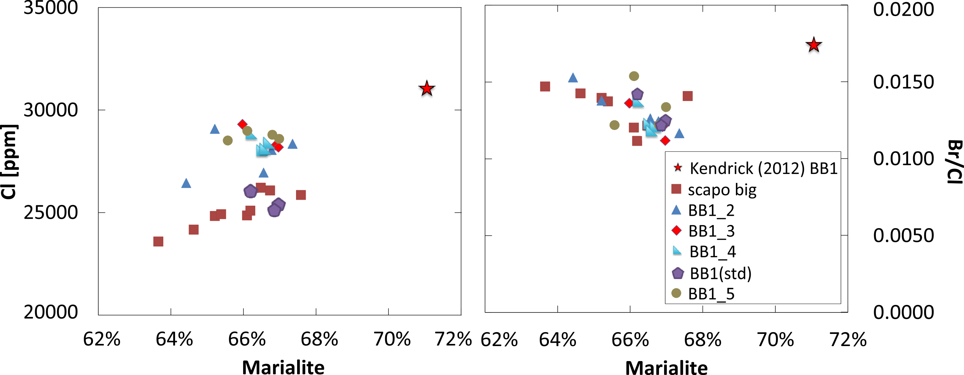
B
A

