High Field Magnetoresistance Measurements of the Surface States of Topological Kondo Insulator SmB₆: Cornering the Parameter Space for Carrier Density and Mobility

Eo, Y.S.; Wolgast, S.; Kurdak, C. (Univ. of Michigan, Physics); Kim, D.J. and Fisk, Z. (Univ. Cal. Irvine, Physics)

Introduction
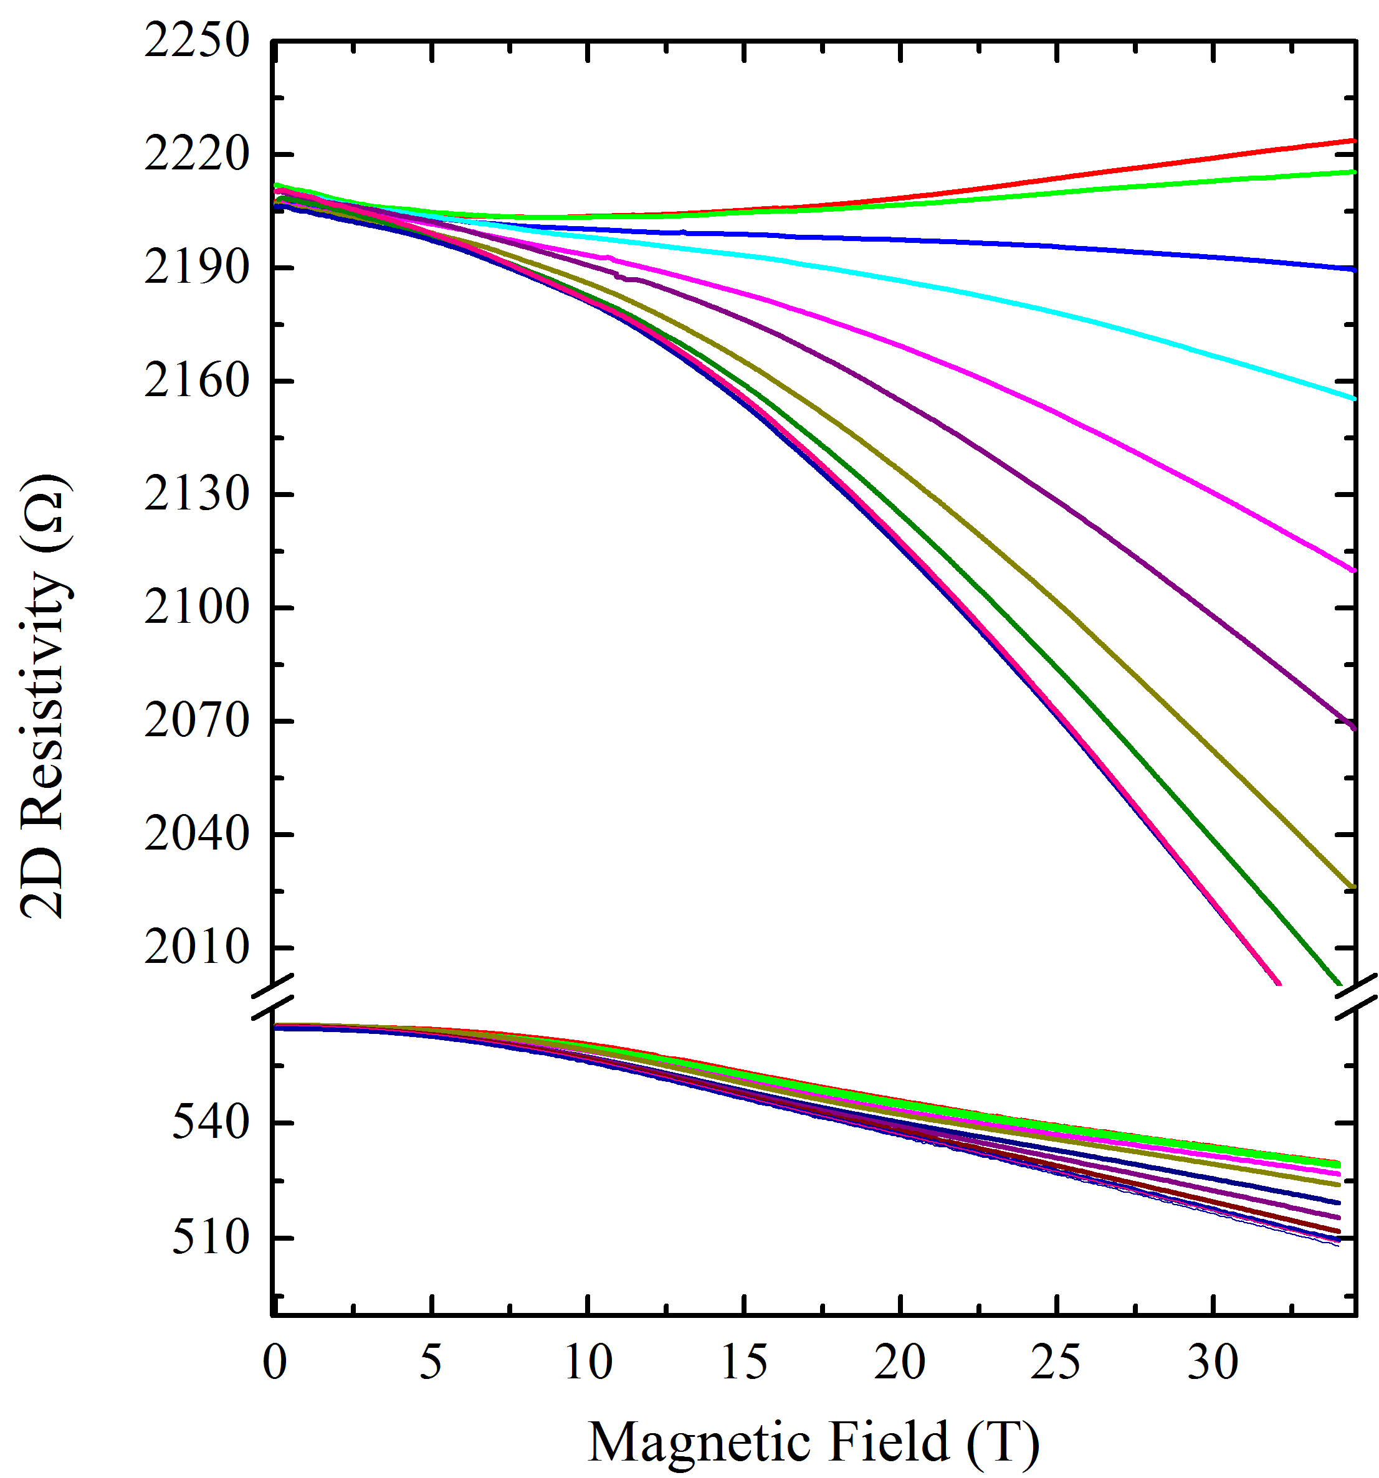
Even though there has been a plethora of research activity focusing on topological Kondo insulator SmB₆ in the last three years, we are far from having complete understanding of surface conduction in this material. Most disturbingly, basic parameters such as the carrier density of the Dirac pockets, extracted from a variety of techniques such as angle resolved photoemission spectroscopy, magnetic torque, and different types of transport measurements do not agree with each other.

Experimental
We use Corbino measurements to characterize the surface conduction in this material. The smoothness of the polished surfaces is controlled by the grit size of the abrasive pads or the size of the polishing powders.

Results and Discussion
We have observed that the resistivity of the surface layer increases with decreasing surface roughness. This remained as a mysterious observation until we found through systematic studies that the material had subsurface cracks, which were harboring additional paths for conduction [1]. To illustrate the significance of surface preparation and surface conduction through subsurface cracks, let us look at the angle-dependent magnetoresistance traces obtained from two same size (100) Corbino samples with different surface roughness (see Fig. 1). We now understand that in the sample with the rougher surface there are additional conduction channels generated by subsurface crack, which pollute the transport experiments. As a result of this the mobility and carrier density extracted from such rough surfaces have large systematic errors.
Figure 1. Magnetoresistance traces obtained from two (100) Corbino samples for different magnetic field directions at T=0.3 K. The upper set of data is obtained from a sample with a smoother surface morphology. Within each set the upper and lower traces correspond to perpendicular and parallel directions of magnetic field, respectively.

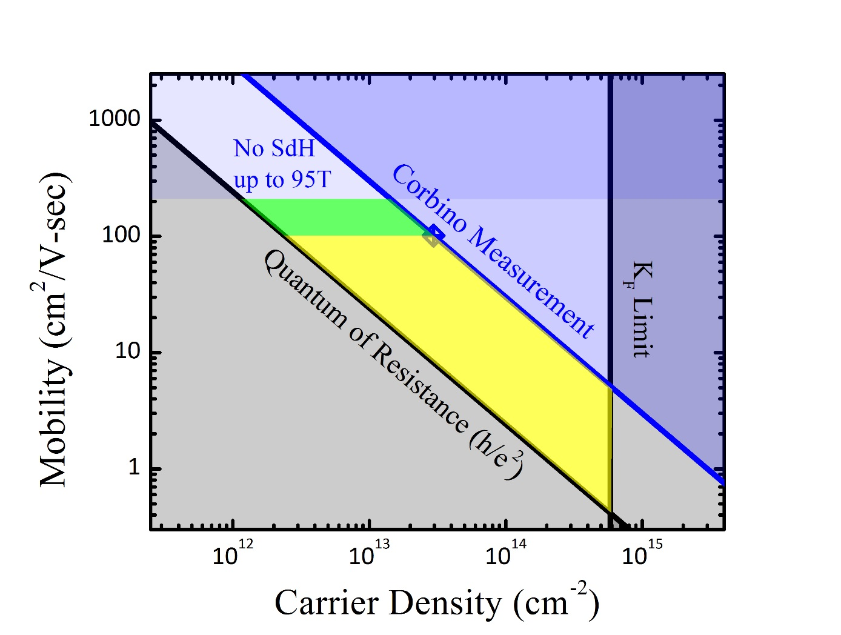
We should note that there are constraints on the allowed carrier density of each conduction channel: (1) the conductivity of each channel participating in conduction must be higher than the quantum conductivity; (2) there is an upper mobility limit given by the lack of SdH oscillations; (3) the Fermi wavevector, k_{F}, cannot be larger that the size of the Brillouin zone. In order to extract useful information from such measurements, we have analyzed the magnetoresistance traces from the smoother sample using a two-channel conduction model and determined the allowed n-μ parameter space for the two conducting channels (see Fig. 2.). The improved transport results remains to be inconsistent with the magnetic torque measurements [2].

Acknowledgements
A portion of this work was performed at the National High Magnetic Field Laboratory, which is supported by National Science Foundation Cooperative Agreement No. DMR-1157490, the State of Florida, and the U.S. Department of Energy. In addition, we acknowledge support by the NSF through grants DMR-1441965, DMR-1006500, and DMR-0801253, and by the Department of Energy award DE-SC0008110.
Figure 2. Allowed carrier density-mobility parameter space for the (100) surface of SmB₆ based on a two-channel analysis of magnetoresistance traces. The parameters for one of the channels must be green region and the other channel must be in the yellow region.

References
[1] Wolgast, S., et al., arXiv preprint arXiv:1506.08233 (2015).
[2] Li, G. et al., Science, 346, 1208-1212 (2014).

