High Field Magnetic Properties of Ce₂Rh₃Ge₅

Wartenbe, M.; Baumbach, R. (FSU, Maglab); McDonald, R.; Bauer, E. (LANL) and Gallagher, A. (FSU, Maglab)

Introduction
Ce₂Rh₃Ge₅ is a strongly correlated f-electron antiferromagnet [1], belonging to a broad family of materials which are interesting for their variety of ground states and their possible relation to other strongly interacting systems such as the cuprates. For instance, Ce₂Rh₃Ge₅ exhibits a pressure driven quantum critical point near P_{c} =0.45 GPa [2] and previous work by Baumbach and Wartenbe shows evidence of a magnetic field driven antiferromagnetic quantum phase transition near H = 22 T as well as quantum oscillations above 35 T [3]. As reported here, we are beginning to directly probe the magnetism of Ce₂Rh₃Ge₅ in an effort to improve our understanding of this material’s high field behavior.

Experimental
Co-aligned single crystal specimens were measured using an extraction magnetometer. This is done by performing one magnet pulse with the sample in a magnetization coil and one without to provide a differential measurement. By scaling the resulting data to that taken in a standard magnetic measurement system (e.g., a Quantum Design MPMS), it is possible to quantitatively determine the magnetization at large H by this technique.
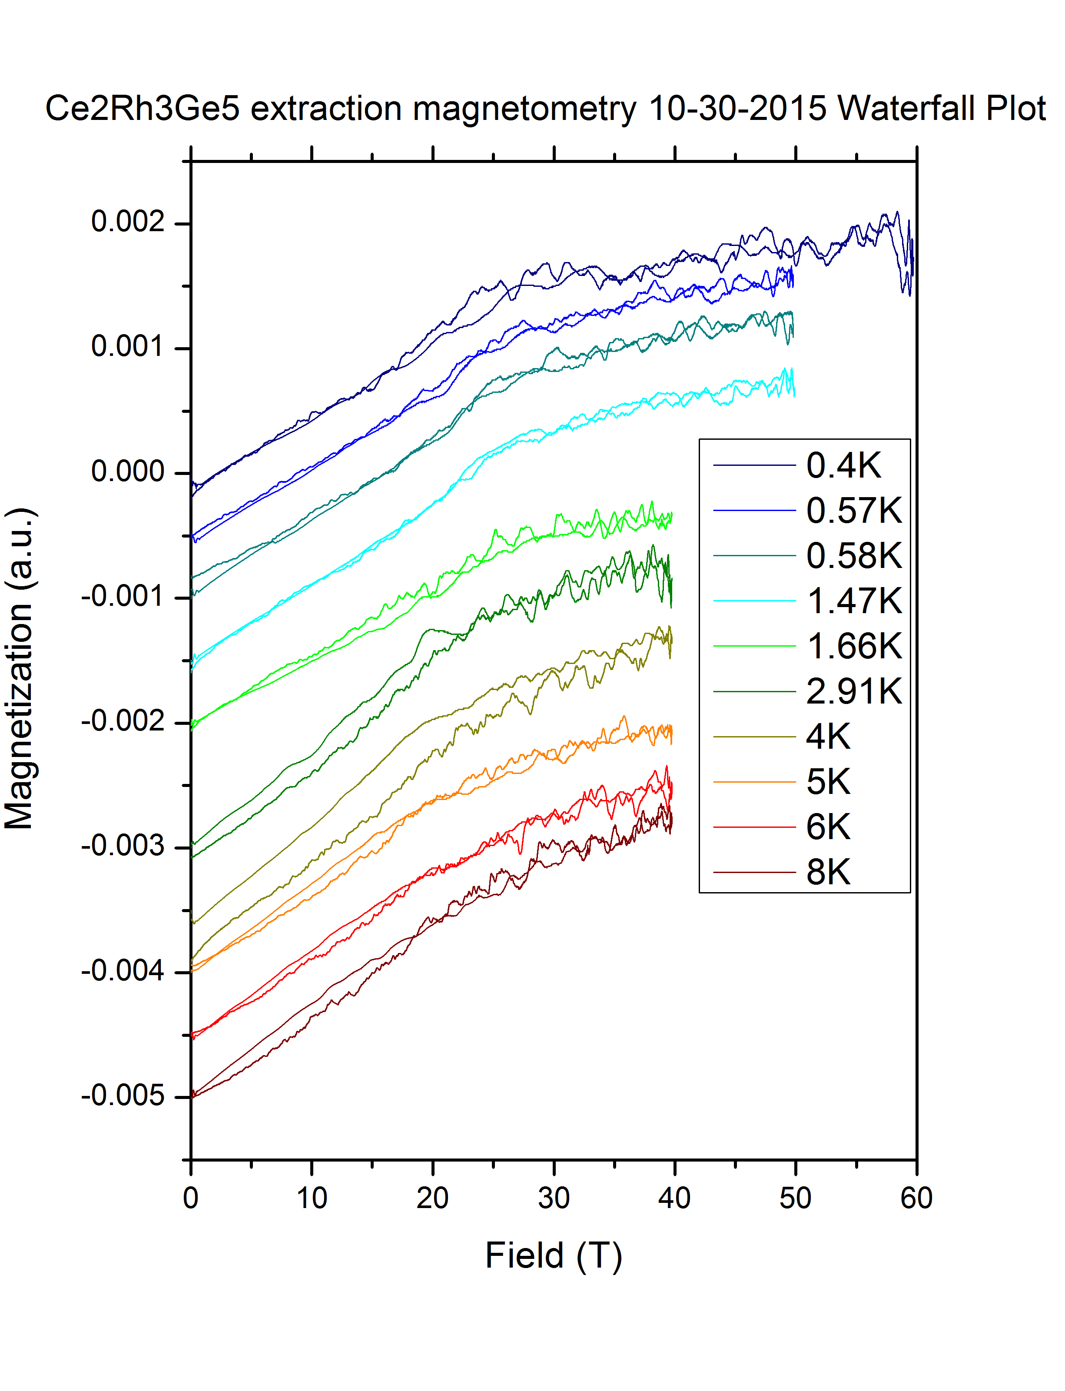
Results, Discussion, and Conclusions
The resulting data are shown in figure 1 as a plot of the signal in arbitrary units of amplitude against the magnetic field in Tesla for multiple temperatures. The data are offset by constant values ΔM for ease of reading and a linear background subtraction was used. As the temperature is lowered, a break in slope appears near H = 22 T, consistent with previous magnetoresistance results that indicated a quantum phase transition at this field. This break in slope reveals a change in magnetization of the material and may indicate the transition into a spin polarized state. These results will be useful to inform theoretical modeling.

Fig. 1 Waterfall plot from extraction magnetometer data. The break in slope indicates a change in the magnetic properties of the material and can be used to produce a number for the magnetization of the compound

Acknowledgements
A portion of this work was performed at the National High Magnetic Field Laboratory, which is supported by National Science Foundation, the DOE and the State of Florida via Cooperative Agreement No. DMR-1157490. R. B. and A. G. acknowledge support from the UCGP program.

References
[1] Z. Hossain, et al., Phys. Rev. B 60 (1999) 10383.
[2] K. Umeo et. al. Physica B 312–313 (2002) 403–405
[3] R. Baumbach et. al. Maglab Reports V.20 No. 2 (2013) 14-15

