Reconstruction of the Fermi Surface in Nd-Substituted CeCoIn₅

Green, E.L. (HLD, HZDR); Klotz, J. (HLD, HZDR); Goetz, K. (HLD, HZDR); Wosnitza, J. (HLD, HZDR) and Petrovic, C. (BNL, Physics)

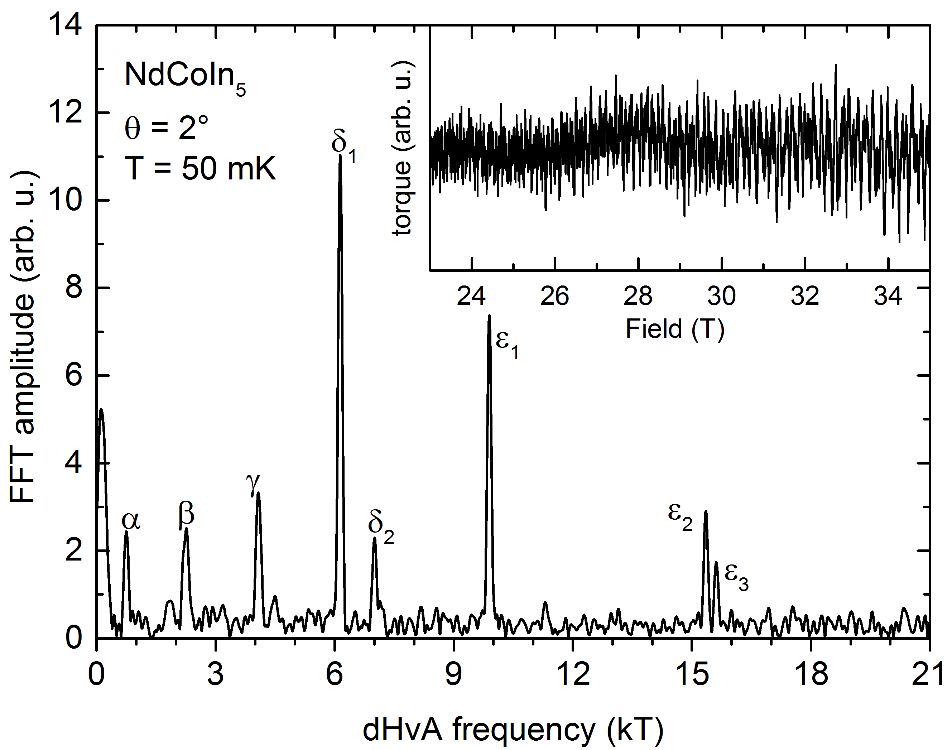
Introduction
In CeCoIn₅, it is generally accepted that the hybridization of the 4f Ce atoms with the conduction electrons plays an important role in superconductivity. By substituting Ce with Nd, a nonhybridizing local moment, one can tune smoothly tune the lattice coupling and test the robustness of the superconducting state [1-2]. Our primary goal was to observe how the Fermi surface evolves with increasing Nd-substitutions. de Haas-van Alphen (dHvA) oscillations for Nd_{0.02} Ce _{0.98} CoIn₅ and Nd_{0.05}Ce_{0.95}CoIn₅ were measured in previous magnet runs at the high field lab in Grenoble. To complete the series, Nd_{0.1}Ce_{0.9}CoIn₅ and NdCoIn₅ were measured at the NHMFL.

Experimental
Due to the Kondo interactions and relatively large effective masses, high magnetic fields (up to 35 T) and low temperatures (down to 40 mK) were necessary to resolve the high frequencies in this doping series (see Fig. 1). A capacitive beam cantilever was used in combination with a rotator in the portable
Fig. 1 Fast Fourier transformation (FFT) of dHvA oscillations for NdCoIn₅ at 50 mK. (inset) Background subtracted dHvA oscillations measured up to 35 T for field aligned at an angle 2º from the [001] direction.
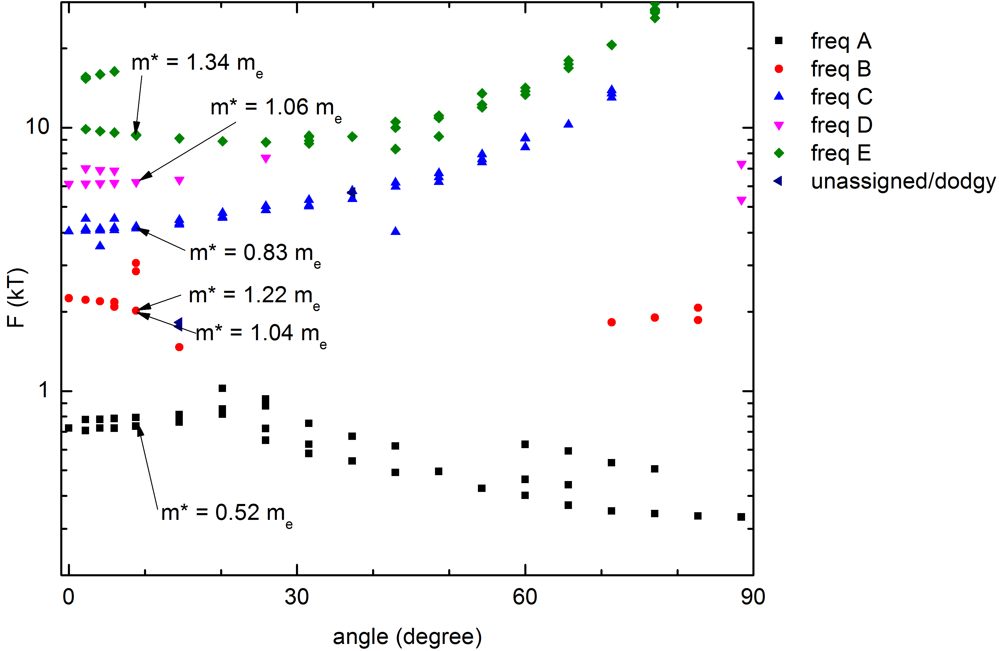
dilution refrigerator in the DC field facility (cell 8).

Results and Discussion
Quantum oscillations, though diminished with increased substitution levels, were resolved up to Nd-10% and were recovered for Nd-100% (see Fig. 2). By using these results, the Fermi surface could be reconstructed using band structure calculations. In addition, effective mass was measured indicating a sharp decrease with increased substitution levels.

Conclusions
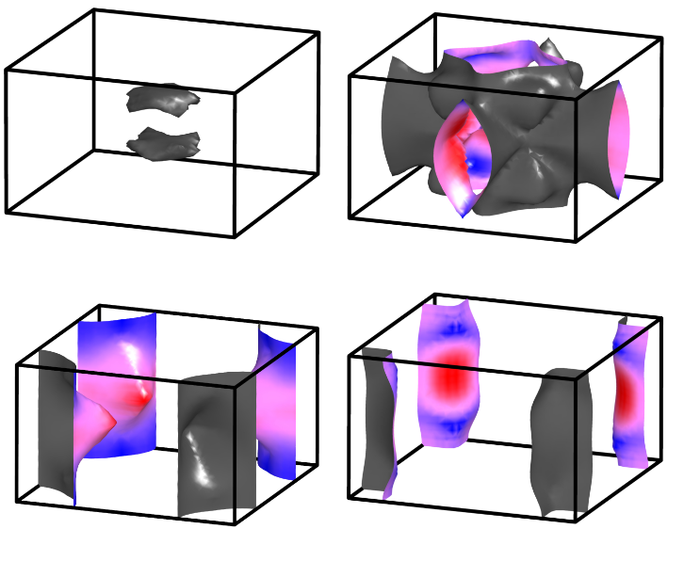
Initial band structure calculations performed on NdCoIn₅ using a low density approximation (LDA) with 4f electrons localized to the core shows striking similarities to the isostructural compound CeCoIn₅ despite the fact that it is magnetic rather than superconducting (Fig. 3). Additional band structure calculations are currently underway to observe how this Fermi surface evolves with increasing Nd-substitution levels.
Fig.2 dHvA oscillation frequencies for NdCoIn₅ measured at 50 mK rotated from [001]-direction (0º) to [100] (90º)

Acknowledgements
A portion of this work was performed at the National High Magnetic Field Laboratory, which is supported by National Science Foundation Cooperative Agreement No. DMR-1157490 and the State of Florida. In addition, a portion of
this research was performed at the Hochfeld-Magnetlabor in Dresden and has
been funded in part by the European Magnetic Field Laboratory (EMFL).

References
[1] Hu, R., et al., PRB 77, 165129 (2008).
Fig.3 Band structure calculations for NdCoIn₅ using the experimental results.
[2] Raymond, S., et al., arxiv:1307.2592v1 (9 July 2013)

