EPR Spectroscopy Towards Achieving Overhauser-DNP at 14.1 T

Akinfaderin, A. (NHMFL and FSU, Physics); van Tol, J.; Wi, S.; Dubroca, T.; Trociewitz, B. (NHMFL); Frydman, L. (Weizmann Institute, Israel and NHMFL) and Hill, S. (NHMFL and FSU, Physics)

Introduction
Overhauser effect predicts a reduction in O-DNP enhancement at high magnetic fields due to microwave heating, solvent-solute dynamics and the fast relaxation properties of radicals and nuclei [1]. However, the model does predict an increment in enhancement if a low-viscosity solvent is utilized. In a bid towards developing O-DNP at high fields, we investigated the microwave characteristics of polarizing radicals in low viscosity solvents such as hexane (η = 0.2 cP).

Experimental
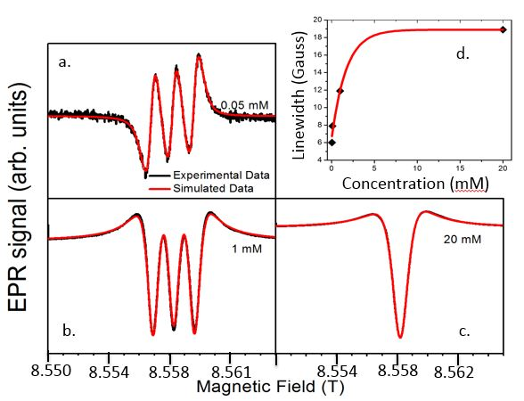 A high field / high frequency electron paramagnetic resonance (HF-EPR) experiment was performed using the NHMFL state-of-the-art quasi-optical EPR superheterodyne spectrometer in continuous wave (CW) mode at 8.5 T / 240 GHz. The initial measurement was performed at room temperature with a 0.7 mL solution sample of hexane and TEMPO radical.

Results and Discussion
d
a
Fig. 1 shows the EPR spectra at 240 GHz for different radical concentration (0.05 mM, 1 mM and 20 mM respectively). The variation of the peak to peak linewidth with different concentration were observed. The simulated data was generated using a pseudo Voight lineshape function. As we increase the concentration from 0.01 mM, the line width increases due to dipolar broadening. At high radical spin concentration, the three hyperfine peaks collapse into one peak. This phenomenon is due to the Heisenberg spin exchange interaction.
c
b

Conclusions and Future Work
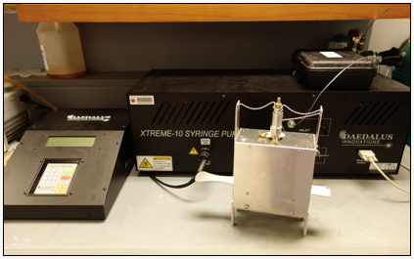
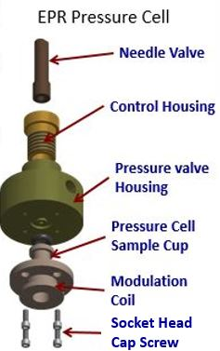 Our finding shows that O-DNP at high field should be performed at higher radical concentration due to the effect of spin rotation interaction and the collapse of the 1/n term in the O-DNP saturation factor (n accounts for the number of the hyperfine EPR lines). Ongoing and future work include incorporating EPR pressure cell with syringe pump system (Fig. 2) for investigating the dynamical effect of pressure and temperature when small molecules are dissolved in SF-CO₂ (η = 0.03cP) and other supercritical fluids.
Fig. 1. (a-c) EPR spectra at 240 GHz for different TEMPO radical concentrations. The simulated date were generated with a pseudo Voight line shape function; (d) Variation of the peak to peak linewidth with concentration.

Acknowledgements
A portion of this work was performed at the National High Magnetic Field Laboratory, which is supported by National Science Foundation Cooperative Agreement No. DMR-1157490 and the State of Florida.

References
[1] Hausser, K.H. and Stehlik, D., Advan. Magn. Reson., 3, 79-139 (1968).
Fig. 2. Picture of Daedalus X-treme 10 syringe pump and an expansion drawing of the EPR pressure cell.

