Magnetic Resonance Electric Properties Tomography at 21.1 T

Amouzandeh, G. (Florida State U., Physics, NHMFL); Abad, N.; Ould Ismail, A.O. and Grant, S.C. (Florida State U., Chemical & Biomedical Engineering, NHMFL)

Introduction
Biological tissues present an anisotropic conductivity and permittivity distribution determined by the electrical properties of numerous interfaces and domains. Magnetic Resonance Electrical Property Tomography (MR-EPT) is a method for quantitative mapping the dielectric properties of tissue [1]. MR-EPT makes use of a standard MRI system and employs post processing of the magnetic field map of the applied RF pulse (B₁) to provide a spatial image of permittivity ε and conductivity σ [2] in three dimensions. Phantom and human experiments have proven the feasibility of MR-EPT at much lower field strengths (< 7 T), with ongoing clinical studies demonstrating encouraging results. We have applied MR-EPT to different phantom studies and have produced the first conductivity and permittivity images of the in vivo rat brain at 21.1 T.

Experimental
All scans were performed using the 21.1-T, 900-MHz ultra-widebore magnet at the National High Magnetic Field Laboratory, Animal procedures were approved by the Institutional Animal Care and Use Committee at the Florida State University. Three anesthetized Sprague-Dawley male rats were used. Multislice, 2D Fast Spin Echo (FSE) scan were acquired with TE=12 ms and TR=2.5 s over different flip angles of 60°,120° and 90°.

Results and Discussion
Eq 1. represents the Helmholtz equation taking into account the impact of the local electrical properties of tissue on the B₁ field (H⁺). Recently, accelerated conductivity imaging based on phase imaging only was introduced and successfully tested with healthy volunteers [3]. In this study, the simplified formulas for phase-based conductivity and magnitude-based permittivity given in Eqs. 2 and 3 were employed [4]. The B₁ phase data were reconstructed from the 90° FSE image phase (Fig.1) by using the transcieve phase assumption, $2φ\left(H^{+}\right)=B_{1}phase$. A double angle method was used to construct B₁ magnitude (Fig. 2) from 60° and 120° flip angle maps .In (Fig.3), the relative conductivity based on phase information only is displayed, while (Fig.4) shows the permittivity.

$k=\frac{-1}{μω^{2}}\frac{∇^{2}H^{+}}{H^{+}} where k=ε-j(\frac{σ}{ω})$(1) $σ=\frac{1}{μ_{0}ω^{2}}∇^{2}φ(H^{+})$ (2) $ε=-\frac{1}{μ_{0}ω^{2}}\frac{∇^{2}|H^{+}|}{|H^{+}|}$ (3)

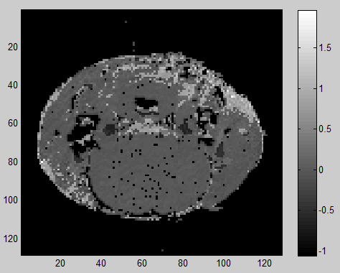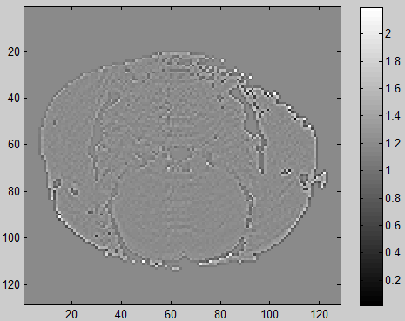
Fig.1 Phase map Fig.2 B₁ magnitude map Fig.3 Relative Permittivity Fig.4 Relative Conductivity

Conclusions
Future studies need to be done to evaluate the error percentage of using transceive phase assumption for ultra-high fields.

Acknowledgements
This work was performed at the National High Magnetic Field Laboratory, which is supported by National Science Foundation Cooperative Agreement No. DMR-1157490 and the State of Florida. Funding for this work was provided by a UCGP award to SCG.

References
[1] Katscher, U., et al., IEEE Trans. Med. Imag., 28(9), 1365-1374 (2009).
[2] Haacke, E.M., et al., Phys.Med.Biol., 36(6), 723-734 (1991).
[3] Voigt, T., et al., Magn. Reson. Med., 66(2) (2011).
[4] Katscher, U., et al., Comput. Math. Methods Med., 2013, 1-11 (2013).

