Augmented Tune/Match Circuits for High Performance Dual Nuclear Transmission Line Resonators

Erickson, M.G.; Mareci, T.H. and Elumalai, M. (AMRIS)

Introduction
The double nuclear surface coil was magnet tested for the first time. The notch filter concept proved out, meeting or exceeding design expectations. This paves the way for final assembly and testing of the quadrature volume coil. As a bonus, ¹⁹F capability for the proton coil was demonstrated. Finally, a method for rapidly determining the resonant frequency of both transmission line resonators and hybrid notch filters was developed. This method involves no direct electrical connections to the resonator, as is required with a VNA or vector voltmeter.
Results and Discussion
- The first magnet tests were confined to one surface coil tuned to ¹H. The ID of this coil is approximately 2 cm. It was machined from copper clad Rexolite 1422 as described in previous reports. The coil was feed in balanced fashion with a previously described current balun and balanced capacitive L tune/match circuit. The coil is shown in Figure 1. The black cables with capacitive termination comprise the ¹³C notch filter. Feed cables from the balun were omitted for clarity. Figure 2 shows a close up of the active area of the coil. The ground foil side of the companion surface coil is shown as well. Unloaded of the coil Q exceeded 400 (Unloaded S₁₁ approximately – 65 dB). The 90 degree flip power level was measured with and without the ¹³C hybrid notch filter in the circuit. SE images were obtained in both situations. With the notch filter in the circuit, there was virtually no change in the 90 degree spin flip. SE image quality was preserved. The RF power for a 90 degree spin flip was approximately 2.5 watts. Figure 3 shows representative SE images of the small copper sulfate phantom. Also, a ¹³C match solution was fund for the ¹³C tune/match circuit. The solution requires rather large values of capacitance. This problem with be circumvented by matching the ¹³C coil to 450 ohms resistive, and Smith Chart inverting with a ¼ wave 150 ohm balanced line. This approach will permit the use of reasonable capacitance values in the tune/match circuit.
- The ¹H coil was readily tuned to ¹⁹F on the bench by merely adjusting the mesh on the termination capacitor until a virtual ground was established in the center of the surface coil loop at the ¹⁹F frequency. Though this approach does not provide for simultaneous ¹⁹F/¹H experiments, it extends the coil’s capabilities by allowing workers to rapidly switch between the two nuclei without disturbing the specimen or the shim. The tune/match circuit has adequate range for both nuclei.
- A method for rapidly determining the resonant frequencies of both transmission line resonators was developed. This method involves the use of a VHF/UHF vacuum tube grid dip meter in conjunction with a small digital RF frequency meter. Unlike measurements made with a VNA or vector volt meter, this method requires no direct electrical connection to the resonator. This method was used both for setting virtual ground locations and for setting notch filter frequencies. Accuracy is more than sufficient for this work.
Figure 1 Figure 2 Figure 3
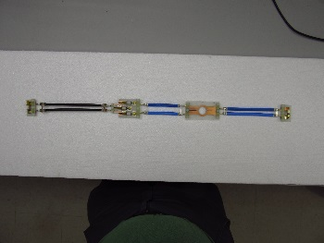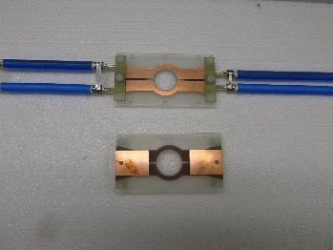

Conclusion
The hybrid notch filter approach has met or exceeded design expectations. It should be possible to isolate the ¹H and ¹³C coils from each other without any serious degradation in performance for either coil. Tests of simultaneous ¹H/¹³C are being configured in the lab at this time. If these tests are successful, the larger volume coil will be fitted with notch filters and put into use for the facility after a brief series of tests. A rapid method for resonator/filter adjustment has been developed. This approach may find wider application at AMRIS. ¹⁹F capability was successfully added to the ¹H resonators.

Acknowledgements AMRIS facility and NHMFL users program

