Selective Wirelessly Adjustable Multiple-Frequency Probe with Automatic Impedance Matching for MR Imaging and Spectroscopy

Bashirullah, R.; Walker T. (UF, Electrical Engineering); Astary, G. (GE Healthcare, Milwaukee, WI) and Mareci, T.H. (UF Biochemistry & Molecular Biology, UF)

Introduction
We developed a high sensitivity multiple-frequency NMR coil system for spectroscopy and imaging measurements, which consists of a selective wirelessly adjustable multiple-frequency probe (SWAMP) with automatic impedance matching (AIM), using inductive-coupling between remote and local NMR resonators that can be used in various applications requiring multiple-frequency operation. This system can be used 1) to monitor tissue function in vivo for a range of nuclei in important biomolecules using remotely implanted coil, and 2) to remotely tune a resonator over a range of frequencies.

Experimental
With previous funding, we designed and built a prototype of the SWAMP and AIM system (1-4) and developed and bench tested a final design and fabricated a fully functioning SWAMP coil with AIM (see Fig. 1, Part A). Here we tested this system in the AMRIS Facility 4.7 T and 11.1 T magnet systems. The SWAMP uses an integrated circuit (IC) implantable microchip fabricated in mainstream complementary-metal-oxide semiconductor (CMOS) technology that incorporates a digitally tunable capacitor array (D-Cap), a clock/data recovery receiver, a microcontroller with register bank and a power management system (not shown).

Results and Discussion
We successfully used the same SWAMP coil and AIM system, with a phantom, to tune and match for H-1 resonance in the 4.7 and 11.1 T magnets (see Fig. 1, Part C), which demonstrates the system capability to tune and match over a broad frequency range.

Conclusions
With this successful result, we have shown that the system is suitable for multiple frequency operation so next we will image with H-1 then measure spectroscopy with C-13, P-31, or F-19 using a suitable phantom, and begin the steps to apply this coil system to animal studies.

Acknowledgements
A portion of this work was performed at the National High Magnetic Field Laboratory, which is supported by National Science Foundation Cooperative Agreement No. DMR-1157490 and the State of Florida. In addition, support for the initial work was provided by the NIH through grant R21 EB009555.

References
[1] Wu, S, et al. Meeting Inter. Soc. for Mag. Res. Med, Stockholm, 1-7 May 2010, #3920.
[2] Beck, BL, et al. Meeting Inter. Soc. for Mag. Res. Med., Montreal, Canada, 7-13 May 2011, #1853.
[3] Turner, WJ, et al. Meeting of the Inter. Soc. for Mag. Res. Med., Montreal, Canada, 7-13 May 2011, #1857.
[4] Turner, WJ, et al. Meeting International Soc. for Mag. Res. Med., Stockholm, Sweden, 1-7 May 2010, #424.
A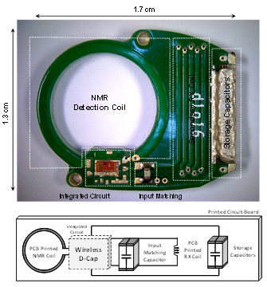 B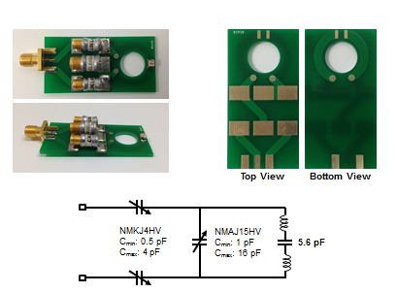 C
200 MHz (4.7 T)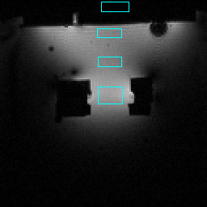
400 MHz (11.1 T)
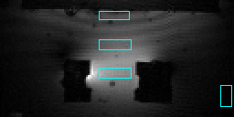

Fig. 1: Part A, SWAMP and AIM system; Part B, transmit receive surface coil; Part C, phantom images.

