**Quench Analysis of Low Resistance Pancake Wound REBCO Coils**

Markiewicz, W.D.; Jaroszynski, J.J.; Abraimov, D.V.; Joyner, R.E. and Khan, A. (NHMFL)

**Introduction**

The introduction of no-insulation (NI) coil windings was a milestone in the development of superconducting magnet technology. Elimination of the turn-to-turn insulation in REBCO pancake wound coils immediately results in the benefit of increased current density in the windings along with improved overall mechanical properties. These advances are critically important for the realization of very high field superconducting magnets. Significant problems also result from the lack of full insulation, including ramping losses and field drift, and these difficulties remain to be completely resolved. A problem area in the application of REBCO conductors has been quench protection, where the high critical temperature of REBCO conductor works against traditional methods of protection. NI technology claims to have solved this problem and the emerging experimental evidence tends to support that claim. For the further development and application of NI coil technology, and the generalization considered here of coils with low resistance (LR) between turns, it is important to understand the mechanism of quench in these coils as the basis for the design of protection systems for future large magnets.

**Analysis**

Quench behavior is calculated for an LR test coil and inner coil of a 30 T magnet. Coil and conductor parameters included are the thickness of copper on the conductor and the possibility of steel co-wind. The resistance between turns is used as a parameter that is varied in the analysis. A coil is subdivided axially and radially into a number of coil sections, with each coil section being modeled as an inductive element in an equivalent circuit with a parallel shunt resistor to model the turn-to-turn resistance and a series variable resistor to model the superconducting to normal transition of the coil section. A quench is initiated by a low critical current coil section and the numerical analysis follows the evolution of the quench throughout the coil.

**Results**

The calculations show in detail how the initial state characterized by heating at the normal zone due to imposed low critical current, and the slow associated spread of the normal zone by thermal diffusion, transforms into a dynamic inductive process of rapid self-propagating quench. The sudden quench of initial coil sections by thermal runaway results in large current transients in adjacent coil sections by inductive coupling which then quench in turn. The large transient currents are precisely allowed in LR coils by the low resistance between turns. The analysis shows a range of turn resistance over which rapid quench occurs extending up to 1x10-6 Ω-m2 and higher. The quench propagation velocity is found to increase as the amount of copper on the conductor is decreased and a coil remains protected at very high copper current density.

**Conclusions**

Quench occurs rapidly in LR coils with sufficiently low turn resistance. During the quench, there is a significant redistribution of circumferential and radial currents in the coil that will result in forces within and between coils in a magnet. ‘These forces need further close examination.

**References**

Markiewicz, W.D., et al. Supercond. Sci. Technol. In publication

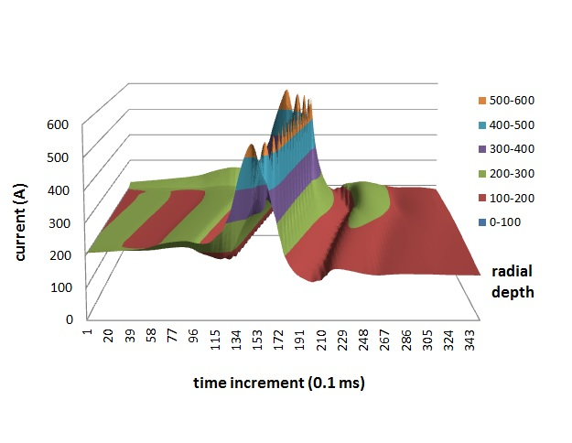



**Fig.2** Transient quench current along coil at selected time intervals during quench.

**Fig.1** Transient induced quench current in time at a given location in the coil.