Ceramic Insulation of Bi-2212 Round Wire for High-Field Magnet Applications

Lu, J.; McGuire, D.; Kandel, H.; Xin, Y.; Chen, P.; Jiang, J.; Trociewitz, U.; Hellstrom, E. and Larbalestier, D. (FSU/NHMFL)

Introduction
Among technologies necessary for Bi-2212 application in magnets, development of insulation technology is critically important and particularly challenging because, in the wind-and-react process, the insulation has to be applied before heat treatment and it must maintain its integrity during heat treatment up to 890 °C in 1 bar oxygen. Compared with the conventional insulation, ceramic coating insulation is preferred due to its achievable thin thickness [1]. In this work, we developed a ceramic dip-coating slurry as the coating application method and built a facility to coat several hundred meter lengths. We faced significant technical challenges but overcame them.

Experimental and Results
The ceramic dip coating consists of TiO₂ nano-powder, polymer binders and other additives. It is applied by machine (Fig. 1) with a controlled, uniform thickness between 10 and 30 μm (Fig. 2). The coating is strongly bonded to the wire and reasonably flexible in the as-applied (green) state, so magnet coils can be wound without cracks or spalling. The Bi-2212 heat treatment allows the coating to sinter which provides reliable ceramic insulation (Fig. 3). A few lengths of Bi-2212 wire including one over 750 m were insulated for our Bi-2212 high-field magnet development program.
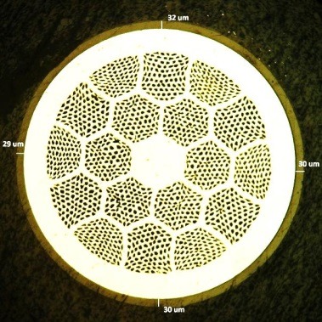
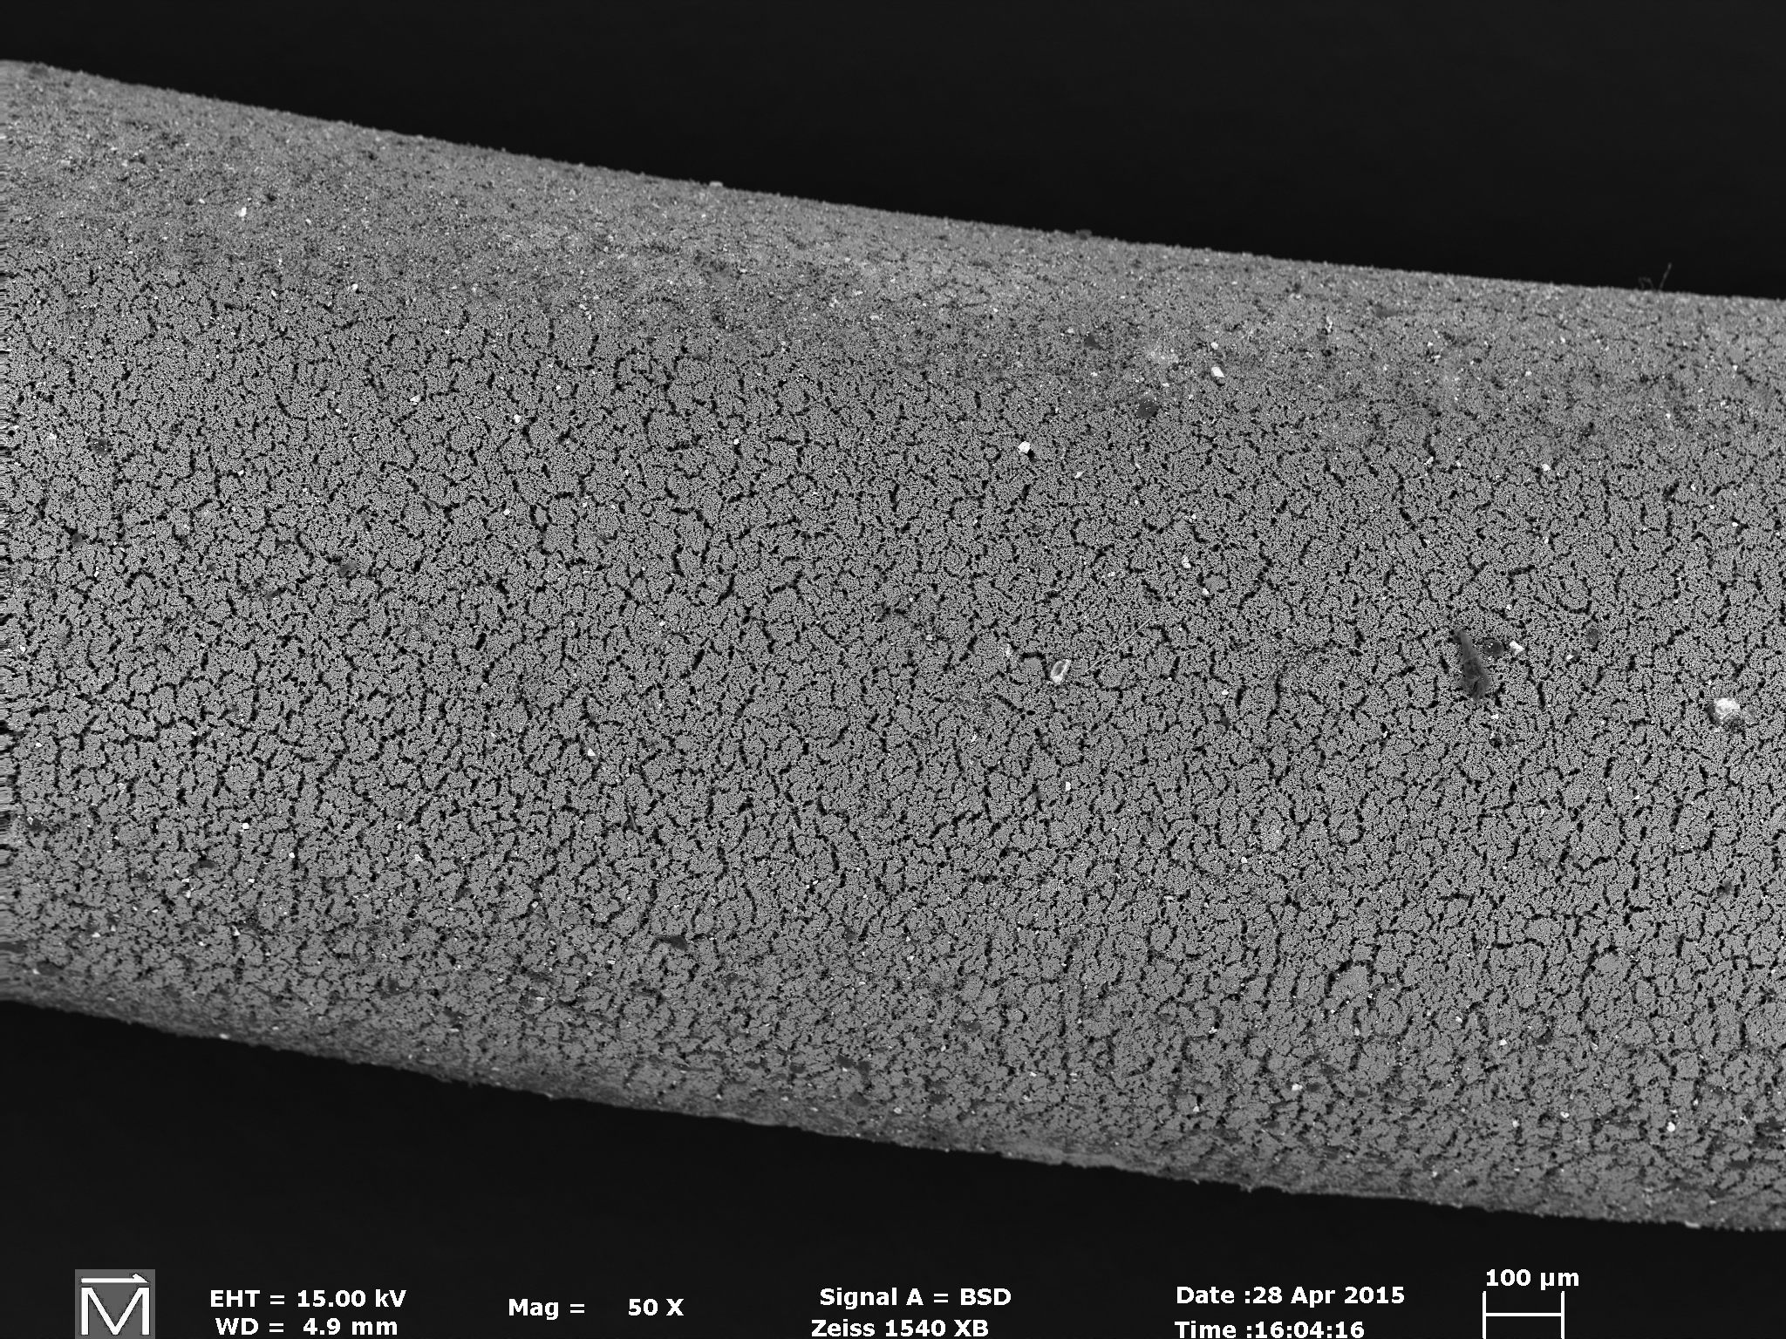
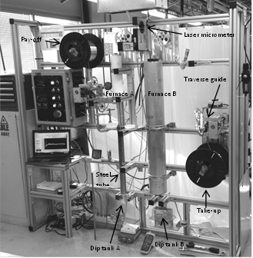
200 μm
200 μm

Fig. 3 Insulated wire surface after heat treatment. The small cracks help oxygen permeation during heat treatment which is beneficial to wire properties.
Fig. 1 Ceramic insulation dip-coating system developed in this work
Fig. 2 Insulated green wire cross-section

Discussion
We observed that freshly coated wires are significantly more flexible than those stored for a week or two, which tend to age and to crack. We do not yet understand this aging effect. After heat treatment, a wire with 25 - 30 μm green coating densifies to 15 - 20 μm coating with a typical breakdown voltage of 300 - 400 V. This is consistent with our previous results [1], and sufficient for a magnet coil turn-to-turn insulation. However, there is some evidence that insulation integrity can be compromised after a heat treatment during which wires are under large contact pressure. This issue is still under investigation.

Conclusions
We developed a ceramic formulation suitable for dip coating insulation of Bi-2212 round wire. Over 1.5 km of Bi-2212 wires have been insulated using this technique.

Acknowledgements
This work was performed at the National High Magnetic Field Laboratory, which is supported by National Science Foundation Cooperative Agreement No. DMR-1157490, and the State of Florida.

References
[1] H. Kandel, et al., Supercond. Sci. Technol. 28, 035010, (2015).
[2] J. Lu, et al., Oral presentation, MT-24 conference, Seoul, Korea, Sept. 2015.

