Structural Integrity of the NHMFL Series Connected Hybrid Magnet Cryostats

Li, T.; Bole, S.; Toth, J. and Bird, M.D. (NHMFL)

Introduction
The National High Magnetic Field Laboratory (NHMFL) has designed and built cryostats for two Series Connected Hybrids (SCH) magnets [1-2]. The first one is for the Helmholtz Zentrum Berlin (HZB). Its cryostat is designed to support an up to 8 MW resistive insert inside a water cooled housing which has a conical warm bore with a 30 degree opening angle and a 5 tons superconducting outsert coil which is housed in a vacuum vessel. Normal operation includes 28 bar of water pressure and 52 kN side load between the resistive insert coils and the superconducting outsert coils due to a potential 3 mm coil misalignment. Under fault condition the resistive coils can generate axial loads up to 1.1 MN. The second cryostat for the Florida State University (FSU) SCH houses the same superconducting outsert but its resistive insert is a high-homogeneity solenoid. The system is designed to support a high field 14 MW insert, operated at 30 bar water pressure, up to 42 kN side load and 2.6 MN fault forces. In this report, the final designs for critical components in both cryostat inserts are presented along with the analysis procedure. Some analysis results of the HZB cryostat are compared with the field test measurements.

Results and Discussion
Table 1. Design parameters for the SCH cryostat insert
Parameters | NHMFL | HZB
Water pressure | 30 bar | 28 bar
Side load between the insert and the ousert | 42 kN | 52 kN
Maximum fault load (after upgrade) | 2.6 MN | 1.1 MN
Maximum system axial deflection in normal operation | 1 mm | 1 mm
Maximum system axial deflection in fault | 2 mm | 2 mm
Safety factor on the fasteners | 3 | 3
Max water velocity general water flow path | 3 m/s | 3 m/s
Max current density on conductor body | 20 A/mm² | 20 A/mm²
Max current density on contact surfaces | 10 A/mm² | 10 A/mm²

The design parameters for both SCH magnet cryostat inserts are listed in Table 1 which have considered the future upgrade. And the design criteria for the mechanical stresses of structural components in the load path of the insert are in compliance with the ASME B&PVC Sec. VIII, Div. 2.
In 2014, the NHMFL completely finalized the cryostat insert design with several enhancements on the structure. For example, 34 Inconel 718 bolts are added on each side of the housing to reduce the total deflection of structure during normal operation and magnet fault. The cryostat has been successfully tested at the HZB.
The SCH-NHMFL cryostat insert, shown in Fig. 1, is designed to let users have the nearest access to the magnetic field center. Therefore, both the cooling water and the electric current are designed to enter and exit the resistive insert at the bottom of the magnet leaving the top space of the magnet to users. The cryostat insert consists four major components, i.e. the Insert Top Cover (ITC), the Double Walled Bore Tube (DWBT), the Center Tube (CT), and the Hydrant which form both the pressure vessel for the cooling water and the load path for the insert loads transferring to the main structure. All components are analyzed with the FEM to guarantee the structural integrity from plastic collapse, local failure [3], compressive bucking and incremental damage. After each part is fabricated, a hydro test is conducted by over pressing the component comparing with the design pressure to check the leakage and strain hardening local stress risers.
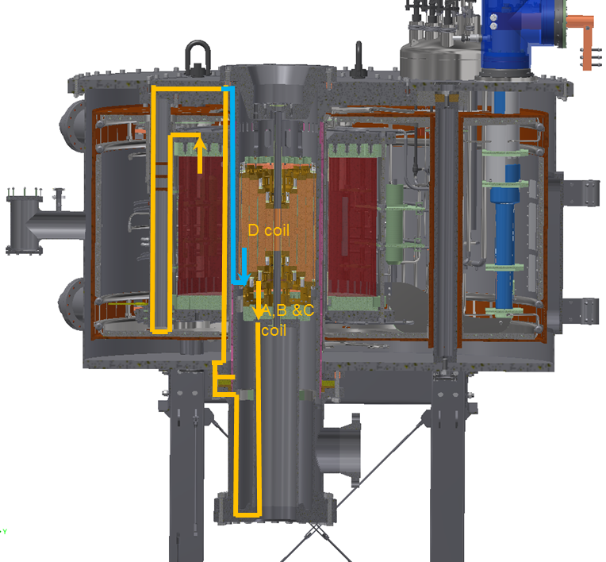

Fig. 1. The SCH-NHMFL magnet system

Conclusions
The National High Magnetic Field Laboratory (NHMFL) has successfully designed and built cryostats for two Series Connected Hybrids (SCH) magnets. The one at the HZB has been tested and charged in service. The one at the NHMFL has been successfully proof tested and will be in service at the first quarter, 2016.

Acknowledgements
This work was supported in part by the German government (Ministry for Education and Research), the National Science Foundation (award DMR-0603042) and the State of Florida.

References
- M. D. Bird, et al, IEEE Trans. Appl. Supercond., V. 19, pp. 1612, (2009).
- P. Smeibidl et al, J Low Temp Phys, V. 159, pp. 402 (2010)
- J. W. Hancock, A. C. Mackenzie, J. Mech. Phys. Solids, V. 24, pp. 147 (1976).

