Full Comprehensive Analysis of Quench Events in the
NHMFL 32T All-Superconducting Magnet during Operation

Gavrilin, A.V.; Hilton, D.K.; Johnson, Z.L.; Noyes, P.D.; Markiewicz, W.D. and Weijers, H.W. (NHMFL)

Introduction
The development of a 32 T, 32 mm cold bore all-superconducting magnet system with high temperature superconducting (HTS) REBCO inner high field coils (insert) and a low-temperature superconducting (LTS) outer multi-section magnet (outsert) is about finished at the NHMFL (Fig. 1); the insert is built and the magnet assembly will be completed soon. Using our in-house developed quench code, we conducted first full-scale analyses of possible topologically complex quench events in the entire magnet system during its operation with the goal of virtually checking the magnet quench protection system “adroitness” and effectiveness.
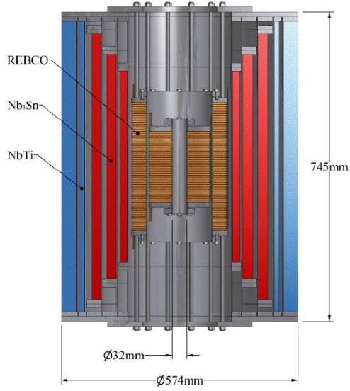
Fig. 1. Cross-section of the 32T magnet with the LTS outsert (schematic) built by Oxford Instruments, Ltd. and the HTS insert REBCO coils.
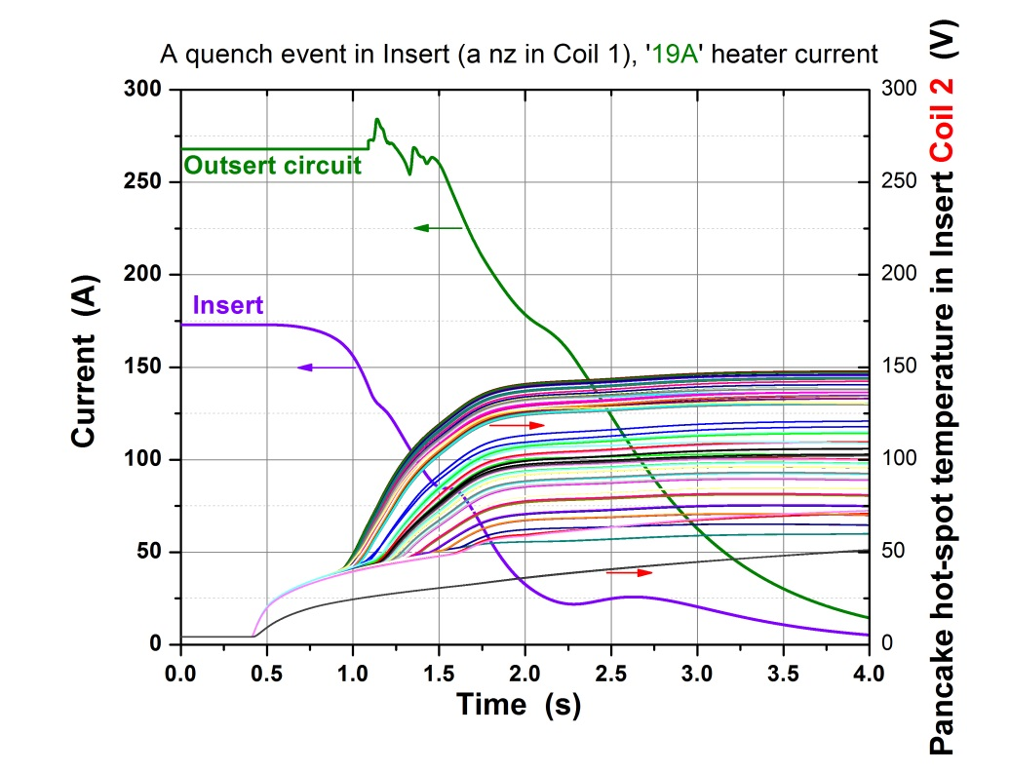
Fig. 2. Insert & outsert currents and hot-spot temperatures of the insert outer coil pancakes during a protected quench. Example.

The quench code input and analysis results
The quench code, which was verified on the prototype coils through comparison of the experimental data obtained during numerous quench tests and the pertinent simulation results [1,2], is supposed to take into account the actual layout and discrete structure of the REBCO coil windings with due regard for the magnetic field (magnitude and angle) and temperature-dependent critical current and other properties of the REBCO tapes supplied by SuperPower, Inc. and used to wind the insert coils. The measurement-based practical fit functions to describe the critical-current dependencies were developed at the NHMFL [3] and presently they are presumably the most scientifically justified approach on this subject. All elements of the active and passive parts of the quench protection systems of the insert and outsert are included in full. Several scenarios of protected quench were viewed, including those when the insert quenches first and when the outsert does. In both cases the protection systems look reliable despite their complexity and the magnet is safe (Fig. 2). The simulations enabled us to make important adjustments. Particularly, the power in the insert quench protection heaters was optimized. Likely, the simulations of such complexity and completeness are the first ever ones for a large HTS & LTS combined contemporary magnet system.

Acknowledgement
This work is supported by the U.S. National Science Foundation under Grants # DMR-0654118, DMR-1157490, DMR-0923070 and the State of Florida.

Reference
[1] Gavrilin, A.V., et al., presented at the 3rd Workshop on Accelerator Magnet in HTS, Lyon, France, Sept. 2015.
[2] Gavrilin, A.V., et al., presented at CHATS AS, Bologna, Italy, Sept. 2015.
[3] Hilton, D.K., Gavrilin, A.V., Trociewitz, U.P., Superconductor Science and Technology, 28, 7, 074002 (2015).

