32 T Prototype Testing: Quench Behavior and Magnetic Field Record

Weijers, H.W.; Markiewicz, W.D.; Gavrilin, A.V.; Voran, A.J.; Viouchkov, Y.L.; Gundlach, S.R.; Noyes, P.D.; Abraimov, D.V.; Hannahs, S.T. and Murphy, T.P. (NHMFL)
_____________________________________________________________________________________________________________________________________________________________________________________
Introduction
The 32 T superconducting magnet is envisioned as a 15 T Low Temperature Superconductor (LTS) magnet combined with a pair of separately powered REBCO High Temperature Superconductor (HTS) insert coils generating 17 T. Quench protection is provided by active quench heaters [1]. Prototype coils, very similar in design to the 32 T REBCO coils but of reduced height [2], have been tested again, this time in the 15 T background magnetic field of the final 32 T LTS magnet that is now available.

Experiments, results, and discussion
The test protocol emphasized two areas: 1) observation of the interaction between the HTS and LTS coils during deliberate quenches, and 2) performance of the HTS prototypes at high stress-strain levels.
A deliberate quench at 24 T, with the LTS outsert at 15 T while the HTS coils generate 9 T, illustrated that the quench detection and protection in both HTS and LTS coils was effective in preserving the coils, with the HTS current reduced to 1/e of its initial value of 200 A in about 1 second. Numerical quench analysis gives a similar result. Quenches at lower LTS fields show that the current decay in the REBCO coils is nearly independent of background field, but does depend on HTS coil current and quench heater power.
Peak stress levels equivalent to 32 T design-conditions were reached over a dozen times in the smaller of the two prototype coils, while the larger prototype coil was operated forty-four times to between 105 and 115% of design hoop-stress. A central magnetic field of 25 T was reached a dozen times, at rates of 1 A/sec in the prototype coils (normal operation will be 0.06 A/s). The prototypes were then slowly operated to 243 A (see Fig. 1) and two days later (see Fig. 2) to 264 A in the 15 T LTS magnet, generating central magnetic fields of 26 and 27 T respectively. The latter is the highest magnetic field generated by a superconducting magnet to date. At 27 T, the prototypes operated at 121% and 135% of 32 T design stress. None of the above experiments caused observable degradation of the coil properties. However, the combination of very high ramp rates (~2 A/sec) at currents above 200 A will reduce temperature margins in the prototypes to levels where the quench protection is no longer effective.

Conclusions
Two prototype coils for the 32 T superconducting magnet were extensively tested, being subjected to deliberate quenches at high magnetic field and operated repeatedly at and above 32 T design equivalent stress levels. The generation of record magnetic field values and absence of observable degradation in the prototype coils give confidence in the 32 T design.

Acknowledgements
This work was performed at the National High Magnetic Field Laboratory, supported in part by the U.S. National Science Foundation Grants No. DMR-0654118, DMR-1157490, DMR-0923070 and the State of Florida.

References
[1] Markiewicz, W.D., et al., IEEE Trans. Appl. Supercond., 22, 4300707 (2012)
[2] Weijers, H.W., et al., IEEE Transactions on Applied Superconductivity, 24-3 4301805 (2015)
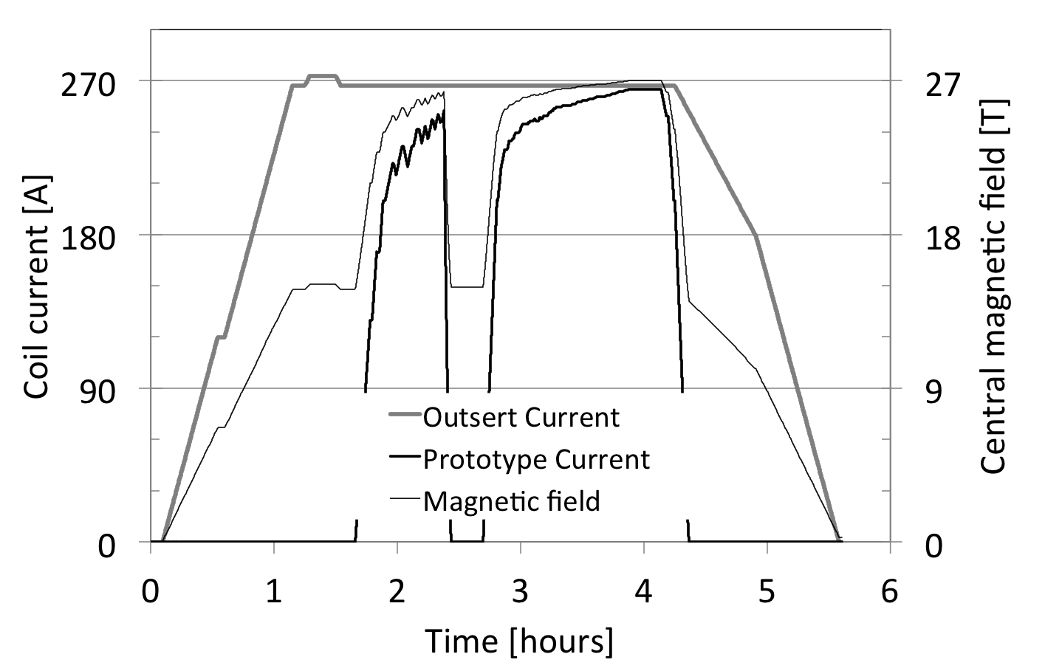
Fig. 2 Measured central magnetic field and current in the outsert and the prototype coils on June 5th, 2015. A stable peak field of 27.0 T was held for 16 minutes.
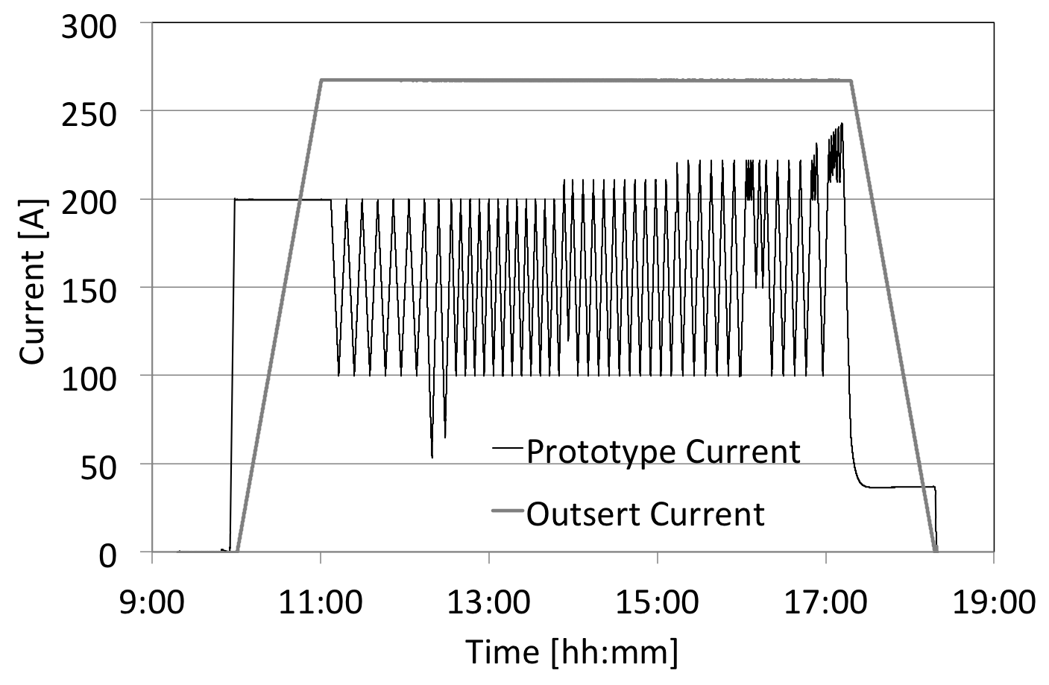
Fig. 1 History of the prototype current and Outsert current during one day of load cycling. At 268 A the Outsert generates 15.0 T, and at 243 A the prototypes generate 11 T at hoop stress levels above 32 T design values.

