**Dependence of Quench Degradation Limit on Axial Stress up to 160 MPa for High Performance Bi-2212 wires up to 30 T**

Ye, L. (Fermilab; NCSU); Li, P. (Fermilab); Jaroszynski, J. (NHMFL); Schwartz, J. (NCSU) and Shen, T. (Fermilab)

**Introduction**

To explore design and limit of Bi-2212 high field magnet technology, we determine the influence of stress and strain on the maximum allowable temperature limit during a quench for the state-of-the-art commercial Bi-2212 strand in magnetic fields up to 30 T in cell 7.

**Experimental Details**

High performance commercial multifilamentary Ag/Bi-2212 round wires (Fig. 1 inset) were heat treated using an overpressure processing at Fermilab to obtain high critical current density. Strands were measured at Fermilab in magnetic fields up to 15 T and then at NHMFL from 15 T to 30 T (Fig. 1). The critical axial stress at which the critical current density degrades irreversibly was determined to be 155 MPa, by using hoop stress generated on the spiral of the ITER barrel through applying unsupported Lorentz force to the conductor (Fig. 2). Quench induced critical current density degradation was then determined at various stress levels up to 135 MPa using a series of voltage taps and thermocouples. An epoxy quench initiation heater was used to minimize the damage to the conductor during handling and was a key factor that such measurement is feasible.

**Results and Discussion**

Samples were measured to carry *J*E of 515 A/mm2 at 4.2 K and 20 T (Fig. 1) and had a critical axial stress of ~150 MPa. Fig. 3 plots the *Ic* after quenching normalized by the initial *Ic*as a function of local peak temperature *Tmax* during the quench for a Bi-2212 barrel tested at 4.2 K, 15 T, for three axial stress levels (0 MPa, 113 MPa, and 135 MPa). It clearly shows that applying a tensile stress decreases the maximum allowable temperature during a quench. Without electromagnetic stress, samples show irreversible degradation when *T*max exceeds 450-500 K whereas the limit drops to 246 – 286 K when an axial stress of 113 MPa was applied. Fig. 4 summarizes results of measurement at other magnetic fields and stress levels. All data fall into a curve that shows a consistent behavior. The dependence of quench degradation limit on axial stress is highly nonlinear.



**Fig.1** (upper left) Engineering critical current density *J*E of 1 m long Bi-2212 strands at 4.2 K and up to 31 T.

**Fig. 2** (upper right) Dependence of *J*E and n-value of Bi-2212 strands on axial stress at 4.2 K.

**Fig. 3** (bottom left) Critical current *Ic* after quenching normalized by the initial *Ic* versus local peak temperature during the quench at 4.2 K and 15 T for three axial stress levels (0, 113, and 135 MPa).

**Fig. 4** (bottom right) Dependence of maximum allowable temperature during a quench on axial stress for Bi-2212 strands up to 30 T.

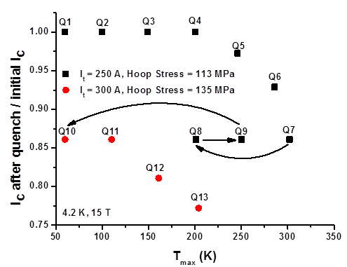 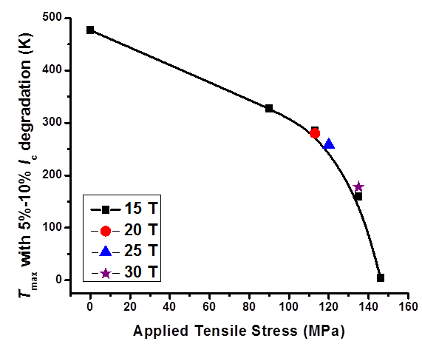

**Acknowledgements**

Work is supported by U.S. DOE-OHEP through a DOE Early Career Award to TS, with the high field (>15 T) measurements performed at NHMFL, which is supported by NSF through DMR-1157490 and the State of Florida.