Anomalous Spin Dynamics of the Coupled Spin-Tetramer Compound CuSeO₃

Lee, S.; Lee, W.-J.; Choi, K.-Y. (Chung-Ang U., Korea, Physics); van Tol, J.; Ozarowski, A. (NHMFL) and
Berger, H. (École Polytechnique Fédérale de Lausanne, Switzerland, ICMP)

Introduction
Coupled spin-tetrahedral systems continue to receive a high level of interest as they host localized and collective magnetism in a single compound. The former is related to an isolated spin tetrahedron while the latter intercluster interactions control a collective magnetic behavior [1]. The particularly prominent example is the linear spin tetramer compound CuSeO₃ [2]. CuSeO₃ has two inequivalent intratetramer interactions, J₁ and J₂ and exhibits antiferromagnetic (AFM) long-range order below T_{N} = 8 K. X-band electron spin resonance (ESR) and torque magnetometry studies [3] showed a rotation of the magnetic principal axis above 50 K and a strong temperature dependence of the effective g-factor along specific crystallographic directions. However, little is known about spin dynamics through T_{N.}

Experimental
High-frequency ESR experiments were performed at 240 GHz using a home-built superheterodyne spectrometer equipped with a sweepable 12.5 T superconducting magnet at the EMR Facility.

Results and Discussion

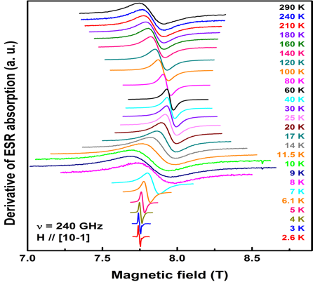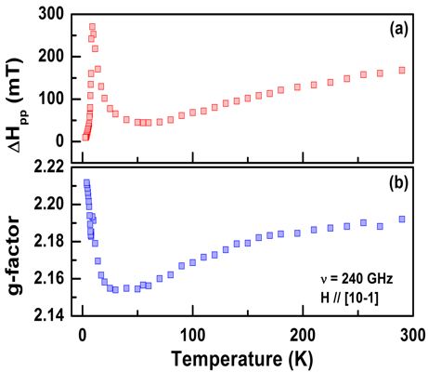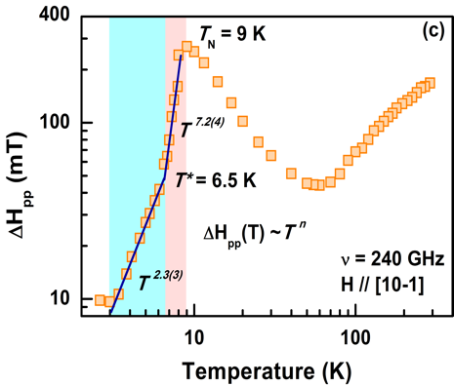

Fig. 1 (Left panel) Temperature dependence of ESR spectra at 240 GHz. (Middle panel) Temperature dependence of peak-to-peak linewidth, ∆H_{pp} and g-factor. (Right panel) Temperature dependence of ∆H_{pp} plotted on a log-log scale. T* denotes the magnetic anomaly.

In Fig. 1 we present the temperature dependence of the ESR spectra and their parameters. With decreasing temperature both the ESR linewidth ΔH_{pp} and g-factor decrease monotonically down to 50 K, and then show the respective critical broadening and upturn at T_{N} = 9 K. For temperatures below T_{N}, a sharp antiferromagnetic resonance (AFMR) mode is observed. As shown in the right panel of Fig. 1, the AFMR linewidth changes its power-law behavior ΔH_{pp} ∝T^{n} from n = 7.2(4) to 2.3(3) around T* = 6.5 K. The determined exponents deviate from n = 4 expected for a classical antiferromagnet, signifying persisting quantum fluctuations. The varying exponent through T* suggests the presence of magnetic anomaly in the magnetic ordered state. Possibly, this is linked to the rearrangement of an ordered moment, which should be confirmed by future neutron experiments.

Conclusions
ESR measurements of CuSeO₃ unveil a magnetic anomaly at T* = 6.5 K. This is tentatively ascribed to a spin reordering and highlights a role of intertetramer interactions which control low-energy and -temperature magnetic properties.

References
[1] Furrer, A., et al., Rev. Mod. Phys., 85, 367 (2013).
[2] Zivkovic, I., et al., Phys. Rev., B 86, 054405 (2012).
[3] Herak, M., et al., Phys. Rev., B 89, 184411 (2014).

