Probing Molecular Magnetism by Infrared & Raman Spectroscopies in Magnetic Fields

Moseley, D.H. (U. Tenn., Chemistry); Thirunavukkuarasu, K.; Ludwig, J.; Smirnov, D. (NHMFL); Stavretis, S.E.; Xue, Z.L. (U. Tenn., Chemistry); Chen, L.; Fei, F. and Chen, X.-T. (Nanjing U., Chemistry)

Introduction
Far-IR and Raman spectroscopies, under variable magnetic fields, are direct methods to determine separations between magnetic ground and excited states in single molecular magnets (SMMs). The determination will help measure magnetic anisotropy barriers and relaxations in SMMs. In SMMs, magnetic peaks often overlap with phonon/vibrational peaks. Far-IR and Raman inside magnetic fields will show that magnetic peaks change, including shifting the positions, or degenerate magnetic levels will split, while phonon/vibrational peaks do not expect to show such changes.
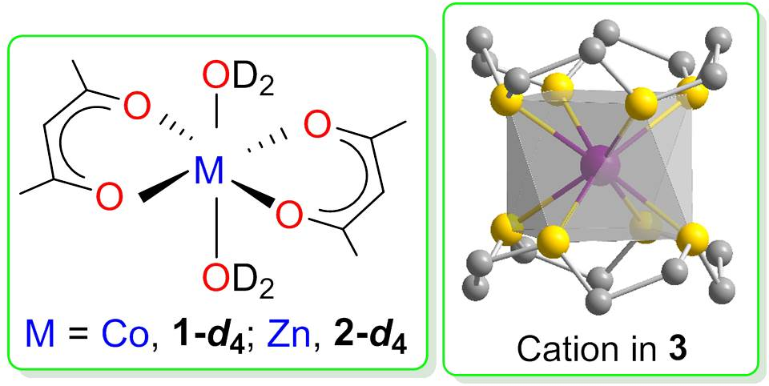
Gómez-Coca et al. reported in 2014 [1] that Co(acac)₂(H₂O)₂ (1, acac = actylacetonate), as a representative compound with the axial zero-field splitting (ZFS) parameter D > 0, shows slow magnetic relaxation as a result of time-reversal symmetry that hinders direct spin-phonon processes. Susceptibility studies gave the magnetic separation of 2D ≈ 114 cm⁻¹. We reported in 2014 [2] that [Co(12-crown-4)₂](I₃)₂ (3) showed a large axial ZFS with a slow magnetic relaxation. Magnetic susceptibility measurements gave 2D = −75.2 cm⁻¹, rhombic ZFS parameter E = 0.1 cm⁻¹. 1 and 3 are attractive as they provide a comparison of two Co(II) compounds with D > 0 and D < 0, respectively.

Experimental
The far-IR spectra of Co(acac)₂(D₂O)₂ (1-d₄; acac = actylacetonate), its non-magnetic analog Zn(acac)₂(D₂O)₂ (2-d₄), and [Co(12-crown-4)₂](I₃)₂ (3) were measured at 5 K and magnetic fields up to 16 T using a Bruker Vertex80v FTIR spectrometer. Samples had been prepared by procedures similar to those in the literature [1-3], except that D₂O rather than H₂O was used in the preparation of 1-d₄ and 2-d₄. The samples had been characterized by power X-ray diffraction before the far-IR studies.

Results and Discussion
Preliminary far-IR spectra of 1-d₄ and 2-d₄, e.g., are given in Fig. 1. A peak at 114 cm⁻¹ in the spectra of 1-d₄ (Fig. 1-Left) is not observed in the spectra of its nonmagnetic Zn(II) analog 2-d₄ (Fig. 1-Right), suggesting that this peak is magnetic. Since it overlaps with a phonon/vibrational peak at 122 cm⁻¹, the feature in Fig. 1-Left may be the result of the magnetoelastic coupling. We plan to confirm these results. Far-IR spectra of 3 did not clearly reveal the magnetic peak expected around 75.2 cm⁻¹ [2] or magnetoelastic couplings. We, however, may need to obtain the far-IR spectra of its nonmagnetic Zn(II) analog [Zn(12-crown-4)₂](I₃)₂ (4) to confirm the results.

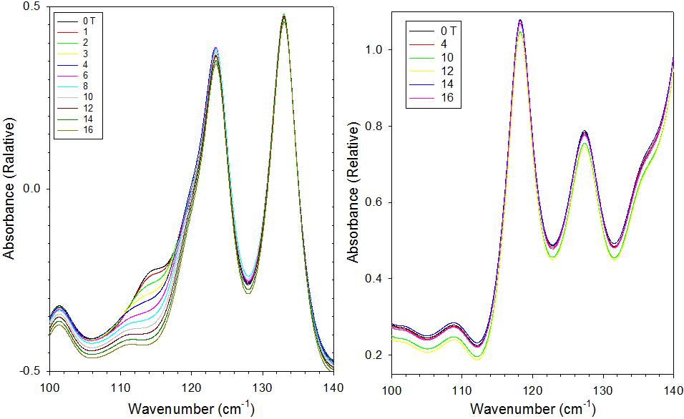
Acknowledgements
A portion of this work was performed at the National High Magnetic Field Laboratory, which is supported by National Science Foundation (NSF) Cooperative Agreement No. DMR-1157490 and the State of Florida. Other parts of the work were conducted at the University of Tennessee, Knoxville with support from NSF (CHE-1362548) or Nanjing University with support from the National Basic Research Program of China (No. 2013CB922102).

References
[1] Gómez-Coca, S. et al., Nature Communications Article No. 4300 (2014).
Fig.1 Far-IR magneto-absorption spectra of 1-d₄ (Left) and 2-d₄ (Right) measured at 5 K and at selected magnetic fields between 0 and 16 T.
[2] Chen, L. et al., Journal of the American Chemical Society, 136, 12213-12216 (2014).
[3] Harbach, P. Acta Crystallographica, E59, m724-m725 (2003).

