Magnetic and Electric Properties of FeTa₂O₆

Lee, M. (FSU Physics, NHMFL); Kweon, J.J. (NHMFL); Choi, E.S. (NHMFL) and Zhou, H.D. (NHMFL, Univ. Of Tennessee)

Introduction
FeTa₂O₆ called tapiolite, named after the god Tapio of Finnish mythology, is one example of low dimensional magnet naturally occurring mineral in nature. Fe²⁺ (S = 2) forms a magnetic layer separated by a nonmagnetic layer formed by the Ta⁵⁺. Its magnetic properties have been investigated in great detail in Ref. [1]. Therein, the heat capacity and the dc magnetic susceptibility indicate a short range ordering due to the low dimensionality around 20 K, and a long-range ordering at T_{N} = 8.07 K. With the magnetic field aligned along <110> direction, the magnetization curve shows the spin-flop transition around 6 T. The spin-flop phase transition is of particular interest because it may induce the change in electric properties via the magnetoelectric effect.

Experimental
A single crystal with large surface perpendicular to <110> direction was grown and polished into plate-like shape to measure the dielectric constant. Silver epoxy was painted on the two large surfaces for the electrical contacts. A commercial capacitance bridge AH 2700A was used to measure the dielectric constant. The high field magnetization was also measured using the high-field VSM up to 35 T at National High Magnetic Field Laboratory in Tallahassee.

Results and Discussion
Fig. 1 (a) shows the field dependence of dielectric constant of FeTa₂O₆ at different temperatures. Below 8 K, the slope starts to change around 6 T, which becomes more prominent at lower temperatures. The temperature dependent dielectric constant begins to increases sharply around 6 K upon cooling above 3 T (Fig. 1 (b)). These dielectric features provide strong evidence that the dielectric anomalies are driven by the spin-flop phase transition observed in magnetization measurement in Ref. [1], and the VSM measurement as shown in Fig. 2. Our high field magnetization data are similar to the previous report at low field region (below 9 T) [1], but starts to deviate at higher fields with slower increase resulting in higher saturation field and smaller saturation moment of 4µ_{B}/Fe²⁺, which, then, calls for revision of previous magnetic parameters based on the low field experiment.
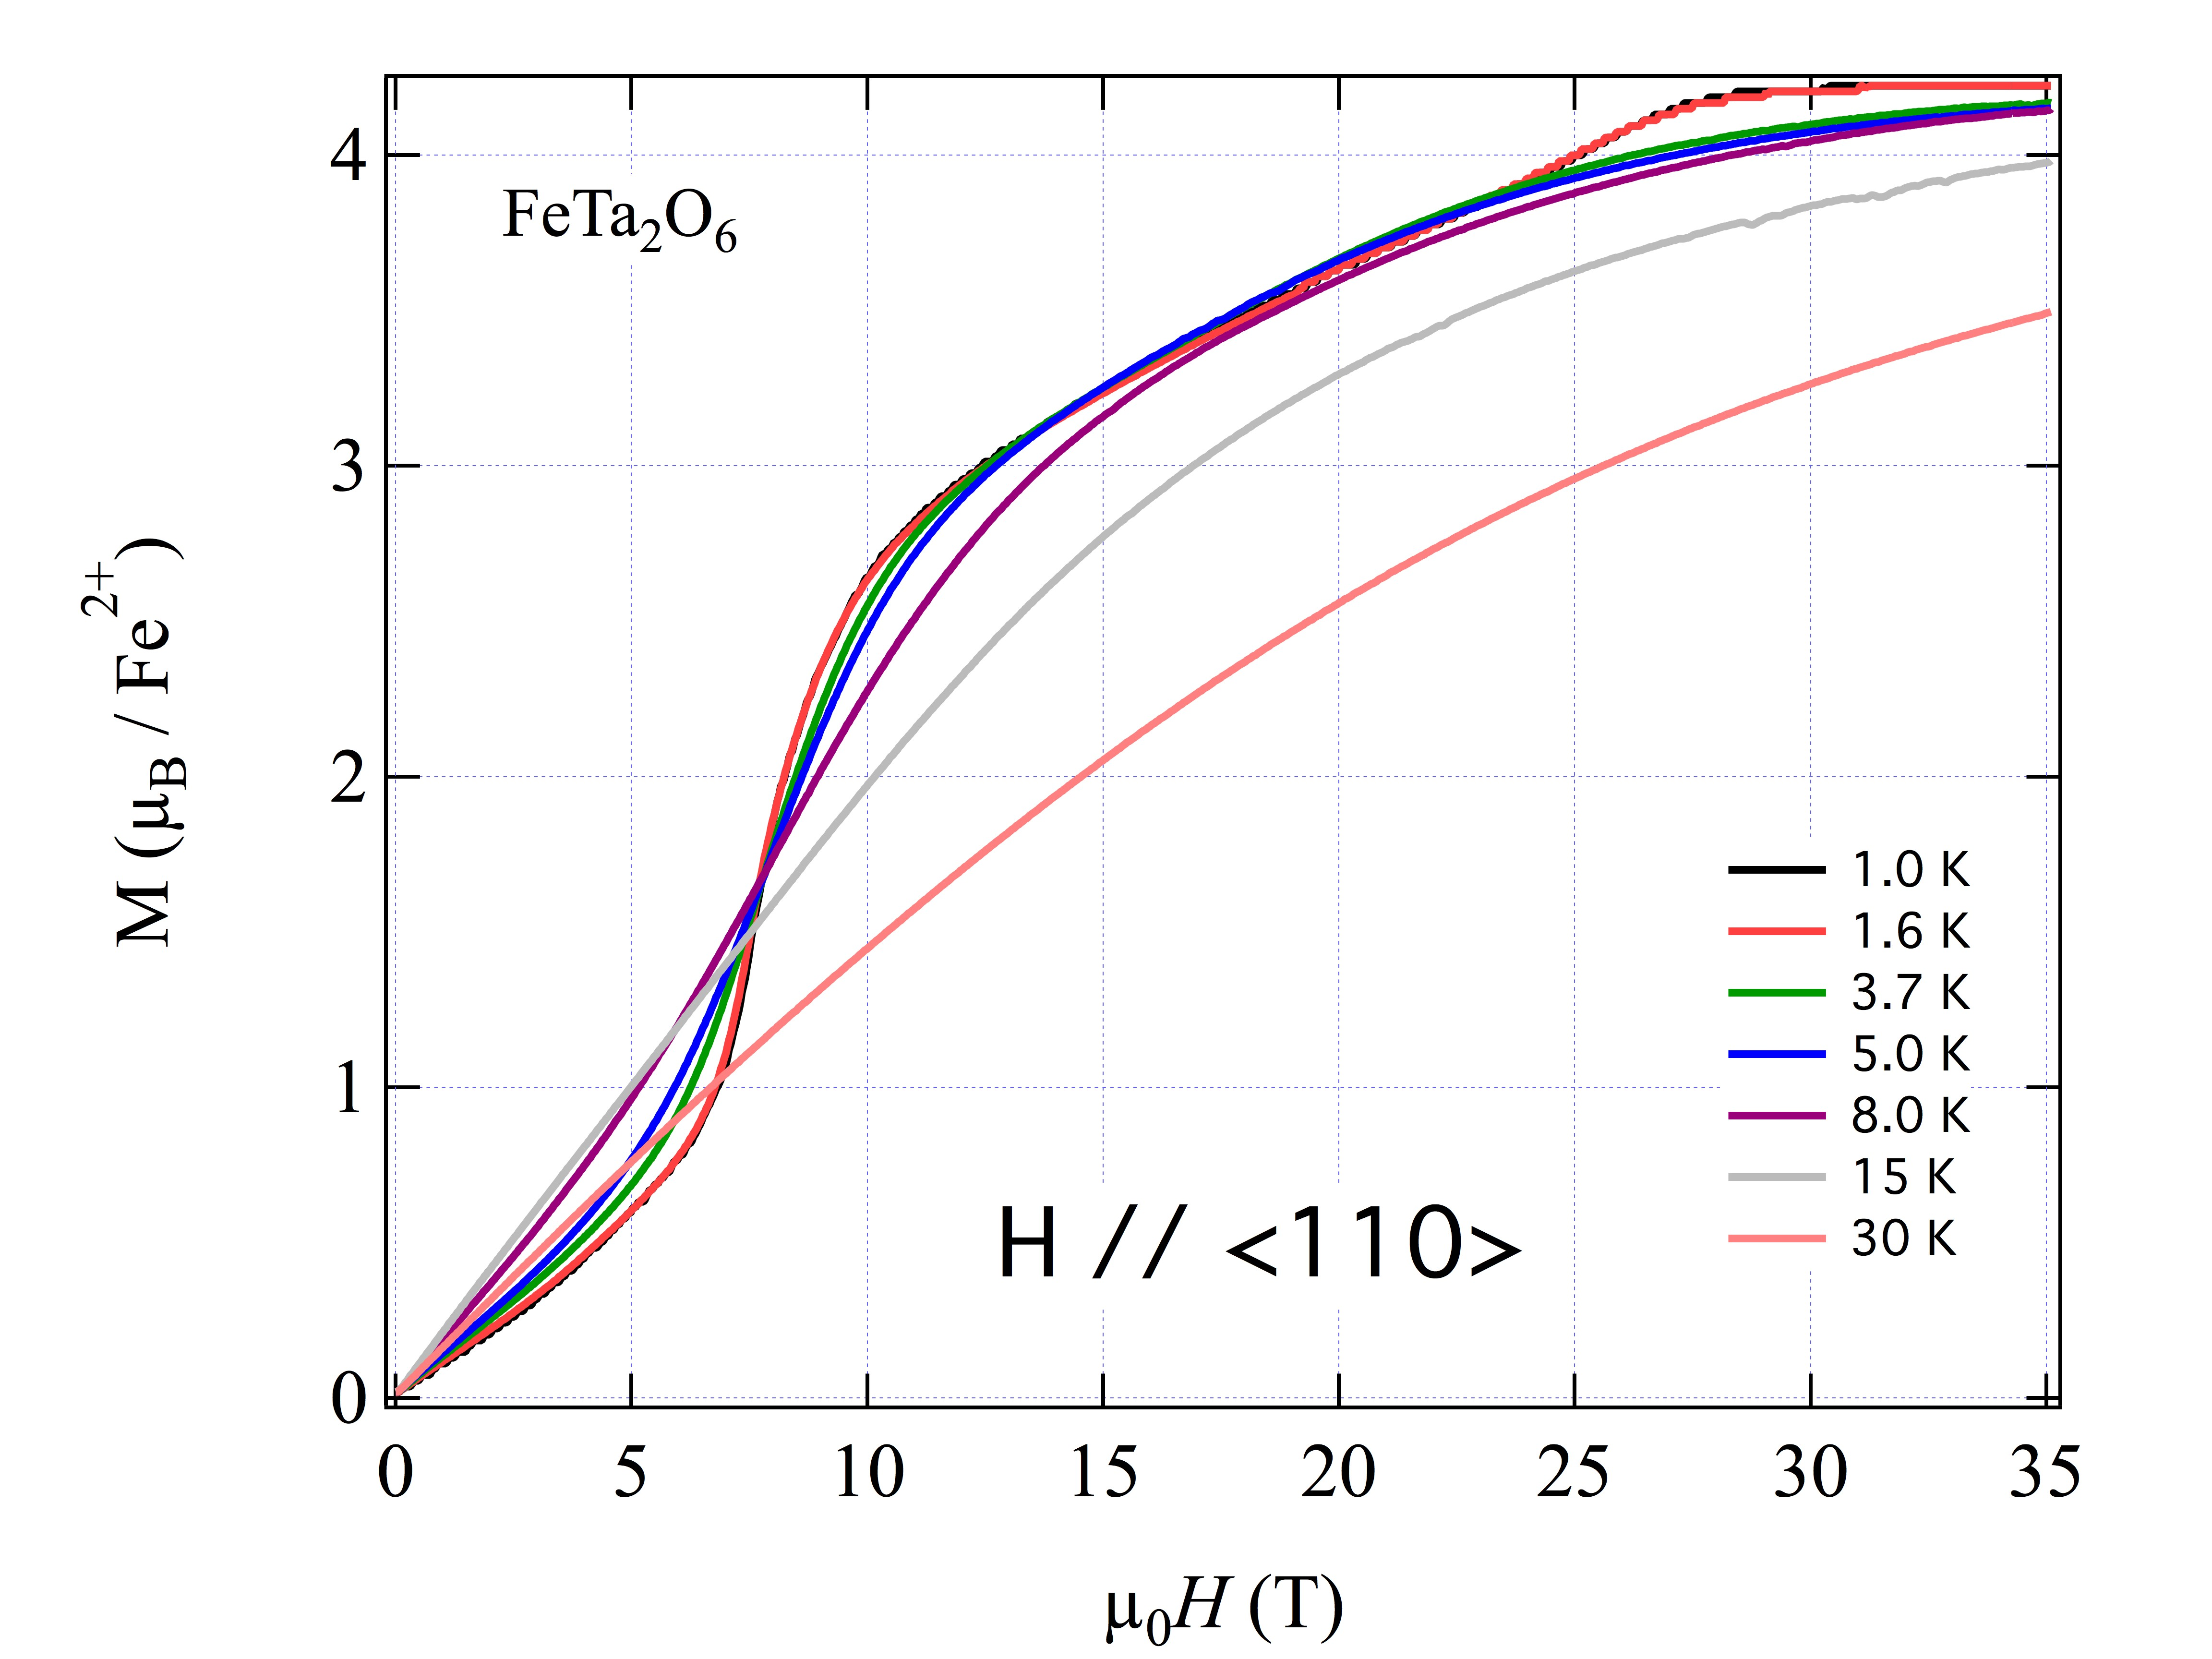
Figure 2 Magnetization Curve up to 35 T at various temperatures

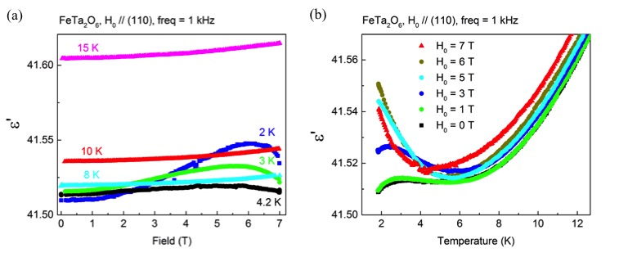
Figure 1 (a) Field dependence of dielectric constant of FeTa₂O₆ at different temperatures. (b) Temperature dependence of dielectric constant at various temperatures.

Conclusions
We have observed dielectric anomalies in the spin-flop phase of FeTa₂O₆, which suggests that FeTa₂O₆ is a quasi two-dimensional magnetoelectric material. High field VSM up to 35 T measurement allowed us to obtain the entire magnetization curve up to saturation, which can be used to estimate more precise parameters to be used in the spin-Hamiltonian.

Acknowledgements
The NHMFL is supported by National Science Foundation Cooperative Agreement No. DMR-1157490 and the State of Florida. We also acknowledge the support of NSF-DMR 1309146.

References
[1] E. M. L. Chung, et al., J. Phys.: Condens. Matter 16, 7837 (2004).

