¹³³Cs NMR Study of Two Transitions in the Triangular Lattice
Antiferromagnetic CsV(MoO₄)₂

Kweon, J.J. (NHMFL); Wilson, D.M. (NHMFL, FSU); Kuhns, P.L. (NHMFL); Lee, M. (NHMFL, FSU); Choi, E. S. (NHMFL); Zhou, H.D. (NHMFL, U. Tennessee) and Reyes, A.P. (NHMFL)

Introduction
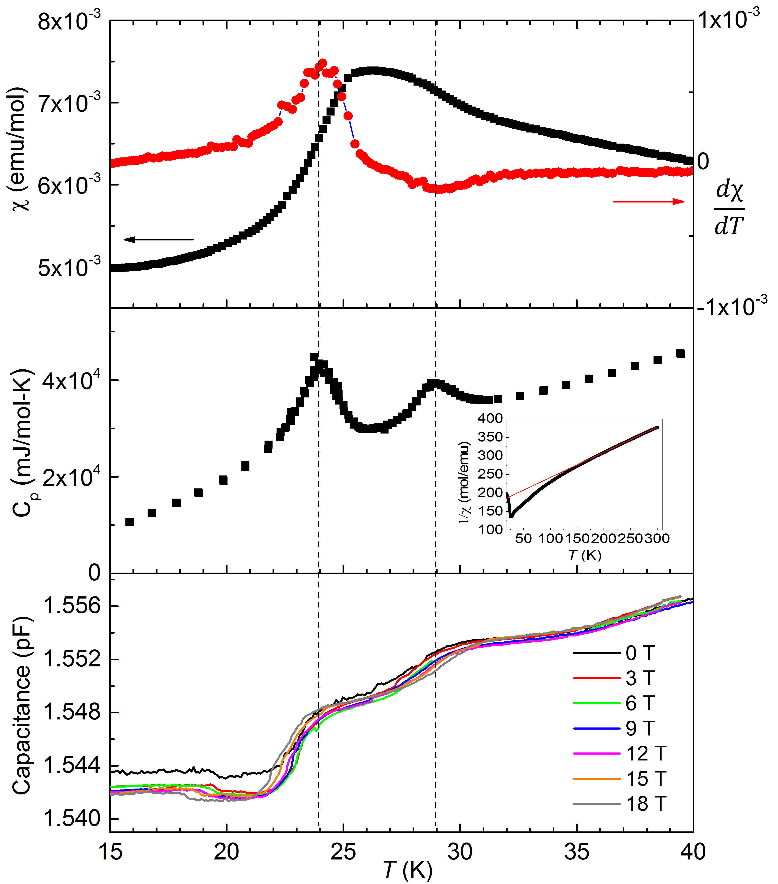

Fig.1. Magnetic susceptibility, heat capacity and dielectric constant of CsV(MoO₄)₂
We carried out ¹³³Cs NMR measurements on triangular lattice magnet CsV(MoO₄)₂ single crystals. CsV(MoO₄)₂ belongs to the trigonal space group at room temperature, where V³⁺ ions (S=1) form a regular triangular lattice in the basal plane with Cs atoms located between them. The heat capacity measurement revealed two phase transitions around 24 K and 29 K (Fig. 1).

Experimental
A small piece of CsV(MoO₄)₂ single crystal (2 mm * 2 mm * 0.8 mm) was used for ¹³³Cs NMR measurements of line shapes and spin-lattice relaxation times (T₁) employing a home-made NMR spectrometer at National High Magnetic Field Laboratory.

Results and Discussion
The ¹³³Cs (I = 7/2, γ= 5.5844 MHz/T) spectrum at 34 K showed a set of simple seven lines due to its electric quadrupole moment (Fig. 2). The seven lines started to shift to lower frequencies below 29 K, at which low temperature XRD measurements also revealed an anomaly. Upon further cooling, each electric quadrupole line split into three pairs below 24 K, which is associated to the AFM ordering at the same temperature. The ¹³³Cs spin-lattice relaxation time (T₁) showed significant change around 24 K but no apparent features around 29 K. The NMR results indicate that CsV(MoO₄)₂ goes through a structural phase transition at 29 K and an AFM transition at 24 K. The splitting of the NMR spectrum suggests the 120 degree ordered phase below 24 K.
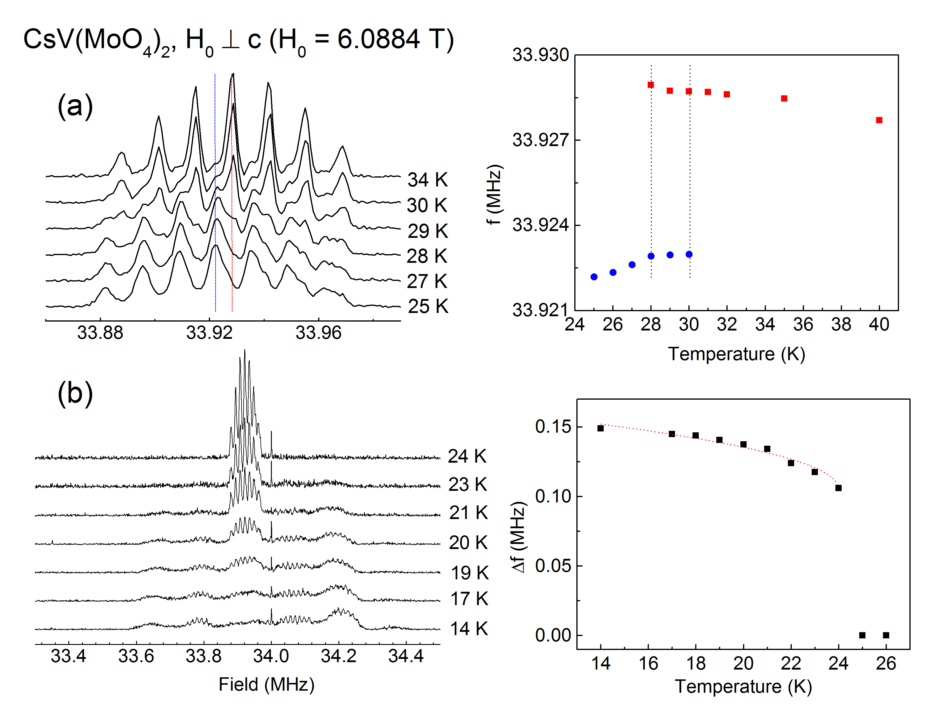
Fig. 2. (a) (Left) ¹³³Cs NMR spectra for H₀ ┴ c at 6.0884 T around 29 K. (Right) The peaks shift toward lower frequency. (b) (Left) ¹³³Cs NMR spectra around 24 K. (Right) The line shift as the order parameter vs. temperature.

Conclusions
The ¹³³Cs NMR measurements were carried out on a triangular lattice magnet CsV(MoO₄)₂ single crystals. The NMR results indicate that CsV(MoO₄)₂ goes through a structural phase transition at 29 K and an AFM transition at 24 K.

Acknowledgements
The NHMFL is supported by National Science Foundation Cooperative Agreement No. DMR-1157490 and the State of Florida. We also acknowledge NSF-DMR 1309146 for the financial support.

References
[1] K. H. Lii, et al., J. Solid State Chem. 80, 144 (1989).
[2] L. E. Svistov, et al., JETP Letters, 81, 102 (2005).
[3] T. M. McQueen, et al., Phys. Rev. Lett. 101, 166402 (2008).

