Magnetometry of the Candidate Kitaev Honeycomb Magnet α-RuCl₃

Singleton, J.; Zapf, V. (NHMFL); Williams, S.C.; Haghighirad, A.A.; Johnson, R.D. and Coldea, R. (University of Oxford)

The layered honeycomb magnet α-RuCl₃ has attracted much attention recently¹⁻³ following the proposal⁴⁻⁶ that it could realize a Kitaev spin model⁷ with strongly frustrated, bond-dependent, anisotropic interactions between spin-orbit entangled j_{eff} = 1/2 Ru⁴⁺ magnetic moments. Here we report detailed magnetometry studies on aligned crystal platelets of α-RuCl₃ in pulsed field up to 60 T to determine the shape of the magnetization curve and the phase diagram in magnetic field applied in the honeycomb layers and perpendicular.

Magnetometry measurements on a stack of aligned platelets were made using a 65 T short-pulse magnet at NHMFL at Los Alamos with an improved version of the experimental setup described in Ref. 9, in a ³He cryostat with a base temperature of 0.4 K; additional VSM measurements were performed at low field. Susceptibility data both for powders and for stacked crystals show a single magnetic transition upon cooling below T_{N} ≃13 K, indicative of long-range antiferromagnetic ordering of the Ru magnetic moments. At lower temperatures, the steep rise in M(H) for pulsed-field measurements on single crystals suggests a field-induced phase transition near 8 T for field in the honeycomb plane (H ⊥ c*) followed by a gradual, asymptotic approach to magnetization saturation, as characteristic of strongly-anisotropic exchange interactions, of Kitaev¹⁰ or another form. For H ǁ c* (out of plane), M(H,T) is around 5 times smaller, and the phase transition at 8 T is not observed. Using neutron diffraction we determined that the zero-field magnetic structure has antiferromagnetic order of zigzag ferromagnetic chains. The susceptibility measurements indicate that the zigzag phase is suppressed by relatively small magnetic fields (∼ 8 T) applied in the honeycomb layers, whereas it is robust in fields applied perpendicular to the honeycomb layers. Figure 1a) shows the magnetic phase diagram constructed from maxima in M(T) and dM/dH.
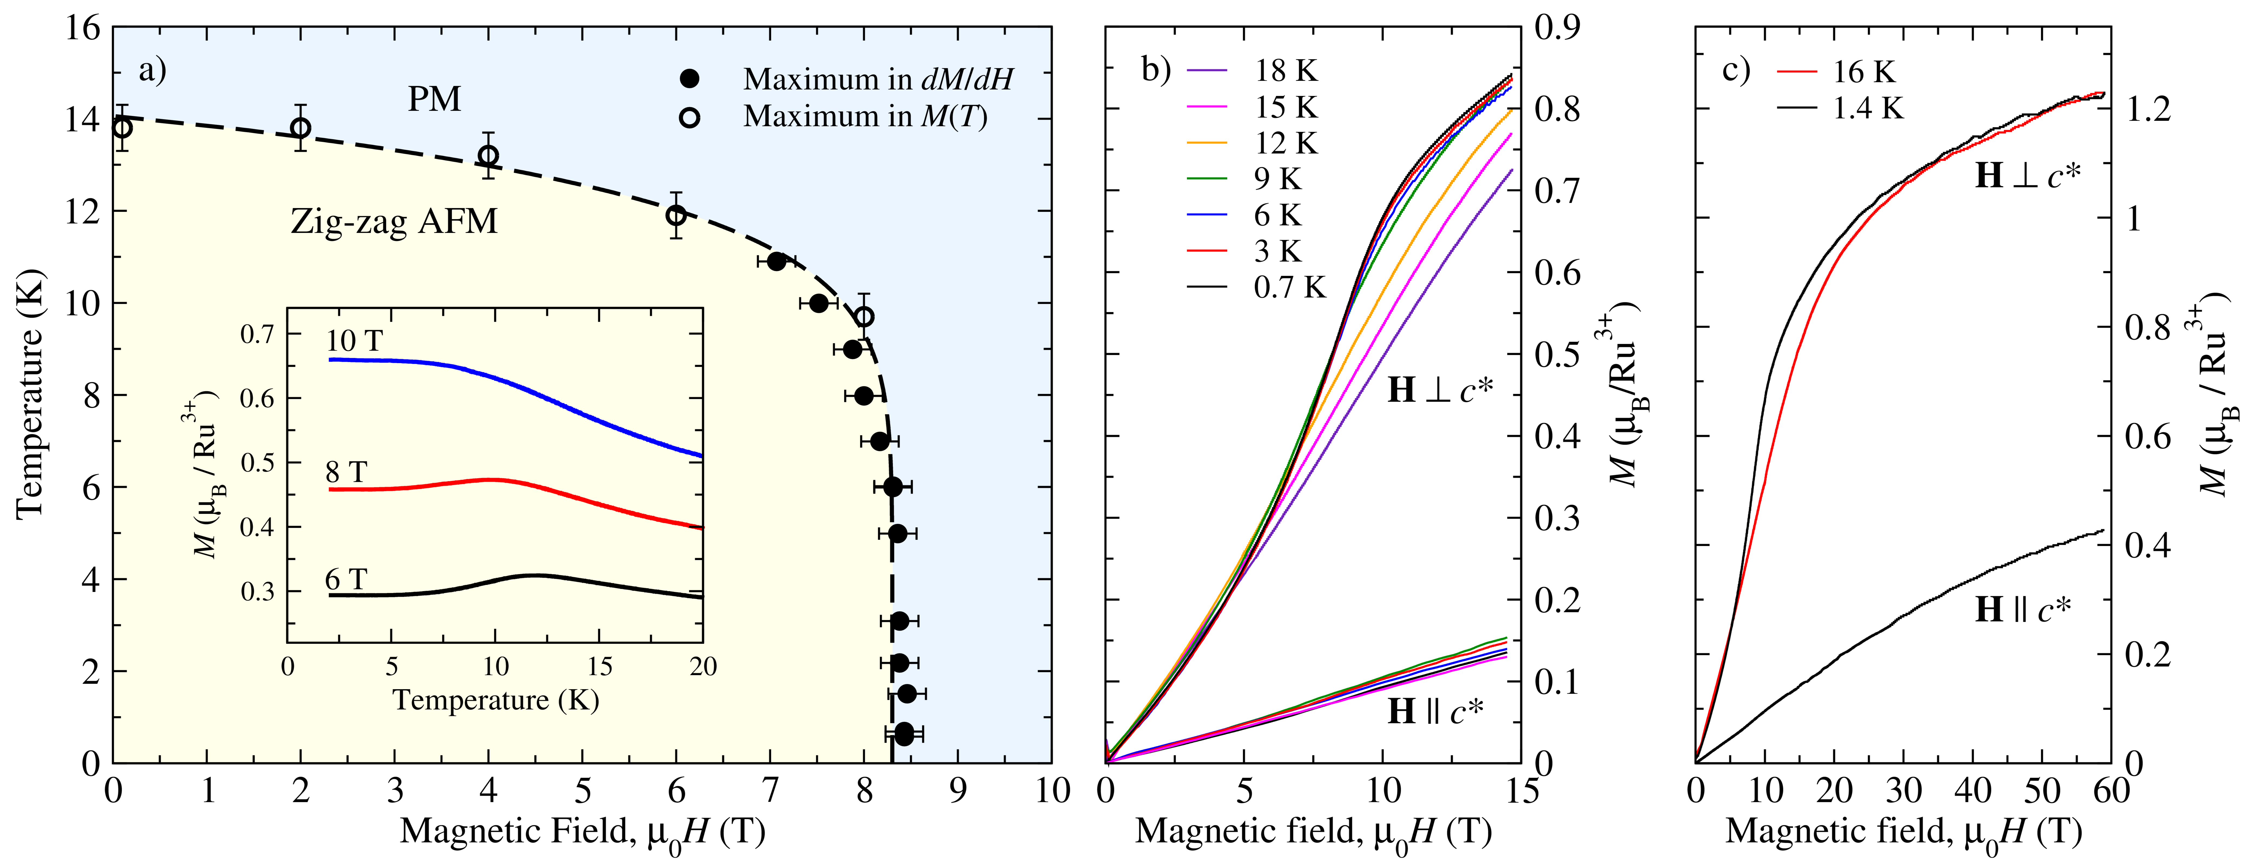
Acknowledgements
Fig.1 a) Magnetic phase diagram for single crystals of α-RuCl3 in magnetic field H ⊥ c*. Solid points from maxima in dM/dH are from data in b) (upper traces). Open symbols are from maxima in M(T) VSM temperature sweeps (see inset). The dashed line is a guide-to-the-eye phase boundary between the zigzag antiferromagnetic phase (AFM, yellow shading) and paramagnetic (PM, blue shading). b) M(H,T) from rising part of 15 T pulses at constant temperatures c) M(H,T) from rising part of 60 T field pulses in both phases.
This work is supported by EPSRC (UK). The pulsed-field measurements at the National High Magnetic Field Laboratory in Los Alamos were supported by the National Science Foundation Cooperative Agreement No. DMR-1157490 and the State of Florida.

References
An extended description of this work is found in Johnson, R. D., et al., Phys. Rev. B 92, 235119 (2015)
[1] Kubota, Y., et al., Phys. Rev. B 91, 094422 (2015). [2] Majumder, M., et al., Phys. Rev. B 91, 180401 (2015). [3] Sears, J. A., et al., Phys. Rev. B 91, 144420 (2015). [4] Plumb, K. W., et al., Phys. Rev. B 90, 041112 (2014). [5] Sandilands, L. J., et al., Phys. Rev. Lett. 114, 147201 (2015). [6] Rousochatzakis, I., et al., arXiv:1506.09185. [7] Banerjee, A., et al., arXiv:1504.08037. [8] Kitaev, A., Annals of Physics 321, 2 (2006), [9] Goddard, P. A., et al., New Journal of Physics, 10, 083025 (2008). [10] Jiang, H.-C., et al., Phys. Rev. B 83, 245104 (2011).

