Magnetoresistance in i-R-Cd Icosahedral Quasicrystals (R=Y, Gd)

Saraswat, G.; Popović, D. (FSU, NHMFL); Kong, T.; Bud’ko, S.L. and Canfield, P.C. (Iowa State, Ames Laboratory)

Introduction
Quasicrystals are ordered but aperiodic lattices. Understanding the relationship between the quasicrystalline structure and magnetism has been a long-standing challenge. Effects of local magnetic moments and intersite spin correlations on transport properties of the quasicrystalline conduction electrons also remain open questions of current interest (see, e.g., Ref. [1]). A class of recently discovered, rare earths and cadmium-based binary quasicrystals, i-R-Cd [2], provide an opportunity to investigate electronic and magnetic properties in quasicrystals with localized moments.

Experimental
We focus on the transport properties of this family of quasicrystals with and without magnetic moments, i-Gd-Cd and i-Y-Cd, respectively. DC magnetization measurements have revealed a spin-glass behavior for i-Gd-Cd quasicrystals, with spin freezing temperature T_{f} = 4.6 K [3]. We have explored the magnetoresistance (MR) up to a magnetic field (H) of 12 T for temperatures (T) ranging from 1.6 K to 300 K.

Results and Discussion
The most interesting behavior is observed in i-Gd-Cd, in which the MR exhibits thermo-magnetic history dependence at low T. In contrast, the i-Y-Cd MR does not depend on magnetic history. Figure 1 shows a comparison of the resistances of i-Gd-Cd and i-Y-Cd as a function of H at 1.6 K for states prepared by zero-field cooling (ZFC) and field cooling (FC) the samples in 12 T. In the quasicrystal with local magnetic moments, there is a clear difference between the ZFC and FC values of the positive MR.
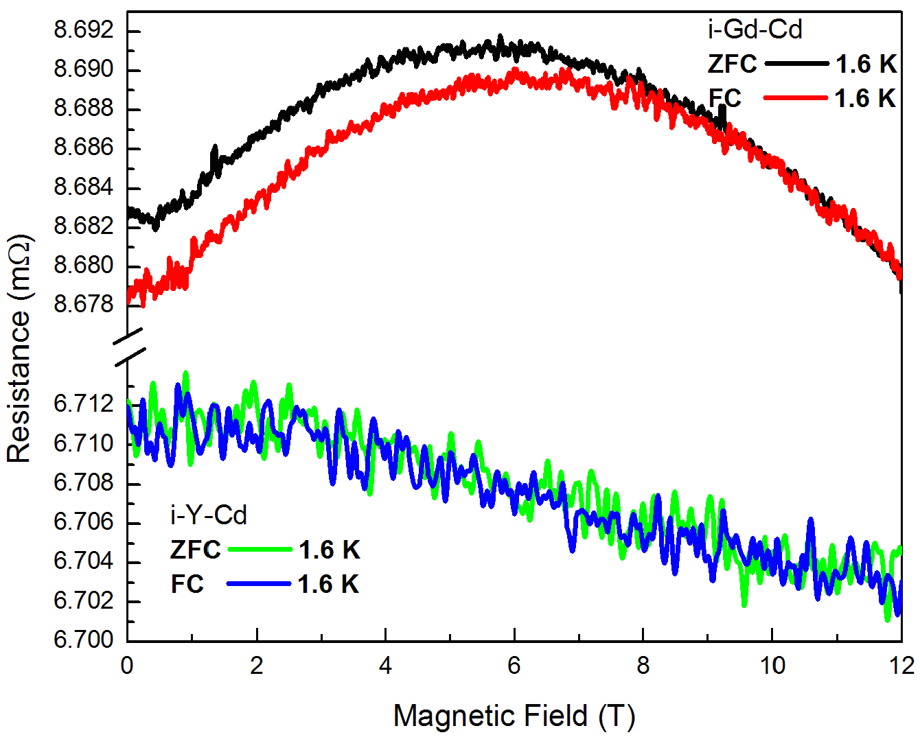
Conclusions
The onset of the positive, history dependent MR at T ~ 20 K > T_{f} may be related to the formation of magnetic clusters above T_{f}, as inferred from the magnetization and specific heat measurements [3]. However, further data analysis is needed to disentangle the possible mechanisms responsible for the observed striking coupling between charge transport and local magnetic environment.

Acknowledgements
A portion of this work was performed the National High Magnetic Field Laboratory (GS, DP), which is supported by National Science Foundation Cooperative Agreement No. DMR-1157490 and the State of Florida. Partial support was also provided by NSF Grant No. DMR-1307075. Work done at Ames Lab (TK, SLB and PCC) was supported by the U.S. D.O.E / B.E.S under Contract No. DE-AC02-07CH11358.
Fig.1 ZFC and FC resistance R of i-Gd-Cd and i-Y-Cd vs. H at 1.6 K. ZFC state is prepared by zero-field cooling from 50 K and FC state is prepared by cooling in H=12 T from 50 K.

References
[1] Eric C. Andrade et al., Phys. Rev. Lett. 115, 036403 (2015).
[2] Alan I. Goldman et al., Nature Mater. 12, 714–718 (2013).
[3] Tai Kong et al., Phys. Rev. B 90, 014424 (2014).

