High Coercive Magnetic Fields in a New Iridate
Chikara, S.; Singleton, J.; Lakis, I. (NHMFL-PFF); Wang, L. (Postech, Korea); Cheong, S.-W. (Rutgers) and Zapf, V. (NHMFL-PFF)

Introduction
Previously, some of the highest coercive magnetic fields were demonstrated in Sr₃NiIrO₆. [1] This frustrated hexagonal antiferromagnet shows a low-temperature magnetic order identified from neutron scattering to be either a modulated antiferromagnet or a partially-disordered antiferromagnet. [2] The Ir⁴⁺ atom occupies a quasi-octahedral oxygen cage that is trigonally distorted. In iridium oxide materials, the comparable energy scales of spin-orbit coupling, crystal-electric fields and Coulomb interactions can conspire to create large spin-lattice couplings. In Sr₃NiIrO₆ we observed coercive magnetic fields up to 55 Tesla in pulsed magnets, with remnant magnetizations with lifetimes of at least 8 hours (the longest time waited). Resonant inelastic x-ray scattering find that the Ir⁴⁺ ion is in a variant of the Jeff = ½ state with even stronger spin-orbit entanglement that was observed in Sr₂IrO_{4.} [3,4] Here we study another iridate compound with similar structure but different magnetic ions, and also find coercive magnetic fields up to 45 Tesla.

Experimental
Magnetization change (ΔM) of this new iridate compound was measured as a function of magnetic field H at the NHMFL-PFF to 65 Tesla in pulsed and DC superconducting magnets [4]. Magnetization was recorded by integrating the signal from a compensated pickup coil and subtracting sample-out shots. Full magnetic hysteresis loops were measured with alternating positive and negative sweeps, after zero-field cooling from above the ordering temperature.

Results and Discussion
Fig. 1 shows the magnetization as a function of magnetic field for positive and negative pulses. The data was taken at different magnetic fields. A selection of temperatures between 0.5 and 25 K are shown. A coercive magnetic field of 45 T is seen for 0.5 K, which decreases monotonically with increasing temperature. Above 50 K, the hysteresis vanishes. In this compound, unlike Sr₃NiIrO₆, not all of the remnant magnetization is retained during the approx. 20-45 minutes between one shot and the next.
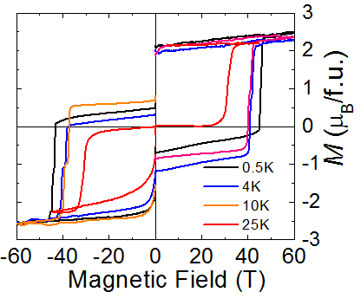Fig. 1 Magnetization change vs magnetic field of an iridate. Data was taken in 65 T capacitor-driven magnets, and is shown for a series of pulses to positive and negative fields. The sample was zero-field cooled to each new temperature.

Conclusions
We have observed some of the highest known coercive magnetic fields in a new iridate compound, and find similar behavior to Sr₃NiIrO₆. Part of the remnant magnetic moment is retained on hour time scales.

Acknowledgements
The NHMFL-PFF facility is supported by National Science Foundation Cooperative Agreement No. DMR-1157490, the State of Florida, and the U.S. Department of Energy. Scientific work was funded by the LDRD program at LANL.

References
[1] J. Singleton, J. W. Kim, C. V. Topping, A. Hansen, E.-D. Mun, S. Ghannadzadeh, P. Goddard, X. Luo, Y. S. Oh, S.-W. Cheong and V. S. Zapf “55 Tesla coercive magnetic field in Sr₃NiIrO₆,” http://arxiv.org/abs/1408.0758.
[2] E. LeFrancois et al, Phys. Rev. B 90, 014408 (2014)
[3] E. LeFrancois et al, http://arxiv.org/abs/1504.05420;
[4] B. J. Kim et al, Phys. Rev. Lett. 101, 076402 (2008); B. J. Kim et al, Science 323, 1329 (2009)

