Investigation of an Itinerant Antiferromagnet in High Magnetic Fields

Svanidze, E. (Rice University, Physics); Chikara, S.; Zapf, V.S.; Singleton, J. (NHMFL-PFF) and Morosan, E. (Rice University, Physics)

Introduction
The tunnel diode oscillator (TDO) technique is widely used to investigate condensed matter systems due to the great precision and high sensitivity with which frequency of an LC-tank circuit can be measured [1, 2]. In particular, it has been suggested that this technique can differentiate between systems with local and itinerant magnetic moments [3]. While the TDO analysis of ferromagnetic materials has been done before [3], the discovery of the first itinerant antiferromagnetic metal composed of nonmagnetic constituents TiAu [4] allows testing whether this technique works for antiferromagnets.

Experimental
The pulsed-field magnetization experiments, described in detail in Ref. [5], were performed on rod-shaped samples of polycrystalline TiAu. The magnetic field was supplied by a 65 T short-pulse magnet at NHMFL. The susceptometer was placed in a ³He cryostat providing temperatures down to 0.4 K.

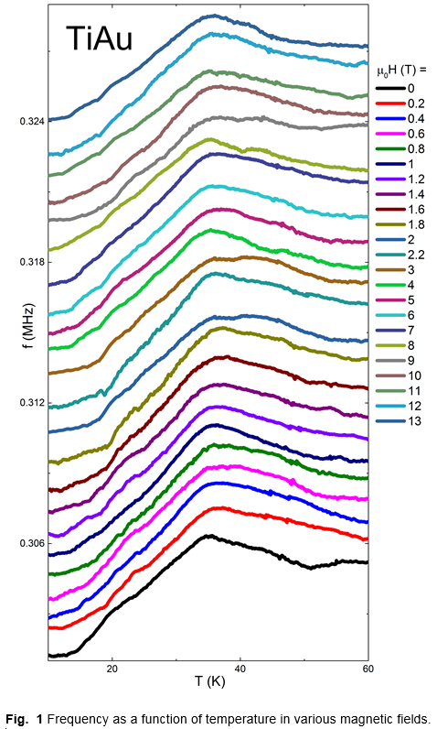
Results and Discussion
The itinerant magnet TiAu, composed of non-magnetic elements, displays antiferromagnetism below the Neel temperature T_{N} = 36 K [4]. The oscillator frequency shift f as a function of temperature T is shown in Fig. 1. The µ₀H = 0 (black) data are in stark contrast with that of a local moment antiferromagnet SmAgSb₂ [6], for which no peak is observed. Further field-dependent experiments are needed to compare the frequency response of SmAgSb₂ and TiAu.
On the other hand, a comparison with ferromagnetic ZrZn₂ [6] reveals another distinct feature: while the peak corresponding to the ordering temperature at T = 28 K is suppressed in ZrZn₂ with µ₀H = 0.05 T, the T = 36 K feature in TiAu remains unchanged as the external magnetic field is increased up to µ₀H = 13 T (Fig. 1).

Conclusions
It was shown that the TDO technique is able to differentiate between local and itinerant moment antiferromagnets. Moreover, the field-dependent data can be used to identify ferro- or antiferromagnetic materials.

Acknowledgements
The work at Rice was supported by NSF DMR 0847681 (E.M. and E.S.). A portion of this work was performed at the NHMFL, which is supported by NSF Cooperative Agreement No. DMR-1157490 and the State of Florida.

References
[1] Degrift, C.T. Review of Scientific Instruments 46, 599-607 (1975).
[2] Srikanth, H. et. al. Review of Scientific Instruments 70, 3097- 3101(1999)
[3] Vannette, M.D. et. al. Journal of Applied Physics 103, 07D302 1-3 (2008)
[4] Svanidze, E. et. al. Nature Communications 6, 7701 1-7 (2015)
[5] Goddard, P. A. et. al. New Journal of Physics 10, 083025 1-11 (2008)
[6] Vannette, M.D. et. al. Journal of Magnetism and Magnetic Materials 320, 354-363 (2008)

