Non-Resonant Absorption in the Kagome-Lattice Metamagnet Cu₃Bi(SeO₃)₂Br

Zorko, A.; Pregelj, M. (Jožef Stefan Institute, Ljubljana, Slovenia); Zaharko, O. (Paul Scherer Institute, Villigen, Switzerland, Laboratory for Neutron Scattering and Imaging) and Ozarowski, A. (NHMFL)

Introduction
Metamagnets, which exhibit a transition from a low-magnetization to a high-magnetization state induced by
the applied magnetic field, are promising materials for broadband absorption of electromagnetic radiation [1]. In the Cu₃Bi(SeO₃)₂O₂Br planar kagome-lattice metamagnet such absorption extends over at least ten decades in frequency (from 100 Hz to a few hundreds of GHz) [1]. As the broadband absorption is a property of a mixed antiferromagnetic (AFM)/ferromagnetic (FM) phase of the material that appears in a narrow magnetic-field window, the absorption is controllable by the external magnetic field, unlike in all other known broadband absorbers.

Experimental
Electron spin resonance (ESR) experiments on a Cu₃Bi(SeO₃)₂Br single crystal were performed at the EMR NHMFL facility on the homodyne detection system equipped with a 17 T superconducting magnet. The magnetic field was applied perpendicular to the kagome layers.

Results and Discussion
Within the mixed phase non-resonant absorption is observed, with critical fields B₁ and B₂, which we define as the lower and the higher borders of the absorption signal, respectively (Fig. 1(a)). These fields are independent of frequency, in clear contrast to the regular ferromagnetic absorption modes [2]. A pronounced hysteresis is found in the value of the higher critical field B₂, which depends significantly on the direction of the field sweep [Fig. 1(b)]. Moreover, this hysteresis effect is strongly temperature dependent. In contrast, there is no hysteresis observed in the lower critical field B₁.
Our investigation thus confirms that the first-order transition from the low-field AFM phase into the high-field FM state is spread over a range of applied fields, which defines the highly absorptive mixed AFM/FM phase. The hysteresis in B₂ is unlikely related to usual hysteresis mechanisms encountered in FM materials. It suggests that thermal fluctuations play an important role in destabilizing the mixed phase [2].
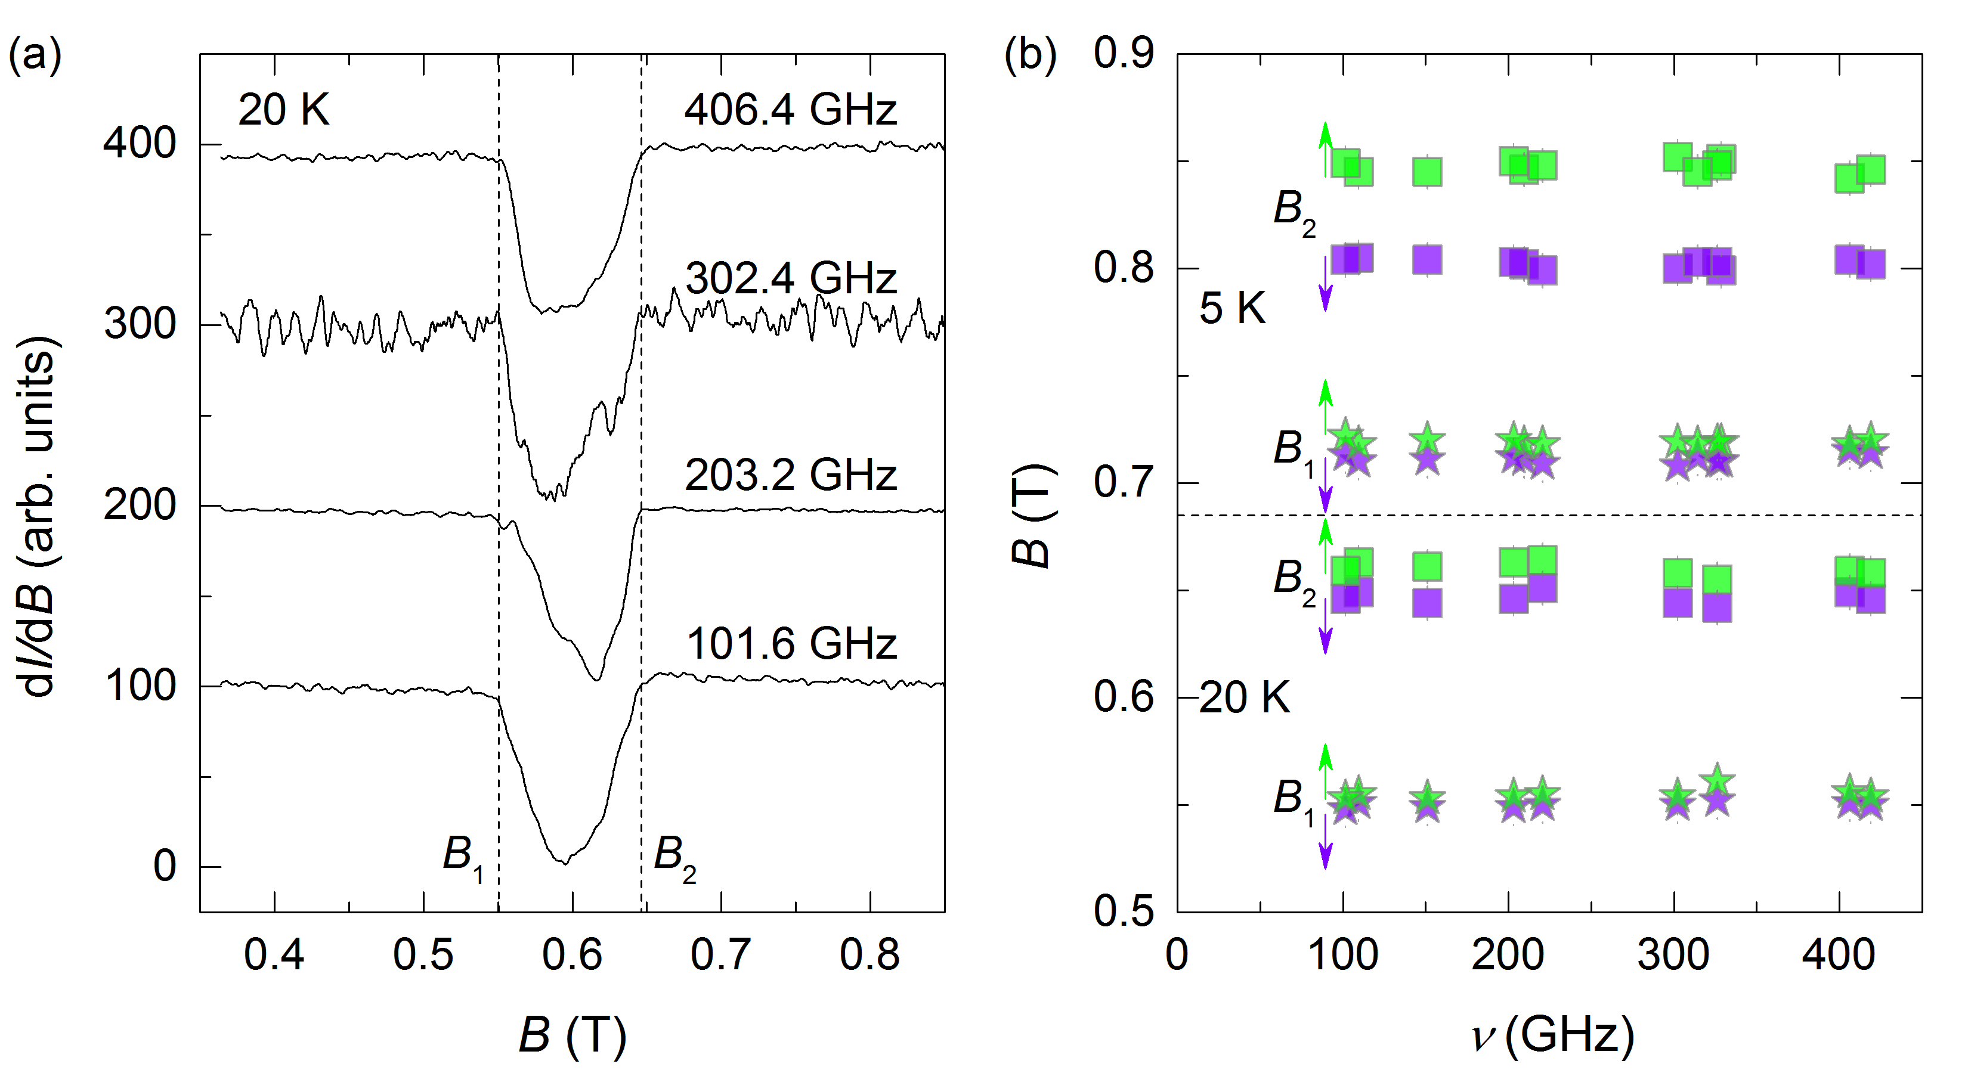
Fig. 1. (a) A collection of non-resonant absorption spectra, offset vertically by corresponding frequencies. (b) The frequency dependence of both critical fields at two temperatures. The direction of the field sweep is indicated by vertical arrows.

Acknowledgements
A portion of this work was performed at the National High Magnetic Field Laboratory, which is supported by National Science Foundation Cooperative Agreement No. DMR-1157490 and the State of Florida. This work has been partially supported by the Slovenian Research Agency through the program No. P1-0125 and project BI-US/14-15-039.

References
[1] Pregelj, M., et al., Adv. Funct. Mater., 25, 3634-3640 (2015).
[2] Zorko, A., et al., submitted for publication in AIP Advances (2016).

