Understanding the Nature of Magnetism in Transition-Metal Substituted Phthalocyanines through High-Field, Low-Temperature Magnetic Measurements at the NHMFL
Seehra, M.S.; Wang, Z. (West Virginia University, Physics); Lee, M.; Choi, E.S. (FSU and NHMFL, Physics) and Poston, J. (DOE, NETL)

Introduction
Transition metal doped phthalocyanines (TMPc, TM = Mn, Fe, Co, Ni and Cu) are molecular semiconductors with potential applications in electro-optic and spintronic devices [1, 2]. The TM atoms form linear chains along the b-axis (Fig.1). Under this project, measurements were completed from 0.4 K to 20 K in β-CoPc at the NHMFL and a manuscript based on these results has now been submitted for publication [3].

Experimental
CoPc powder sample used in these experiments was purchased from Alfa Aesar (stock # 41496) and characterized by X-ray diffraction. Magnetization M versus temperature T (2 K to 300 K) was measured by a Physical Property Measurement System (PPMS) at West Virginia University. The morphology of CoPc powder sample was characterized by Scanning electron microscope at NETL/DOE. M vs. T data from 0.4 K to 20 K with field H = 10 kOe was measured by DC field facility (SCM2) at NHMFL and the data was scaled to M vs.T data taken at West Virginia University.

Results and Discussion
X-ray diffraction of the sample confirmed the β-phase and SEM showed plate-like morphology for the sample. Magnetically, the M vs. T data in H = 10 kOe fitting the Curie-Weiss (CW) law above T > 3 K yielding θ = 2.5 K, µ = 2.16 µ_{B} per Co²⁺ and g = 2.49 for spin S = 1/2 (Fig.2). Below 3 K, the data deviates from the CW law yielding a peak in M near 2 K (Fig.2). Also, the data from 0.4 K to 300 K fits well with the prediction of the Bonner-Fisher (BF) model for S = 1/2 Antiferromagnetic (AFM) Heisenberg linear chain [4] yielding the Co²⁺-Co²⁺ exchange constant J/k_{B} = -1.5 K (H = -2J Σ S_{i}•S_{i+1}) [3].

Conclusions
Our measurements and analysis of the M vs. T data in β-CoPc show it to be a Heisenberg linear chain of antiferromagnetically coupled spins with S = 1/2 and intrachain exchange constant J/k_{B} = -1.5 K with negligible interchain coupling.

Acknowledgements
A portion of this work was performed at the National High Magnetic Field Laboratory, which is supported by National Science Foundation Cooperative Agreement No. DMR-1157490 and the State of Florida.

References
[1] Mugarza, A., et al., Phys. Rev. B, 85, 155437/1-13 (2012).
[2] Serri, M., et al., Nat. Commun, 5, 3079/1-9 (2014).
[3] Wang, Z, M. Lee, E.S. Choi, J. Poston, and M.S. Seehra, J. Magn. Magn. Mater. (under review).
[4] Bonner, J. C., et al., Phys. Rev, 135, A640-A658 (1964).
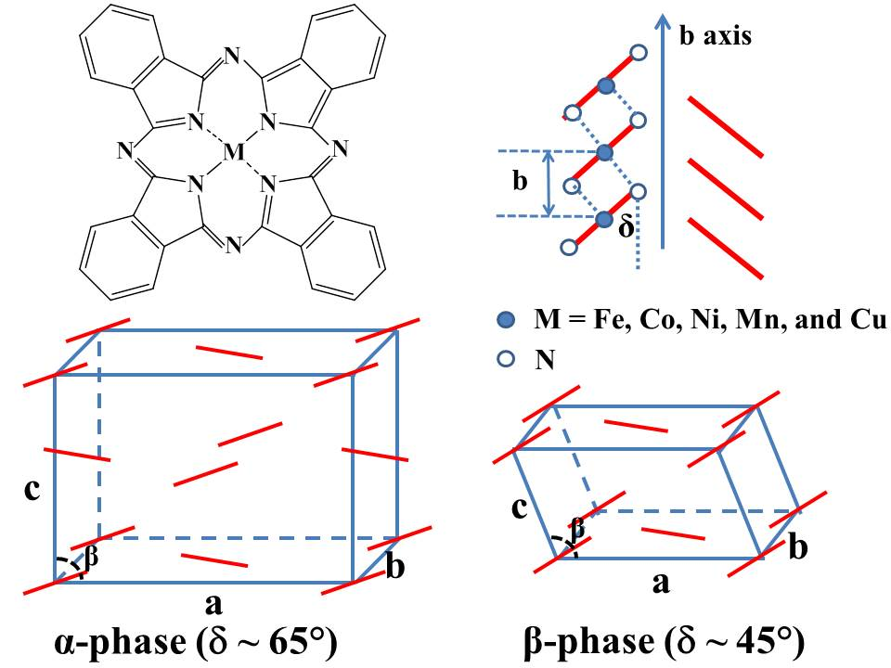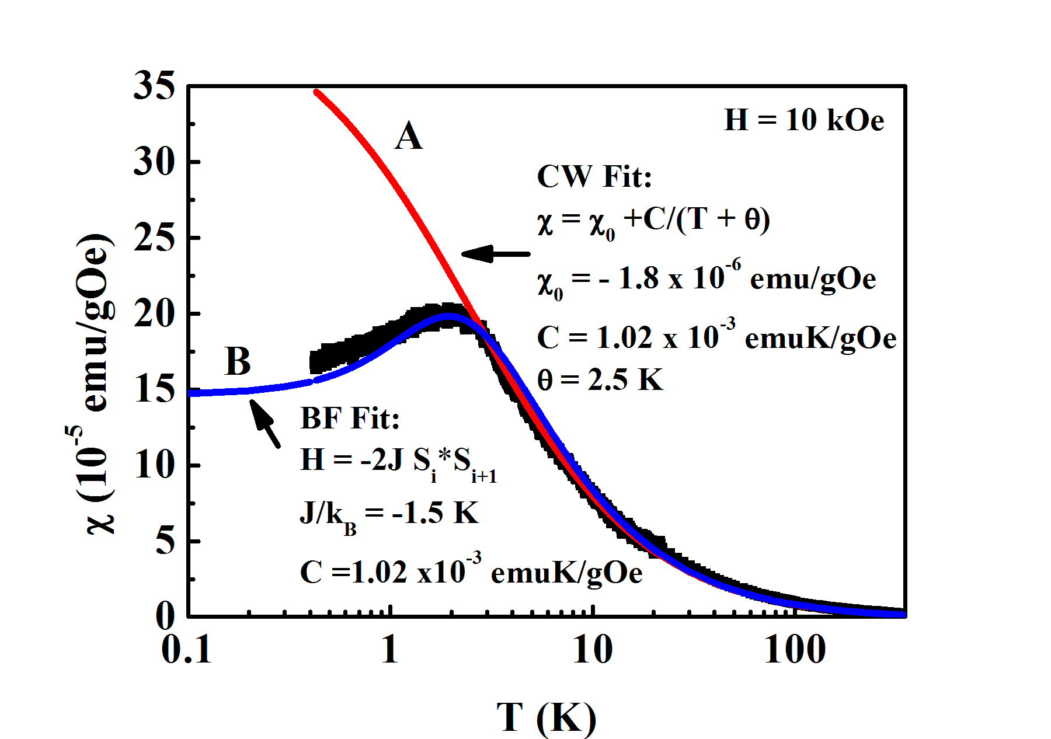
Fig.1 Molecular model, unit cells, and molecular arrangement of TMPc.
Fig.2 M vs. T with H = 10 kOe. Solid line A and B are fits to the CW law and the BF model, respectively.

