Magnetic Criticality Controlled by Magnetic Field Sweep in La_{1-x}Sr_{x}CoO₃

Chikara, S.; Singleton, J.; Harrison, N. (NHMFL-PFF); Chern, G.-W. (U. Virgina); Batista, C. (Theory Division, LANL); Mitchell, J. (Argonne National Laboratory) and Zapf, V. (NHMFL-PFF)

Introduction
Ordinary magnetic exchange interactions are modeled as static quantities. However, when spins interact via propagating objects such as magnons, then time becomes a factor. Here we show that in such a system, magnetic field sweep rate can tune the interaction strength and the existence of phase transitions. La_{1-x}Sr_{x}CoO₃ is a cluster magnet in which local ferromagnetic regions seeded by Co⁴⁺ ions exist in an antiferromagnetic or non-magnetic background of Co⁺³. For x < 0.17, the system behaves like an insulating cluster glass, while for x > 0.17 a percolation to ferromagnetic metallic behavior takes place. [1, 2] In similar systems, particularly the analogous manganites, magnetic avalanches have been observed, resulting in sharp random steps in the magnetization with a power-law distribution. [3] Here we find that we can tune magnetic avalanche behavior effectively inducing criticality for an intermediate regime of field sweep rate.
Experimental
Magnetization change (ΔM) was measured as a function of magnetic field H at the NHMFL-PFF to 65 Tesla in pulsed and DC superconducting magnets. [4] Polycrystalline La_{1-x}Sr_{x}CoO₃ (0.01 ≤x≤0.22) was studied at different magnetic field sweep rates dH/dt by varying the peak field of the pulse.
Results and Discussion
Fig. 1 depicts ΔM(H) after reversal of the magnetic field. Fig 1(a) demonstrates step-like behavior for x =0.10 at 4 and 10 T peak fields (dH/dt < 2 kT/s) but not 20 T (dH/dt < 8kT/s). No steps occur in superconducting magnets with dH/dt = 5e⁻³ T/s (not shown). In Fig 1(b), the magnetization steps can be seen for x = 0.1 and 0.15 but not x = 0.01, 0.17 or 0.22. Fig 1(c) shows simulation results for a magnetic cluster glass where clusters interact via magnon propagation with the power law distribution of the number of simultaneously flipped clusters.
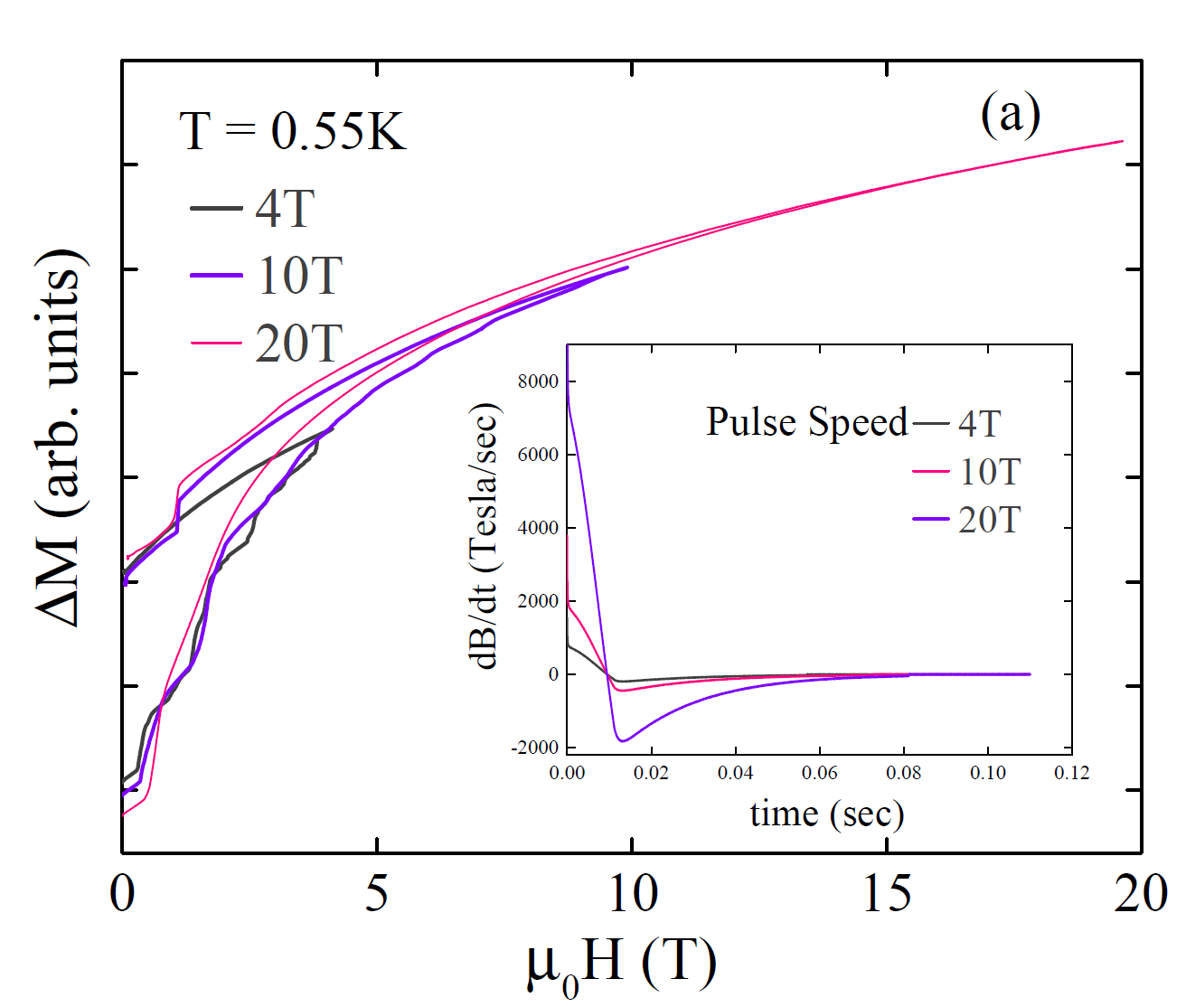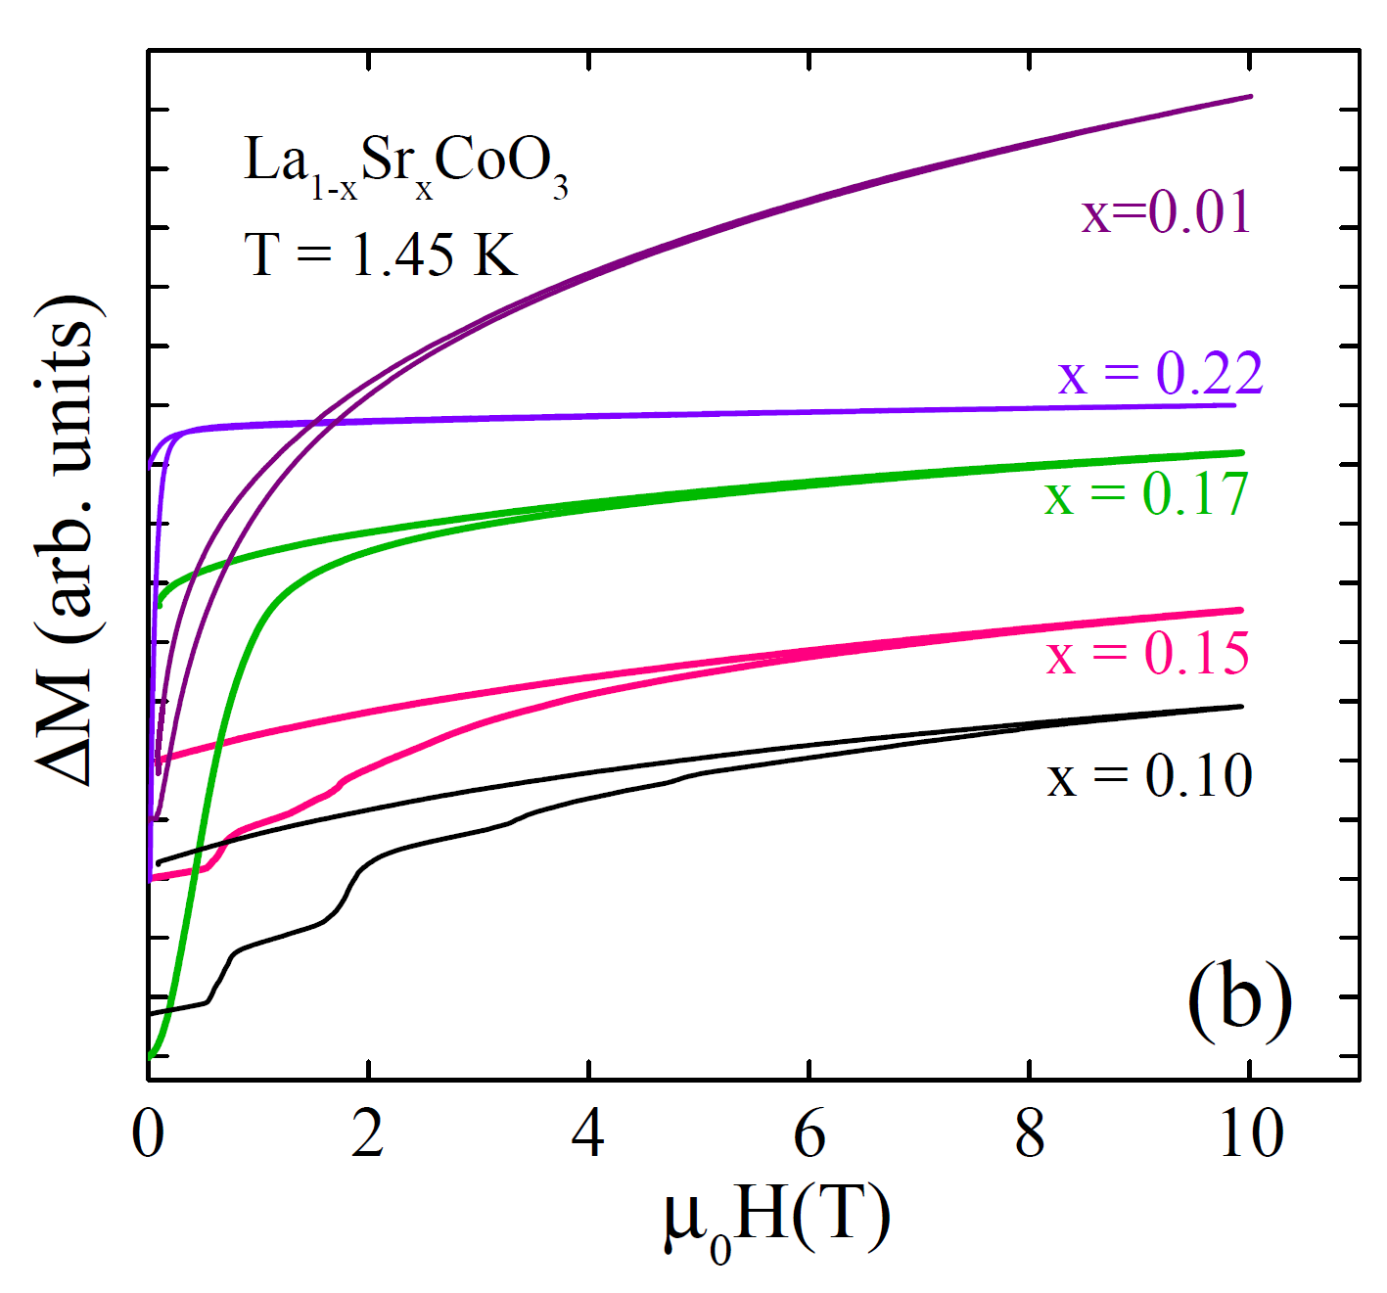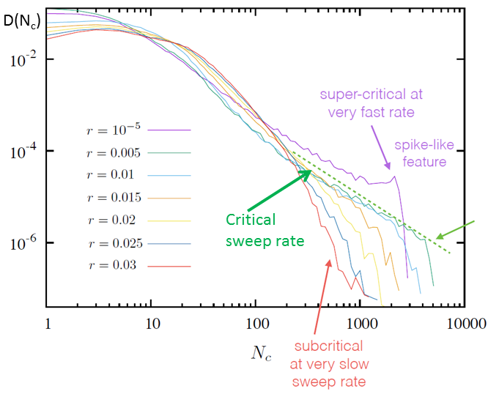 Fig.1 (a) Magnetization change ΔM with field H for different pulse speeds (peak field) for x=0.10 (b) ΔM(H) for samples with different x for a 10 T pulse. (c) Distribution D(N_{c}) of the number of simultaneously flipped clusters N_{c} for different sweep rates r.
(c)

Conclusions
We have observed magnetic avalanche behavior in La_{1-x}Sr_{x}CoO₃ with x = 0.1 to 0.15 due to competing dynamic time and energy scales. Phase transitions are induced for a window of magnetic field sweep rates, reflecting magnetic interactions that propagate at finite speeds. Simulations confirm that avalanches can be induced by intermediate sweep rates, and also show power-law distributions of cluster flips when approaching the phase transition (sweep-rate-induced criticality).
Acknowledgements
The NHMFL-PFF facility is supported by National Science Foundation Cooperative Agreement No. DMR-1157490, the State of Florida, and the U.S. Department of Energy. Scientific work was funded by the LDRD program at LANL.
References
[1] R.X. Smith et al, Phys Rev. B 86, 054428 (2012), D. Phelan et al, Phys. Rev. Lett 97, 235501 (2006), D. Louca et al, Phys. Rev. Lett 97, 155501 (2003)
[2] R. Caciuffo et al, Phys. Rev. B 59, 1068 (1999)
[3] V. Hardy et al, Phys. Rev. B 70, 104423 (2004)
[4] V. S. Zapf et al, Phys. Rev. B 82, 060402 (2010)

