Magnetization of a New Kagome Antiferromagnet

Han, T.-H.; Isaacs, E.D. (U of Chicago, Physics); Schlueter, J.A. (Argonne National Laboratory) and Singleton, J. (NHMFL LANL)

Introduction
Frustration happens when competing interactions cannot be simultaneously satisfied [1-4]. Strong
frustration produces exotic ground states, such as valence bond crystals, quantum spin liquids, etc. In these states, the spins are entangled without freezing or ordering down to T = 0. Experimental realization of such states have been challenging since static local moments are almost always stabilized as T 0 due to disorder, symmetry breaking interactions, etc.
Lattices involving kagome motifs have been an active playground. Recently, barlowite has emerged as a new mother compound of spin liquids [5]. Thermodynamic studies often provide crucial hints for precise theoretical modeling [6]. We would like to understand the magnetization of single crystalline barlowite at varies temperatures.

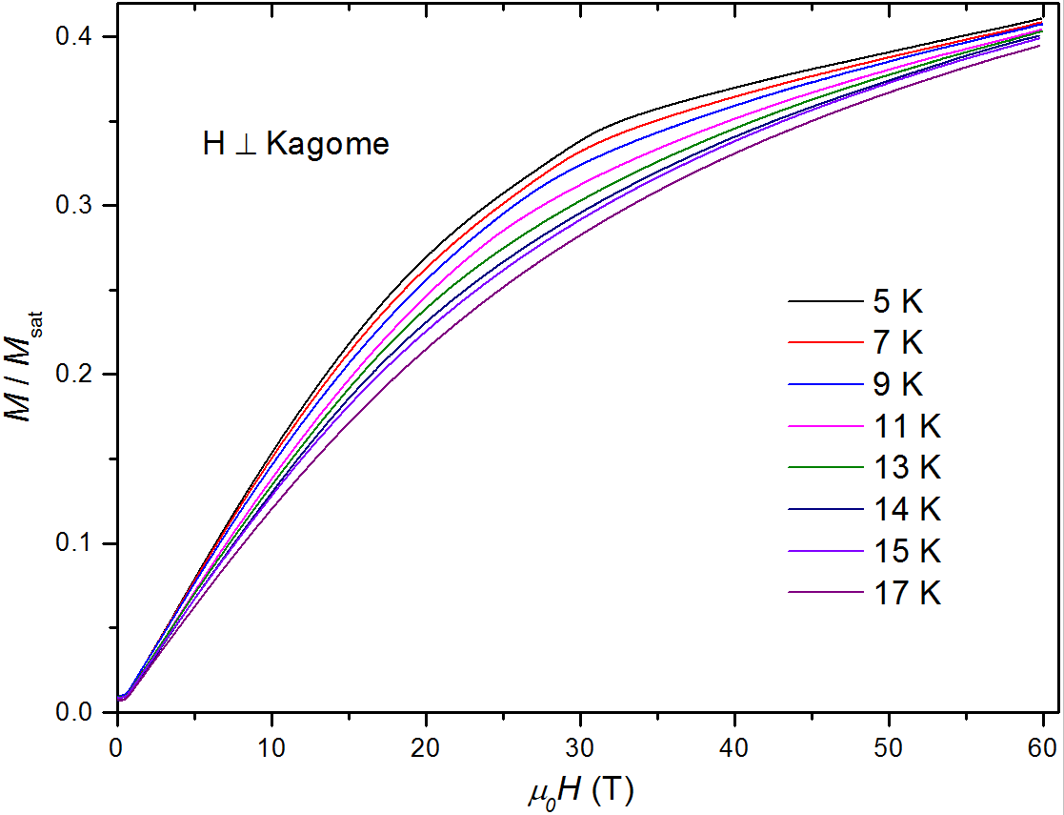
Experimental
The field dependence of magnetization, with H applied normal to the kagome lattices, has been measured using a pulsed magnet with a Helium-3 cryostat at NHMFL LANL. Below 5 K, the temperature dependence becomes very weak. In Fig.1, M vs H has been measured using an extraction magnetometer up to 60 T at several temperatures above and below the spin ordering temperature of 15 K [5].

Result and Discussion
The magnetization shows a kink around 30 T at 5 K. This anomaly gradually phases out as temperature approaches 15 K.

Conclusion
The 30 T features is likely related to the long-range spin order.
Fig.1 Magnetization of barlowite as a function of field applied normal to the kagome lattice. Long-range spin ordering occurs below 15 K [5].

Acknowledgements
A portion of this work was performed at the National High Magnetic Field Laboratory, which is supported by National Science Foundation Cooperative Agreement No. DMR-1157490, the State of Florida, and the U.S. Department of Energy (DOE). T.-H. Han was supported by the Provost’s Office, University of Chicago. The work at Argonne National Laboratory was supported under contract with the U.S. DOE (DE-AC02-06CH11357).

References
[1] Tian-Heng Han et al., Nature (London) 492, 406 (2012).
[2] T. H. Han et al., Phys. Rev. B 83, 100402(R) (2011).
[3] Oren Ofer et al., J. Phys. Condens. Matter 23, 164207 (2011).
[4] T. M. McQueen et al, J. Solid State Chem. 184, 3319 (2011).
[5] Tian-Heng Han et al., Phys. Rev. Lett. 113, 227203 (2014).
[6] Tianheng Han et al., Phys. Rev. Lett. 108, 157202 (2012).

